Original Plan Adoption: July 6, 2005
Updated: <insert date>, 2016
IP

City of Montello
Comprehensive Plan
2016 Planning Assistance by:
MAYOR’S PLANNING AND ADVISORY COMMITTEE RESOLUTION 2016-____
ADOPTING AND RECOMMENDING AN UPDATE TO THE
CITY OF MONTELLO, WISCONSIN COMPREHENSIVE PLAN

WHEREAS, section 66.1001(4), Wisconsin Statutes, establishes the required procedure for a local government to amend their adopted comprehensive plan, and section 66.1001(2) identifies the required elements of a comprehensive plan; and
WHEREAS, the City of Montello Mayor’s Planning and Advisory Committee has the authority to recommend that the City Council adopt an update to the CITY OF MONTELLO COMPREHENSIVE PLAN under section 66.1001(4)(b); and
WHEREAS, the City has prepared the attached updated, CITY OF MONTELLO COMPREHENSIVE PLAN, containing all maps and other descriptive materials, to be the comprehensive plan for the City under section 66.1001, Wisconsin Statutes; and
NOW, THEREFORE, BE IT RESOLVED that the Mayor’s Planning and Advisory Committee of the City of Montello hereby adopts the attached amended Comprehensive Plan as the City’s comprehensive plan under section 66.1001(4), Wisconsin Statutes; and
BE IT FURTHER RESOLVED that the Secretary of the Mayor’s Planning and Advisory Committee certifies a copy of the attached amended Comprehensive Plan to the City Council; and
BE IT FINALLY RESOLVED that the Mayor’s Planning and Advisory Committee hereby recommends that, following a public hearing, the City Council adopt an ordinance to constitute official City approval of the updated CITY OF MONTELLO COMPREHENSIVE PLAN as the City’s comprehensive plan under section 66.1001, Wisconsin Statutes.

Adopted this <insert date> day of <insert month>, 2016.

________________________________
Gary Doudna
Mayor’s Planning and Advisory Committee Chair

Attest:
__________________________________
Dawn Calnin
Planning and Advisory Committee Secretary
ORDINANCE NO. 2016-___
AN ORDINANCE TO ADOPT THE UPDATED CITY OF MONTELLO, WISCONSIN COMPREHENSIVE PLAN.

The City Council of the City of Montello, Wisconsin, does ordain as follows:
SECTION 1. Pursuant to sections 60.22(3) and 62.23(2) and (3) of Wisconsin Statutes, the City of Montello is authorized to prepare and adopt an update to the CITY OF MONTELLO COMPREHENSIVE PLAN as defined in sections 66.1001(1)(a) and 66.1001(2) of Wisconsin Statutes.
SECTION 2. The City Council of the City of Montello has adopted and followed written procedures designed to foster public participation in every stage of the comprehensive plan amendment process as required by section 66.1001(4)(a) of Wisconsin Statues.
SECTION 3. The Planning Advisory Committee of the City of Montello, by a majority vote of the entire Committee recorded in its official minutes, has adopted a resolution recommending the City Council adopt the amended CITY OF MONTELLO COMPREHENSIVE PLAN, containing all of the elements specified in section 66.1001(2) of the Wisconsin Statutes.
SECTION 4. The City of Montello has held at least one public hearing on this ordinance and associated Comprehensive Plan, in compliance with the requirements of section 66.1001(4)(d) of Wisconsin Statutes, and provided numerous other opportunities for public involvement per its adopted public participation strategy and procedures.
SECTION 5: The City Council of the City of Montello, Wisconsin, does, by enactment of this ordinance, formally adopt the updated CITY OF MONTELLO COMPREHENSIVE PLAN, pursuant to section 66.1001(4)(c) of Wisconsin Statutes.
SECTION 6: This ordinance shall take effect upon passage by a majority vote of the members-elect of the City Council and publication/posting as required by law.

Adopted this <insert date> day of <insert month>, 2016.

________________________
Gary Doudna, Mayor

Attest:
______________________
Dawn Calnin, City Clerk

Published/Posted on: ____________, 2016
Acknowledgements
City Council: | City Staff:
Gary Doudna, Mayor  Jim Houdek  Fran Demke  Barb Jordan  Venise Mugler  Karlene Utke  Ken Streich  Frank Breitenbach | Michael Kohnke, Public Works Director  Dawn Calnin, City Clerk  Marquette County Staff:  Tom Onofrey, Zoning Administrator  Jerry Smart, County Surveyor
Mayor’s Planning and Advisory Committee:
Gary Doudna, Chair
Jeanna Fishbach
Thorne Wittstruck
John Hoffmann
Dennis Schrimpf
Ken Streich
Karlene Utke
2016 Plan Update Assistance by:
Osterberg Planning
5594 Cabernet Court
Stevens Point, WI 54482
715) 252-9459

Table of Contents
Chapter One: Issues and Opportunities 1
A. Purpose of this Plan 2
B. Planning Process 2
Map 1: Jurisdictional Framework 5
C. Population Trends and Forecasts 7
Figure 1: Population Trends, 1970 - 2000 7
Figure 2: Population Forecasts, 2005 - 2025 7
D. Demographic Trends and Forecasts 7
Figure 3: Age and Gender Distribution, 2000 8
Figure 4: County Age Cohort Forecasts, 2000 to 2020 8
E. Household Trends and Forecasts 9
Figure 5: Household Characteristic Comparisons - 2000 9
F. Education and Income Levels 9
Figure 6: Education and Income Levels, 2000 10
G. Employment Characteristics and Forecasts 10
Figure 7: Labor Force Characteristics, 2000 10
Figure 8: Jobs in Marquette County, 1997 - 2001 11
H. Results of Public Participation Efforts 11
I. County and Local Opportunities 14
J. Statement of Overall Vision and Goals 17
Chapter Two: Agricultural, Natural and Cultural Resources 19
A. Natural Resource Inventory 20
B. Natural Resource Goals, Objectives and Policies 23
C. Natural Resource Recommendations 24
Figure 9: Example of Vegetative Buffer 27
D. Agricultural Resource Inventory 31
E. Agricultural Resource Goals, Objectives and Polices 31
F. Cultural Resource Inventory 32
G. Cultural Resource Goals, Objectives and Policies 34
H. Cultural Resource Recommendations 34
Map 2: Natural Areas 36
Chapter Three: Land Use 37
A. Existing Land Use 38
Figure 10: Existing Land Use Totals – City of Montello 40
Figure 11: Marquette County Equalized Land Values, 1980 - 2000 41
Map 3: Existing Land Use 43
Figure 12: Projected City Residential Land Use Demand 45
B. Land Use Goals, Objectives and Policies 46
C. Land Use Recommendations 46
Map 4: Planned Land Use 55
Chapter Four: Transportation 56
A. Existing Transportation Network 57
B. Transportation Goals, Objectives, Policies, and Programs 61
Map 5: Transportation and Community Facilities 66
Chapter Five: Utilities and Community Facilities 68
A. Existing Utility and Community Facilities 69
Figure 13: Fire and Ambulance District Boundaries (2004) 70
Figure 14: School District Enrollment, 1997 - 2003 71
B. Utilities and Community Facilities Goals, Objectives, Policies & Programs 72
Figure 15: Timetable to Improve or Enhance Utilities and Facilities 76
Chapter Six: Housing & Neighborhood Development 78
A. Existing Housing Framework 79
Figure 16: Housing Types: 1990- 2000 79
Figure 17: Comparison of Housing Stock Characteristics - 2000 79
Figure 18: Age of City of Montello Housing 80
As a Percent of the Total 2000 Housing Stock 80
B. Housing & Neighborhood Development Goals, Objectives and Policies 83
Chapter Seven: Economic Development 88
A. Existing Economic Development Framework 89
Figure 19: City of Montello Strengths and Weaknesses for Economic Development 94
B. Economic Development Goals, Objectives, Policies, and Programs 94
Chapter Eight: Intergovernmental Cooperation 99
A. Existing Regional Framework 100
B. Intergovernmental Cooperation Goals, Objectives, Policies and Programs 102
C. Potential Town-City Intergovernmental Agreement 104
Chapter Nine: Implementation 108
A. Plan Adoption 109
B. Implementation Recommendations 109
Figure 20: Recommended Implementation Actions 110
C. Plan Monitoring, Amendments, and Update 114
D. Consistency Among Plan Elements 114

Appendix: Map 6: Sewer Service Area Map 116

Chapter One: Issues and Opportunities

The City of Montello is the largest incorporated community and the county seat of Marquette County. Known as “Mont Leau” (the Hill by the Water) to early settlers, today Montello is a hub of transportation systems, commerce, and tourism in the County. The City is also regionally connected to other major population areas. It is located about 20 miles northeast of Portage and 50 miles north of Madison. This Plan can be instrumental in shaping the City’s future role in the County and region and influencing quality-of-life for residents.
This chapter provides an introduction to the planning process, baseline data and information and results of public participation exercises used to complete this plan. This chapter also includes the City’s vision and overall goals to guide the future preservation, development and redevelopment in Montello over the 20-year planning period.

Purpose of this Plan
Plan Adoption Process
Before adoption, a Plan must go through a formal public hearing and review process. The Mayor’s Planning and Advisory Committee adopts the Plan by resolution and recommends that the City Council enact an ordinance adopting the Plan as the City’s official comprehensive plan. Following the Mayor’s Planning and Advisory Committee approval, the City’s Council holds a public hearing to discuss the proposed ordinance adopting the Plan. Copies of the public hearing draft of the Plan are forwarded to a list of local and state governments for review. A Class 1 notice must precede the public hearing at least 30 days before the hearing. The notice must include a summary of the Plan and information concerning where the entire document may be inspected or obtained. The Council may then adopt the ordinance approving the Plan as the City’s official Comprehensive Plan, and forward this Plan to Marquette County, adjoining and overlapping jurisdictions.
This formal, well-publicized process facilitates broad support of plan goals and recommendations. Consideration by both the Mayor’s Planning and Advisory Committee and Council assures that both bodies understand and endorse the Plan’s recommendations.
The purpose of the City of Montello Comprehensive Plan is to help guide local decision-making by:
- Identifying areas appropriate for development and preservation over the next 20 years;
- Recommend types of land use for specific areas in and close to the City;
- Identifying needed transportation and community facilities to serve future land uses;
- Providing detailed strategies to implement recommendations.
This Comprehensive Plan is being prepared under the State of Wisconsin’s comprehensive planning legislation contained in §66.1001, Wisconsin Statutes. This Plan meets all of the statutory elements and requirements. The planning process that created the City of Montello’s initial 2005 Comprehensive Plan was conducted concurrently with Marquette County, 14 towns, and four villages (see Map 1).
This Comprehensive Plan is organized in nine chapters containing all of the required elements listed above. Each chapter begins with background information on the element (e.g., land use, transportation, economic development), followed by an outline of the City’s policy desires related to that element, and ends with detailed recommendations for the element. The final chapter (Implementation) provides recommendations, strategies, and timelines to ensure the implementation of this Plan.

Early 2000s Planning Process
Marquette County’s multi-jurisdictional comprehensive planning process completed in the early 2000s involved work done simultaneously at both the local and County level. Much of the initial public input in the Countywide planning process was obtained through an opinion survey conducted in early 2002, with more local input provided during a series of visioning workshops held in each of the participating towns, villages and the City during 2002 and 2003.
Most of the data collection and inventory mapping for this multi-jurisdictional project was completed at the County level, with supplemental information and more detailed maps prepared for the local participating communities. An opportunities analysis was also conducted at the County level to identify the “big picture” influences in the region from which each local community could advance specific goals or strategies to take advantage of these unique opportunities. Each local community had a chance to review the background data, opportunities analysis, and inventory maps and customize this information in their individual plan document to address specific issues and concerns.

Early 2016 Planning Process
In 2016, the City of Montello undertook a process to update the City’s Comprehensive Plan. The 2016 update to the City of Montello Comprehensive Plan was more strategic in nature but included multiple meetings of the Mayor’s Planning and Advisory Committee, two Citywide open house events, and a public opinion survey. The Mayor’s Planning and Advisory Committee oversaw the update process thoroughly reviewed each chapter of the Comprehensive Plan, and actively sought public input in the update process.
The City of Montello distributed a final version of 2005 and 2016 comprehensive plan documents to surrounding jurisdictions, and followed all of the required procedures to formally adopt a comprehensive plan as prescribed in Wisconsin’s comprehensive planning legislation.
Map 1: Jurisdictional Framework

Population Trends and Forecasts
Over the past thirty years, the City of Montello has experienced moderate population growth. Figure 1 compares the City of Montello’s population over the past thirty years with neighboring communities, the County, and the State. In the ten years between 2000 and 2010, the City of Montello’s growth rate was about 7.0 percent, significantly higher than other local communities, but comparable to the State’s rate of growth. The County as a whole also experienced a moderate growth rate over this ten-year period (5.8 percent), while the surrounding Town of Montello saw its population decrease by 1 percent. The City of Montello’s estimated 2015 population was 1,535 residents according to the Wisconsin Department of Administration (DOA).

Figure 1: Population Trends, 1980 - 2010
 | 1980 | 1990 | 2000 | 2010 | Pop. Change | % Change
City of Montello | 1,273 | 1,329 | 1,397 | 1,495 | 98 | 7.0%
Town of Montello | 640 | 940 | 1,043 | 1,033 | -10 | -1.0%
Village of Neshkoro | 386 | 384 | 453 | 434 | -19 | -4.2%
Village of Westfield | 1,003 | 1,125 | 1,217 | 1,254 | 37 | 3.0%
Marquette County | 11,672 | 12,321 | 14,555 | 15,404 | 849 | 5.8%
Wisconsin | 4,705,767 | 4,891,769 | 5,363,675 | 5,686,986 | 323,311 | 6.0%
Source: U.S. Census of Population and Housing, 1980 – 2010;
* Population change from 2000 to 2010

Figure 2 shows the projected population in five-year increments through 2040. This information is based on 2013 forecasts from the Wisconsin Department of Administration for the City of Montello, its neighboring villages, the Town of Montello, Marquette County, and the State of Wisconsin. The projected population for the City of Montello is expected to reach 1,605 residents by the year 2030 and then decreasing to 1,550 by the year 2040.
These future population forecasts are useful for long-term planning in areas such as land use, housing, and community facilities. It is important, however, to recognize the limitations associated with these numbers. The State bases these projections on historical growth patterns and the composition of the current population base. The reliability of this information depends on the continuation of past growth trends. Population projections in areas with smaller populations are subject to error, as minor changes in birth, death, or migration rates can significantly alter growth rates. Given the importance of in-migration rates in the City of Montello and the County as a whole, these projections are especially vulnerable to external “push” and “pull” factors that determine migration flow. The actual future population will depend on a variety of other factors, including market conditions, utility availability, attitudes towards growth, and regulations on development.
Figure 2: Population Forecasts, 2015 - 2040
 | 2015 | 2020 | 2025 | 2030 | 2035 | 2040
City of Montello | 1,535 | 1,550 | 1,595 | 1,605 | 1,595 | 1,550
Town of Montello | 1,070 | 1,075 | 1,105 | 1,115 | 1,100 | 1,065
Village of Neshkoro | 440 | 440 | 445 | 445 | 430 | 415
Village of Westfield | 1,310 | 1,330 | 1,380 | 1,400 | 1,395 | 1,370
Marquette County | 16,000 | 16,315 | 16,970 | 17,325 | 17,305 | 17,015
Wisconsin | 5,783,015 | 6,005,080 | 6,203,850 | 6,375,910 | 6,476,270 | 6,491,635
Source: Wisconsin Department of Administration, 2013

Demographic Trends and Forecasts
Demographic information suggests that the City of Montello has a middle-aged population base, as is shown in Figure 3. Over the past few decades, the median age of the City’s residents has fluctuated, increasing slightly in the past two decades (from 42.3 in 1990, to 40.3 in 2000 and to 44.1 in 2010). Reflecting the City’s increased median age, the proportion of the City residents under age 18 decreased between 2000 and 2010, from 23.7 in 2000 to 21.2 in 2010. The percentage of the population over the age of 65 increased slightly between 2000 and 2010. In 2000, 22.3 percent of the population was over 65, this population increased to 23 percent in 2010. These trends point to an increase in the average age of City residents, something that the City of Montello has in common with Marquette County and the State as a whole. Overall, the percentage of City residents who are school-aged is higher than the Village of Neshkoro, the Town of Montello, and Marquette County as a whole but is lower than the Village of Westfield.

Figure 3: Age and Gender Distribution, 2010
 | Median Age | % Under 18 | % Over 65 | % Female
City of Montello | 44.1 | 21.2 | 23 | 50.4
Village of Neshkoro | 49.2 | 18.4 | 23.7 | 51.2
Village of Westfield | 36.8 | 27.4 | 15.7 | 51.8
Town of Montello | 50.8 | 17.8 | 23.5 | 48.1
Marquette County | 47.4 | 20 | 21.1 | 49.3
Wisconsin | 38.5 | 23.6 | 13.7 | 50.4
Source: U.S. Census Bureau, 2010 Census
Population projections for specific age cohorts through 2040 are available for Marquette County. According to projections for Marquette County, the “baby boom” and the elderly age cohort will dramatically increase over the 20-year period from 3,246 residents over 65 in 2010 to 6,555 residents over 65 in 2040, while the number of residents in all other age segments is projected to decrease. Montello’s population trends may increasingly reflect the County’s over that period, as older residents relocate to the City in order to be in closer proximity to services. This projected change in age groups will have important planning implications for the future, including recognition of the need to plan for elderly services, housing, and transportation needs, as well as school facilities.

Figure 4: County Age Cohort Forecasts, 2010 to 2040
Year | Under 5 | Ages 5 -19 | Ages 20 -64 | Ages 65+
2010 | 801 | 2,569 | 8,788 | 3,246
2015 | 780 | 2,470 | 9,105 | 3,645
2020 | 785 | 2,405 | 8,730 | 4,395
2025 | 775 | 2,470 | 8,325 | 5,400
2030 | 760 | 2,475 | 7,885 | 6,205
2035 | 715 | 2,390 | 7,700 | 6,500
2040 | 660 | 2,210 | 7,590 | 6,555
Source: Wisconsin Department of Administration, 2013
The City of Montello’s racial composition reflects the rest of the County. Just over 95 percent of the City’s residents reported their only race as “White”. “Black or African American”, “American Indian and Alaskan Native”, “Asian”, and “Native Hawaiian and other Pacific Islander” make up the rest of the total population.

Household Trends and Forecasts
Comparing statistics between the City of Montello, nearby communities, the County, and the State provides insight into housing characteristics and trends. The City’s average household size was slightly lower than the Village of Westfield, Marquette County, and the State of Wisconsin; however it was almost equal to the average household size of the Town of Montello. Over the past twenty years, the City’s average household size has slightly decreased from 2.27 in 1990 to 2.25 in 2000 and then to 2.23 in 2010. This is similar to the Marquette County pattern, where average household size has also decreased from 2.52 in 1990, to 2.41 in 2000 and then to 2.32 in 2010. It is also important to note that the percentage of City residents living in single-person households (37.6 percent) is significantly higher than all of the neighboring communities, Marquette County (27.3 percent), and the State of Wisconsin (28.2 percent).

Figure 5: Household Characteristic Comparisons – 2010
 | Units | Full-Time Households | Average Household Size | % Single Person Household
City of Montello | 823 | 628 | 2.23 | 37.6
Village of Neshkoro | 230 | 204 | 2.12 | 36.6
Village of Westfield | 529 | 523 | 2.40 | 32.7
Town of Montello | 796 | 453 | 2.25 | 25.8
Marquette County | 9,896 | 6,571 | 2.32 | 27.3
Wisconsin | 2,624,358 | 2,279,768 | 2.43 | 28.2
Source: U.S. Census of Bureau, 2010 Census
Wisconsin Department of Administration forecasts suggest that the City of Montello will continue to experience a decrease in household size at a constant rate (2.12 in 2020, 2.07 in 2025, 2.04 in 2030, and 2.00 in 2035) before reaching 1.95 persons per household in 2040. These projected household sizes can be used to predict future housing unit demand in the City of Montello through the year 2040. More information on the City’s housing characteristics is provided in Chapter Six: Housing and Neighborhood Development.

Education and Income Levels
Educational attainment is one variable that affects a community’s labor force potential. According to the U.S. Census Bureau 2014 American Community Survey, 88.3 percent of the City’s population ages 25 and over have attained a high school degree or higher. This was slightly higher than the County (87.8 percent) and neighboring communities but lower than the State of Wisconsin (90.8 percent).
Income is another important economic indicator. Data from the 2010-2014 American Community Survey indicates that the City of Montello’s median household income ($40,156) is lower than the Village of Westfield, the Town of Montello, Marquette County as a whole, and the State of Wisconsin. However, income in the City of Montello is higher than the Village of Neshkoro. This is in stark contrast to educational attainment, which is generally higher in the City of Montello than in the other communities.

Figure 6: Education and Income Levels, 2010 - 2014
 | High School Graduate or Higher | Bachelor's Degree or Higher | Median Household Income
City of Montello | 88.3 | 17.8 | $40,156
Village of Neshkoro | 86.8 | 7.0 | $32,321
Village of Westfield | 87.4 | 16.7 | $45,446
Town of Montello | 87.4 | 7.1 | $45,119
Marquette County | 87.8 | 13.0 | $46,875
State of Wisconsin | 90.8 | 27.4 | $52,738
Source: U.S. Census Bureau, 2010-2014 American Community Survey 5-Year Estimates

Employment Characteristics and Forecasts
The City’s labor force characteristics are generally similar to Marquette County’s. In 2014, approximately 23 percent of the labor force of the City of Montello worked in the educational services, healthcare, and social assistance sector and 22 percent were employed in the manufacturing sector. These were, by far, the largest sector of employment for City residents. The City has a notably lower percentage of its labor force working in agriculture/forestry/fishing and hunting/mining sector than Marquette County, but a larger percentage of City residents were employed in the public administration and educational services, healthcare, and social assistances sectors. When comparing the breakdown of occupations held by City residents in 2014 with similar data for 2000, most of the employment growth has occurred in the educational services, healthcare and social assistance sector, with notable declines in the manufacturing and construction sectors.
Figure 7: Labor Force Characteristics, 2010-2014
Occupational Group | % of Labor Force (City of Montello) | % of Labor Force (Marquette County)
Agriculture, forestry, fishing and hunting, mining | 1% | 6%
Construction | 5% | 6%
Manufacturing | 22% | 24%
Wholesale Trade | 2% | 2%
Retail Trade | 12% | 10%
Transportation and warehousing, and utilities | 5% | 6%
Information | 1% | 1%
Finance and Insurance, and real estate, rental and leasing | 2% | 4%
Professional, scientific, and management | 2% | 4%
Educational services, healthcare, and social assistance | 23% | 17%
Arts, entertainment and recreation, and accommodation and food service | 12% | 9%
Other services, except public administration | 5% | 4%
Public administration | 9% | 6%
Source: U.S. Census Bureau, 2010-2014 5-Year American Community Survey

Additional employment data is available at the County level. The number of jobs in the County decreased by 4% between 2001 and 2013; with a total of 3,653 Marquette County jobs in 2013. The County’s job base is centered in the education, health, and manufacturing industries. According to the State’s Department of Workforce Development (WisDWD), manufacturing is the largest industry segment within the County. Food Manufacturing comprises the largest industry sub-segment, due to the location of Brakebush Brothers, Inc. within the County. Between 2007 and 2012, the total number of jobs in the Fabricated Metal Product Manufacturing and Animal Production industries increased. Fabricated metal product manufacturing grew by 24 jobs, most likely due to growth of TW Design and Manufacturing in the City of Montello. All other reported industries observed a decrease in number of jobs, likely a result of the “Great Recession” that occurred during this period.
As of 2010, the largest private employers in Marquette County included: Brakebush Brothers, Inc. (poultry processing); Gumz Muck Farms LLC (crop farming); Wisconsin Illinois Senior (nursing care); TW Design and Manufacturing LLC (machining shop); Northland Community Services, Inc (individual and family services); and Arimon Technologies Inc. (electric component manufacturing). Greater than half of the residents in the County commute to other counties for work, indicating that many residents find it necessary to obtain employment outside of the City or County.
Figure 8: Jobs in Marquette County, 2011- 2014
 | 2011 | 2012 | 2013 | 2014
Natural Resources & Mining | 230 | 251 | 262 | 286
Construction | 80 | 80 | 77 | 75
Manufacturing | 1,192 | 1,218 | 1,206 | 1,133
Trade, Transportation, Utilities | 486 | 467 | 501 | 510
Information | 40 | 41 | 38 | 40
Financial Activities | 100 | 102 | 96 | 90
Professional & Business Services | 133 | 90 | 72 | 74
Education & Health Services | 636 | 666 | 683 | 688
Leisure & Hospitality | 439 | 446 | 419 | 419
Other Services | 93 | 96 | 88 | 86
Public Administration | 193 | 199 | 183 | 186
Total | 3,621 | 3,654 | 3,623 | 3,587
Source: Wisconsin Department of Workforce Development, 2015
While there is no data available on the total number of jobs in the City of Montello, Figure 8 shows the number jobs in Marquette County from 2011 to 2014. Overall, the number of jobs provided in the County decreased slightly over the three-year period. Certain sectors have gained jobs, while other sectors were negatively impacted by the mid 2000s economic down turn, particularly the Professional and Business Services, and Leisure and Hospitality sectors.
Employment projections for the County come from the Department of Workforce Development. The WisDWD sees growth for jobs in the “Merchant Wholesalers, Nondurable Goods” 3-digit NAICS code, noticing a growth of 32% in the industry within the County between 2007 and 2012. Another potential area for growth is in animal production, which saw a 10% increase between 2007 and 2012. Gasoline stations, food services, and nursing and residential care facilities saw dramatic decrease – each around 25% - during the same time period.
Additional economic information is available through Economic Modeling Specialists (EMSI), a firm providing comprehensive labor market analysis. EMSI projects that the manufacturing and poultry processing industries will continue to grow between 2013 and 2023, with a total increase of 221 jobs within Marquette County. However, this is somewhat offset by the projected declines in employment in farming, sawmills, and drinking establishments. EMSI projects that the total number of jobs within Marquette County will grow by 8% during this time period. Given the land available in the City for manufacturing uses, it’s scenic resources and function as the County government seat; the City will likely accommodate some of this projected job growth over the planning period. More information on the City’s employment characteristics is provided in Chapter Eight: Economic Development.

Results of Public Participation Efforts
Recognizing and honoring the significant public investment in the early 2000s comprehensive planning process, the 2016 City of Montello Comprehensive Plan update process was more strategic and efficient in nature. The 2016 update sought to reflect the progress the City of Montello made in implementing the 2005 Comprehensive Plan, update the demographic information in the Plan to reflect current information available from the U.S. Census and Wisconsin Department of Administration, and summarize key grant programs available to the City, its businesses and residents.
In early 2016, the City of Montello began the Comprehensive Plan update process. Given limited population growth and land use changes within the City since adoption of the original plan in 2005, public participation was more focused and condensed, including:
- Six Meetings with the Mayor’s Planning and Advisory Committee and Common Council. Each City Common Council and Planning and Advisory Committee meeting was appropriately noticed, open to the public, and provided an opportunity for members of the general public to provide input in the Comprehensive Plan update process.
- Two Open House events that provided an opportunity for City residents to actively participate in updating the City of Montello Comprehensive Plan. Participants were encouraged to assist in updating the City’s Planned Land Use Map, identify key plan directions, and respond to potential programs and initiatives to be included in the updated Comprehensive Plan.
- Updated City Opinion Survey. The Mayor’s Planning and Advisory Committee developed a public opinion survey based on the 2002 survey conducted as part of the initial comprehensive planning process. The survey was available through the City’s website and publicized through the first public open house, municipal utility bills, a newspaper article and informational handouts.
The survey was available for approximately four months and received a total of 44 responses. Unfortunately, the low rate of response means that survey results are not considered statistically significant, however, they can still provide insight into residents’ views on issues facing the City.
Highlights of the survey include:
- Greater than 50% of the respondents live in the City due to it’s small town atmosphere
- Lack of economic opportunities and good paying jobs were identified as concerns throughout the survey
- Generally respondents thought that public facilities were average/good with the exceptions of childcare, hospital facilities, and road conditions
- Respondents felt that there is a general need for greater housing opportunities in the City
- New commercial or industrial development was not perceived as a need
- All respondents felt that the City should establish a long-term vision and plan for the City.
- Most of the respondents had lived within City for greater than 10 years
- The formal public hearing before the City Council as required under Section 66.1001 of Wisconsin Statutes.
Below is a summary of the considerable public participation efforts that were a part of the initial early 2000s comprehensive planning process:
    - City Opinion Survey
In June 2002, the City of Montello participated in a countywide opinion survey. The purpose of the survey was to obtain input from residents and property owners on local and County land use planning issues and their preferred approaches to addressing those issues.
The results of this survey suggest that City of Montello residents are generally supportive of planning for the community’s future. Residents are most concerned with preserving their natural resources (such as groundwater, lakes, streams, rivers) and improving the quality of life for future generations, while protecting private property rights and promoting a modest level of economic development in the future. Residents tend to rate the quality of the public facilities and services and the quality of the environment as very high and educational opportunities as fairly high. However, residents rate economic opportunities and access to goods and services low. Increases in taxes and lack of job opportunities were cited as major problems or concerns facing the City. Most residents prefer to promote small-scale retail development and industrial, as well as moderate scale economic development in the future.
    - City Visioning
The City created a Vision Planning Committee in 2002 to coordinate the community’s visioning efforts. That Committee was responsible for publicizing and encouraging local participation in local visioning sessions held in 2003 to ensure that this Plan is based on the vision of the City residents. Local residents were informed of these sessions through press releases, flyers, and notices inserted in tax bill mailings. The City’s visioning efforts, including the City’s self-assessment are summarized in the following paragraphs.
Montello residents value their natural and historic resources which reflect the City’s rich history as a granite mining community. Montello is also known for the two significant waterways that help shape the City’s topography. There is a significant sense of pride associated with the natural resources and historical aspects of the community. Residents appreciate the many parks in the community, which provide residents with opportunities for recreation and serve as a local attraction for visitors. Residents hope to see those resources protected, preserved and available for future recreational opportunities.
The abundant recreational opportunities within the City and the surrounding area provide Montello with a significant tourism base. Many local businesses and the community thrive on tourism and have worked together to revitalize the downtown area. Residents value the City’s many businesses and envision a thriving downtown area in the future.
The City has much to offer including good school facilities and educational system with all schools being located together. In addition, much of the local housing stock is within walking distance to the school. Montello also has much to offer to the senior population in the community and surrounding area including a Senior Citizens Dome, a newly developed senior housing complex and close proximity to numerous County services. Resident can also enjoy a local public library, an assortment of churches and numerous local events that take place throughout the year. Residents appreciate the emergency services available and consider the fire department as one of the best things in their community.
Residents enjoy the small town feeling that Montello has to offer and appreciate the friendly people in the community. Although residents would like to see growth and development for the City, it is important that the city work to maintain the small town atmosphere and preserve natural resources.
    - Plan Commission Meetings, Open House, and Public Hearings
In October 2003, the City Council adopted its Public Participation Strategy and Procedures. This plan was developed to assure that citizens had a variety of opportunities and methods for receiving information about and having input into the City’s planning process and planning related issues. Those procedures featured consultant-facilitated efforts, including:
- Regular Plan Commission Meetings (Fall 2003-Fall 2004). All Plan Commission meetings to discuss the Comprehensive Plan were noticed and held as open public meetings, and provided for a public comment period.
- Community Open House (December 8, 2004). The complete draft Plan was presented at an open house involving presentation of the Plan, a question and answer period, plan review summaries and displays, and opportunity for oral and written comments. Comments were summarized and made available for public review.
- Formal Public Hearing (July 6, 2005). The Town held a formal public hearing on its Plan and the adopting ordinance prior to adoption. All members of the public had an opportunity to present testimony and offer comments at the public hearing.

County and Local Opportunities
The City of Montello is strategically located within central Wisconsin’s larger regional population and recreational base. Montello’s central location, the areas’ wealth of natural resources and rural lands, and the City’s transportation and economic links to neighboring communities and metropolitan regions offer unique opportunities that will help drive the future growth and health of the City surrounding area. The City of Montello has several assets that create opportunities for future enhancements to economic and community health. These assets include Montello’s:
- Intact Downtown
- Proximity to Regional Tourist Destinations
- Proximity to Metropolitan Areas
- Natural Resource Base/Unique Natural Setting (Isthmus setting, Quarry Park, Waterfall)
- Available Workforce
- Local Schools
- Position as a County and Regional Hub (State Highways, Government Hub, Regional Center)
The combination of these factors create several opportunities for the City’s future including:
- Downtown Revitalization
- Tourism Growth
- Traditional Economic and Workforce Development
    - “Marquette County’s Downtown”
The City has a distinct downtown, focused centrally along the isthmus between Montello and Buffalo Lakes. The downtown’s existing amenities include County and City municipal buildings, several historic buildings, institutional structures (parks, schools, churches), and commercial development that includes a variety of service-oriented businesses, sporting goods, grocery, specialty shops, and restaurants. Its location at the confluence of two State Highways also contributes to the downtown serving as “Marquette County’s Downtown.”
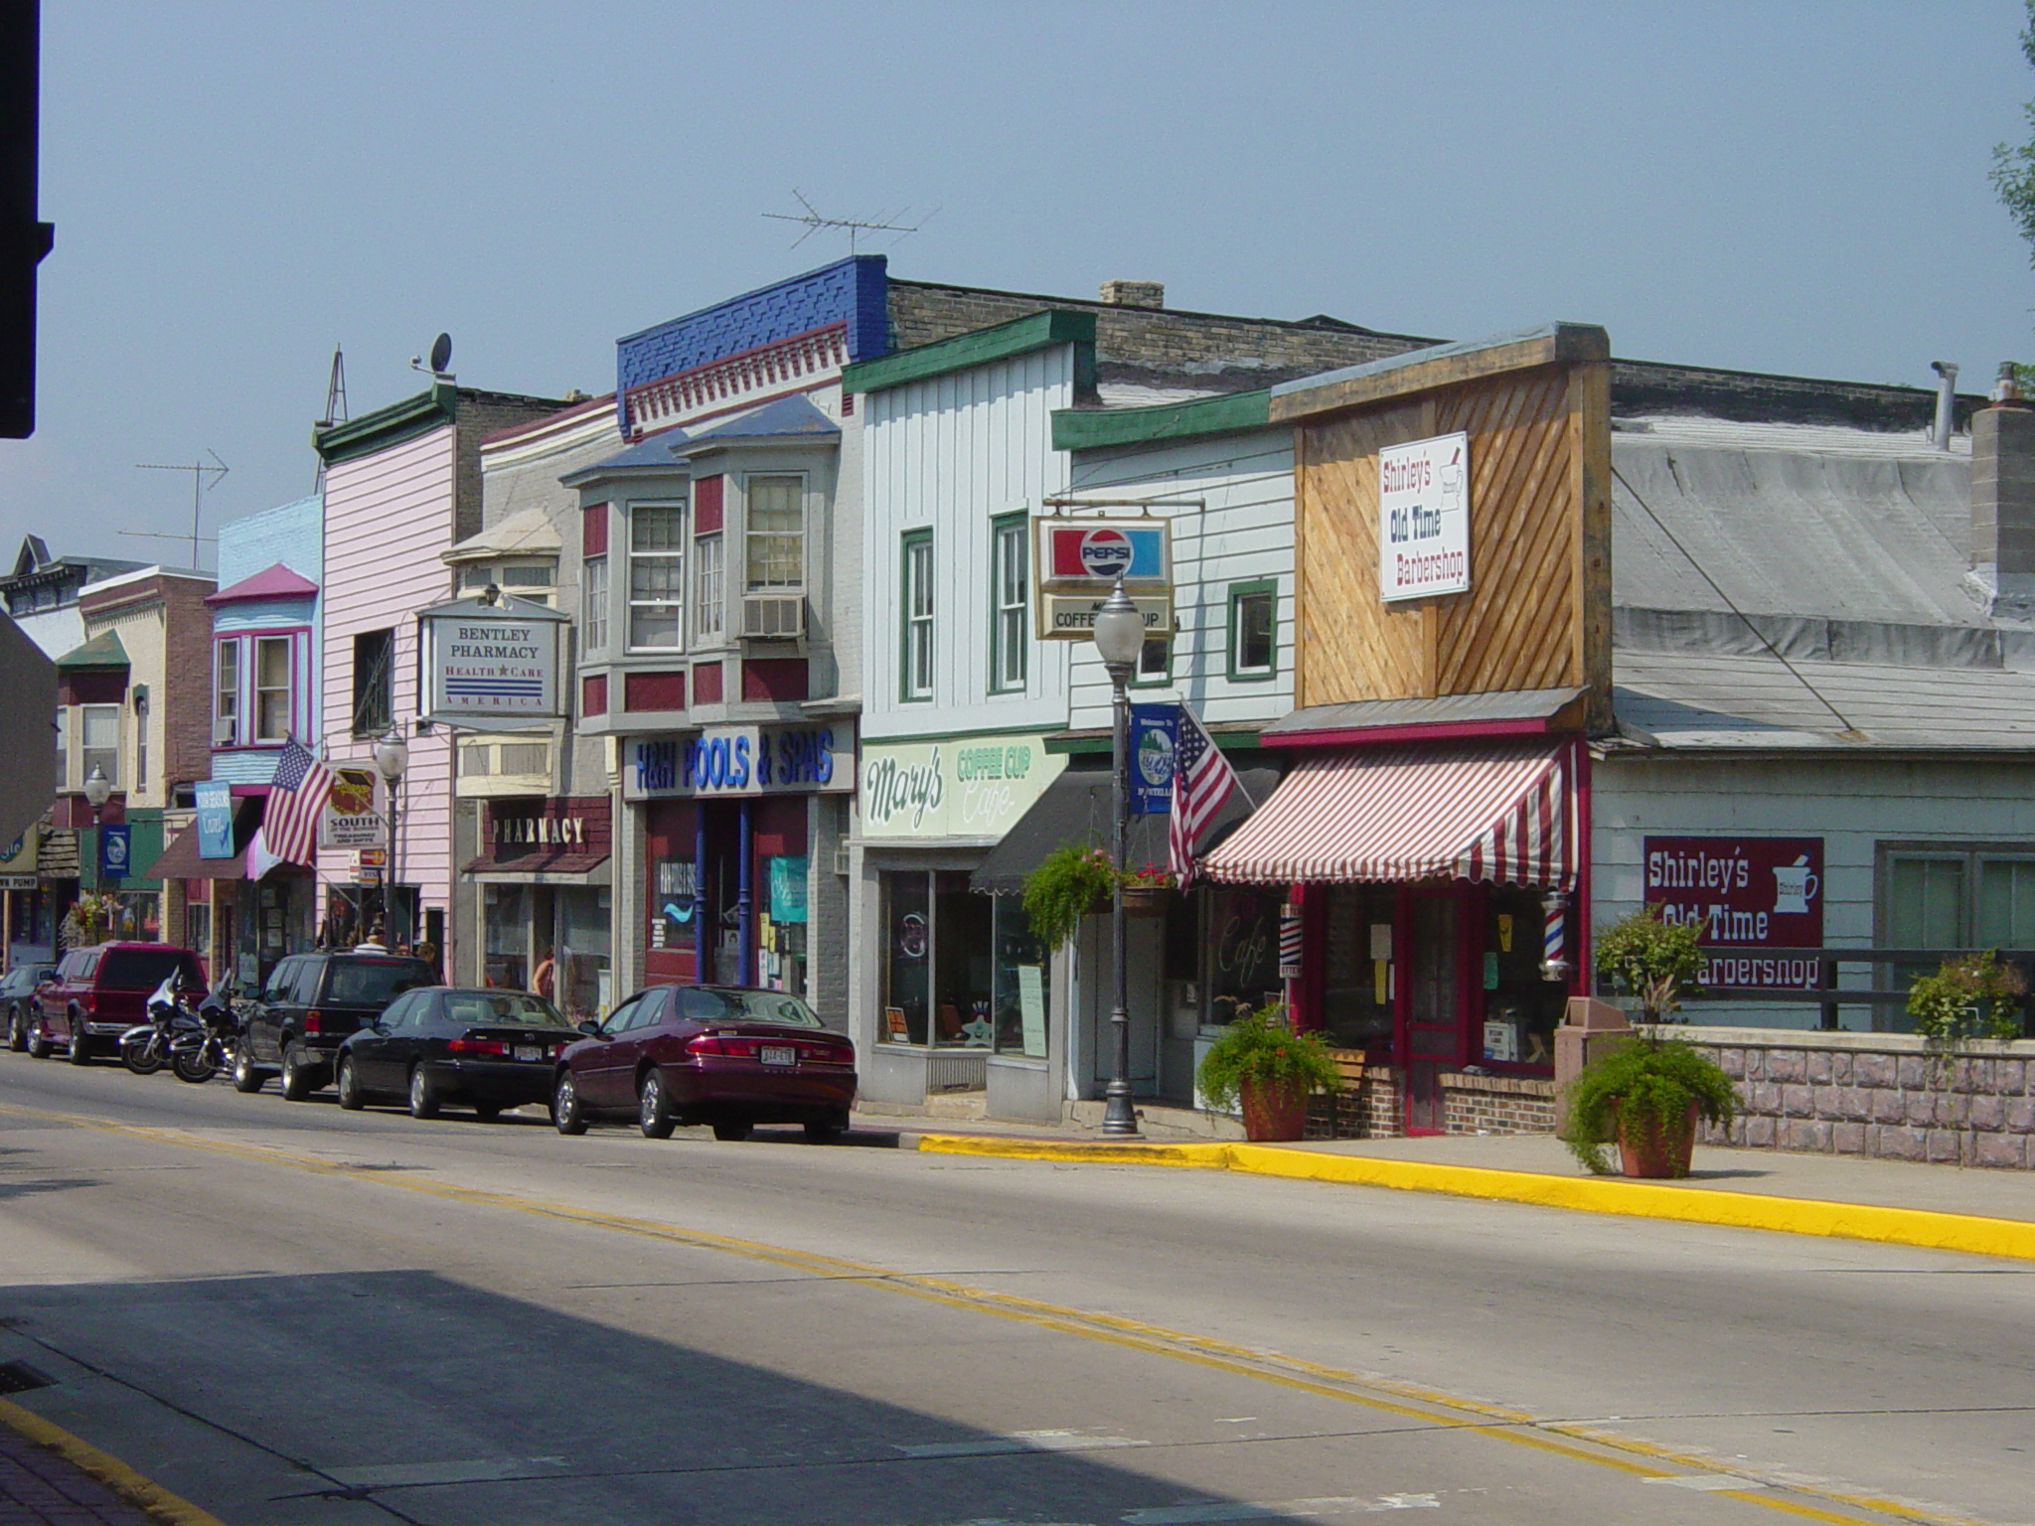
Opportunities for further strengthening the downtown include emphasizing the link between the downtown area, the City’s abundant parks and public spaces, and the lakes. The Montello Granite Park waterfalls provide a scenic centerpiece for the downtown. Montello and Buffalo Lakes, as well as the Fox and Montello Rivers, provide significant opportunities to the downtown area as places to enhance existing public open space, and to serve as backdrops for commercial development. Efforts to improve water quality would aid this effort.
In addition, the City may support remediation of contaminated sites at the edges of the downtown area for redevelopment. The largely intact streetscape of historic buildings is a tremendous asset compared to other downtowns where buildings have previously been removed. Measures to preserve and rehabilitate significant historical buildings would contribute to maintaining Montello’s unique community character. A combination of protecting and enhancing the natural and civic resources of the downtown, preserving historic features, and taking advantages of opportunities for cleanup, remediation, and new infill development serve to “marry the old to the new.”
Montello could benefit from carving a unique business niche for its downtown that capitalizes on its unique setting, existing business mix, and current position as “Marquette County’s Downtown.”
    - Tourism Potential
Opportunities for tourism in Montello combine its natural and recreational assets with the historic, cultural, and civic amenities that define the City and its surrounding area.
Tourism is one of Wisconsin’s top three industries and in 2013 travelers spent nearly $10.6 billion in the State (with an estimated $20.2 million in Marquette County). National trends are showing that consumers are traveling closer to home and choosing car over air transportation. With its proximity to growing metropolitan areas, its position as the “Gathering Place” for Marquette County, and its lakes and parks, the City is poised to take advantage of this current trend for years to come. There are opportunities to cooperatively develop and market these tourism opportunities with other counties and cities in the region to a growing, eager market in nearby metro areas (see “Links” section below).
The Fox and Montello Rivers and Buffalo and Montello Lakes provide unique regional tourism opportunities. Over the past decade, there have been several efforts related to the designation and development of the Fox-Wisconsin Heritage Water Trail, a two mile wide corridor connecting Prairie du Chien to Green Bay. Once fully developed, this State parkway would promote the cultural, historical, recreational and natural resources of this river corridor. Along the Upper Fox River portion of the parkway, opportunities to promote designated canoe routes that would re-trace the discovery route of Marquette and Joliet, early French explorers have been identified. Land-based trail systems along the corridor including hiking trails, multi-use trails, bike routes and greenways have been promoted. The City may develop a trail from the downtown area, along Montello Lake. Efforts to maintain the lakes for fishing and water-based recreation, as well as for a backdrop for commercial and seasonal home development may also stimulate tourism.
Montello is located within 15 minutes of Princeton and Wautoma. Montello’s central location and the transportation systems radiating out of the City make Montello a hub in the network of existing tourist entertainment destinations, including:
- Hotels and water parks located in the Wisconsin Dells/Lake Delton area
- Weekend flea market and vibrant tourist-oriented downtown in Princeton
- Hotels and vacation homes in Green Lake County, provide an established customer base for Montello businesses
Establishing itself as a link among other commonly visited tourist destinations could enhance business opportunities in the City of Montello. The continued growth potential for the tourism destination niche, if carefully planned, will provide a significant economic growth opportunity for the City.
    - Links to Nearby Communities and Metropolitan Areas
The Town and City of Montello have the unique opportunity to plan cooperatively for the shared land use and economic development potential of the combined “Montello Community.” These opportunities include expansion of utilities and sewer service to areas in close proximity of the City. More integrated approaches to service provision and economic development and land use will ultimately benefit both the Town and City.
Montello’s Opportunities
- Downtown revitalization
- Tourism Growth
- Recreation
- Community Events
- Small Town Living
- Traditional Economic Development
- Small entrepreneurs
- Schools
- Workforce development
- Job training
Montello lies within a 1-to 3-hour driving time from the Madison, Milwaukee, Fox Valley, and Chicago metro areas. It is often defined as an “urban field,” a term used to describe peripheral rural areas that share a strong flow of people, commodities, money, and information with their nearby metropolitan magnets. Rural places in the “urban field” are popular for weekend visits, seasonal recreation, vacation homes, and retirement living.
This flow of people and goods will undoubtedly increase as the surrounding metropolitan areas become more populated and congested. Today, over half of the County’s workforce commutes outside of the County for work. This trend will likely continue as job opportunities expand in the Madison and Fox Valley metropolitan areas. Telecommuting will also become more prevalent as more people in the City choose to work a few days out of the week from home and telecommunication facilities improve, particularly given the exceptional quality of life in Montello.
    - Small Town Living
Marquette County and the City of Montello have an abundant supply of another resource often overlooked in assessing economic development opportunities: small town atmosphere. The City offers an opportunity to live a slower pace, find affordable housing, be within short walking or biking distance to schools and shops, and be in proximity to the recreational and entertainment assets of the region. The City will work with Marquette County to attract new residents, from young families to commuters to “urban refugees” to retirees—all seeking a quality, affordable, living environment.
The City of Montello desires to proactively address (and hopefully reverse) the aging demographic and limited population growth, capitalizing on the unique quality of life offered in the City and on new efforts to improve it. A “Marquette Life” theme is advanced throughout the County’s Comprehensive Plan. “Marquette Life” encompasses a set of initiatives and programs to improve the quality of life and opportunities for existing residents, prospective residents, and visitors (who sometimes become residents). Through the 2016 Comprehensive Plan Update process, the City has identified key measures to attract and retain residents.
    - Surrounding Natural and Recreational Amenities
Outside of the City, Marquette County’s open lands, trout streams, wetlands, lakes, river impoundments and woodlands make it a popular destination for not only permanent residents, but also seasonal hunters, fishermen, boaters, hikers, campers, and tourists. Montello and Buffalo Lakes are popular locations for fishing and other recreational uses that could be further enhanced by measures to improve water quality. The Town land surrounding Montello offers four seasons of outdoor recreational opportunities. In addition to active recreational pursuits, the surrounding rural character, scenic qualities, and secluded wooded areas provide an ideal backdrop for residential development.
    - Traditional Economic Development
Accessibility created by Highways 22 and 23 and Interstate 39, a growing local resident base Countywide, and industrial entrepreneurship all bode well for continued growth in the industrial development sector. These opportunities largely take the form in helping existing City and County businesses grow and keeping more money in Marquette County. Efforts should focus on starting and growing local businesses through “business incubation” programs that could use space available in the City’s downtown areas or vacant buildings in industrial parks. There are also opportunities for Montello to work with other County communities to cooperatively plan for and benefit from new economic marketing initiatives. Growing sectors in the region that the County could tap into include technology-based businesses, food processing, and electronics machinery manufacturing. The recognition that production-based businesses will continue to play a key role in the regional economy should not be overlooked.
Further, partnerships between the City and local and regional educational institutions can help facilitate economic development alternatives that provide job and skills-oriented training for potential businesses. Montello’s existing schools play an important role in providing appropriate job training to local youth.
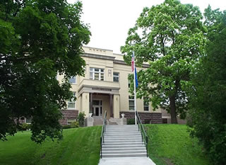
    - County and Regional Hub
Montello holds an important position both geographically and in its role as County seat. Geographically, Montello is located at the center of Marquette County and the greater region, making it a logical stop-over point for travelers and tourists and an ideal location for commuters, enhanced by its outstanding quality of life. As the hub of two major State highways (STH 22 and STH 23), as well as several country trunk highways and major local roads, Montello is well connected to smaller communities in the County as well as major metropolitan areas. As a result, Montello is a center for trade and commerce locally, and has access to a broader range of services, commerce and jobs of the State’s major metropolitan regions.
As the County seat, Montello hosts County facilities including the handsome Marquette County Courthouse situated on the north edge of the downtown on a knoll overlooking Lake Montello. Other County facilities include the highway department facility and service center, both located along Underwood Avenue. These facilities bring additional high quality jobs and activity to the City.

Statement of Overall Vision and Goals
Each chapter of this Comprehensive Plan includes a set of goals, objectives and policies which will provide the vision and policy guidance that the Mayor’s Planning and Advisory Committee, City Council, City residents, and other interested groups and individuals need to guide the future preservation and development of the City of Montello over the next 20+ years.
Visions, goals, objectives and policies are defined below:
- A Vision is an expression of the direction the City of Montello wishes to head over the next 20 years and beyond. This statement serves as the foundation for setting goals, objectives, and policies.
- Goals are broad statements that express general public priorities about how the City should approach development issues during the next 20+ years. These goals are based on key issues, opportunities and problems that affect the community.
- Objectives are more specific than goals and are usually attainable through planning and implementation activities. The accomplishment of an objective contributes to the fulfillment of a goal.
- Policies are rules or courses of action used to ensure plan implementation and to accomplish the goals and objectives. The policies are intended to be used by decision-makers on a day-to-day basis.
- Programs are specific projects or services that are advised to achieve plan goals, objectives, and policies. Programs are sometimes included in the same list as “policies” and are sometimes included in the same section as “recommendations,” depending on the chapter.
Below is an overall vision and statement of goals to guide the future preservation and development in the City of Montello over the 20-year planning period.

City of Montello Overall Vision and Goals:

Vision Statement
The City of Montello wishes to retain its small town/neighborhood atmosphere. The City will strive to maintain a higher quality of life for ourselves and our children by encouraging more economic opportunities, supporting adequate housing, healthcare and education while protecting our historical, recreational and natural resources.

Goals
- Promote growth and residential development while maintaining a quality small town atmosphere.
- Preserve and enhance Montello as a commercial, civic, social and tourist center.
- Protect and improve the natural resources within the City and the surrounding area, including lakes, rivers, wetlands, and forests.
- Capitalize on and improve existing housing and community facilities to ensure a high quality of life for City residents of all ages and income levels.
- Encourage economic development.
Policies and programs that forward these goals relevant to each element of this Plan are presented in subsequent chapters.

Chapter Two: Agricultural, Natural and Cultural Resources
The City of Montello is located in the historic Fox River valley. Historically, natural resources helped drive growth, with a granite quarry and lock and dam on the Fox River important to Montello’s development. Today, surface water and gently rolling terrain continue to define Montello’s landscape and natural resource base. This chapter contains a compilation of background data, goals, objectives, policies, and recommended programs for natural resource conservation, agricultural preservation, and cultural resource protection.
  - Natural Resource Inventory
Although Montello is a fairly developed City, it is surrounded by wetlands, woodlands, agricultural land, lakes, and open spaces that contribute to the high quality of life and make the area a desirable location. Map 2 depicts the City’s key natural resources, which are described in more detail below.
    - Landforms/Topography/Nonmetallic Resources
The terrain in the Montello area is gently rolling with wetlands and floodplain areas characterizing the lower elevations. The City’s landforms and topography have been shaped by several glacial advances and retreats over northeastern and central Wisconsin some 15,000 to 25,000 years ago.
Glaciers and their melt water scoured the area, resulting in a rich network of surface water features that today are the City’s wetlands, rivers, and surface water. These features define the ecological region known as the “Central Sand Hills.” This region is located at the eastern edge of the old Glacial Lake Wisconsin and contains a series of glacial moraines and partially covered glacial outwash. Pre-settlement vegetation consisted of oak forests, oak savanna, and a variety of prairie types.
Under State Statutes (295.20), landowners who want to register their property as a nonmetallic mining deposit are required to notify each County, city, village and/or town that has zoning authority over their property. Registrations must be recorded at the County Register of Deeds in the County where the mineral deposit is located. State law limits the ability of a municipality or a County to rezone or otherwise interfere with the future extraction of a mineral resource from a registered nonmetallic mineral deposit. It is important to note that zoning changes prohibiting mining on land registered as a marketable nonmetallic mining deposit cannot take effect during the registration period. Registration is effective for 10 years and renewable for an additional 10 years. In addition, registration on property with active mining operations can be renewed for as long as mining is ongoing. Zoning changes may take affect after the registration has expired. Within the City of Montello, mining activities are permitted as a conditional use in the General Industrial District (I-1). There are no active quarries within the City.
    - Woodlands
There are several forested areas scattered throughout the City and surrounding areas. The numerous woodlots are dominated by jack pine and scrub and black oak. In general, the western part of the City of more forested than the east. There is no forestland in the City of Montello enrolled in the State’s Managed Forest Law (MFL) program.
    - Drainage Basins
The City of Montello is located in the Upper Fox River Basin, which is subdivided into several smaller watersheds including the Buffalo and Puckaway Lakes Watershed and the Montello River Watershed.
The northern portion of the City lies in the Montello River Watershed, which spans 152 square miles in total. The Montello River Watershed is predominantly agricultural. There are also significant forested areas and numerous wetlands in the watershed. The streams in this watershed are generally high quality- there are several Class I and II trout streams. The Village of Westfield is the only municipal wastewater discharger operating in this watershed.
The southern portion of the City lies in the Buffalo and Puckaway Lakes Watershed, spanning 232 square miles. This watershed is characterized by agricultural land, but also contains many wetland areas. This watershed includes the communities of Endeavor, Marquette, Packwaukee, as well as the Cities of Portage and Montello. Montello’s wastewater treatment plant discharges in this watershed.
    - Surface Waters
The Fox and Montello Rivers are prominent surface waters that have shaped development. The two rivers have their confluence in the southern part of the City. Each is impounded to create two large water bodies: Lake Montello and Buffalo Lake.
The Fox River was a historically exploratory route and primary commercial waterway. Today, the River and its impoundment support a warm water fishery, including largemouth bass, northern pike, walleye, and channel catfish. Concerns about the River include over-fishing, water quality, and water quantity.
Lake Organizations
Landowner concern over degradation of the water quality and character of lake provided the impetus behind the formation of organizations to address these issues.
Lake organizations include incorporated lake associations, qualified incorporated lake associations, and lake districts. Lake associations typically are financed through voluntary membership dues, whereas lake districts function through property tax levy. Both also have some access to State or other grants.
Lake Associations have a variety of powers and functions, including acquisition of property, borrowing and investing funds, habitat improvement, applying for grants, maintaining lake access, and purchasing sensitive areas.
Lake Districts can levy taxes, monitor water quality, dredge, harvest or treat vegetation, adopt and enact boating and other ordinances, require inspection of private sewage systems, fix and collect charges for solid waste disposal.
Buffalo Lake is a 2,210-acre shallow impoundment that extends approximately twelve miles southwest from the City, averaging 2,000 feet in width. Historically, Buffalo Lake was a natural lake; the Montello dam, owned by WisDNR, in Montello has caused the lake to expand substantially. The lake is a warm water fishery. While the lake is a popular setting for residential development, boating can be difficult because of aquatic vegetation. There are two boat landings in the City limits, owned by the City and County.
The Montello River meets the Fox River in the City, just downstream of the dam creating Buffalo Lake. This River is generally thought to have favorable water quality, with abundant woodlands and wetlands buffering the river. The Montello River rushes through the heart of downtown Montello. Two dams exist on the Montello River; one at Harris Pond used to generate electricity, and one at Montello.
The dam at Montello, owned by the City, creates the 286-acre Lake Montello impoundment. The lake has a maximum depth of 17 feet. Although generally thought to be clear, the lake is fertile and may have excessive aquatic plant growth. Whereas some of this may be due to natural nutrient loading, there is concern about increasing run off pollution increasing nutrient loads. The lake hosts a warm water fishery and abundant waterfowl. There are three City parks located along the shores of Lake Montello and; one of these is located at the confluence of the Montello and Fox Rivers.
Kilby Lake is one of several smaller lakes formed by the terminal moraine in the Montello area. This 50-acre lake has a warm water fishery and a sandy muck bottom. The City maintains a small boat launch on the southern shore of Kilby Lake.
The City has several opportunities to enhance the quality and use of its valuable water resources. Many residents desire greater access to the lakes and rivers, as well as designated swimming areas. This includes improving water quality through standard cleanup, maintenance, and weed removal, which will be addressed further later in this chapter.
Buffalo, Montello, and Kilby Lakes have active Lake Districts. The Buffalo Lake Improvement Association and the Buffalo Lake Improvement District are both interested in the long-term management and protection of Buffalo Lake. The Lake Improvement Association supports studies conducted by the WisDNR, and the mechanical harvesting of weeds.
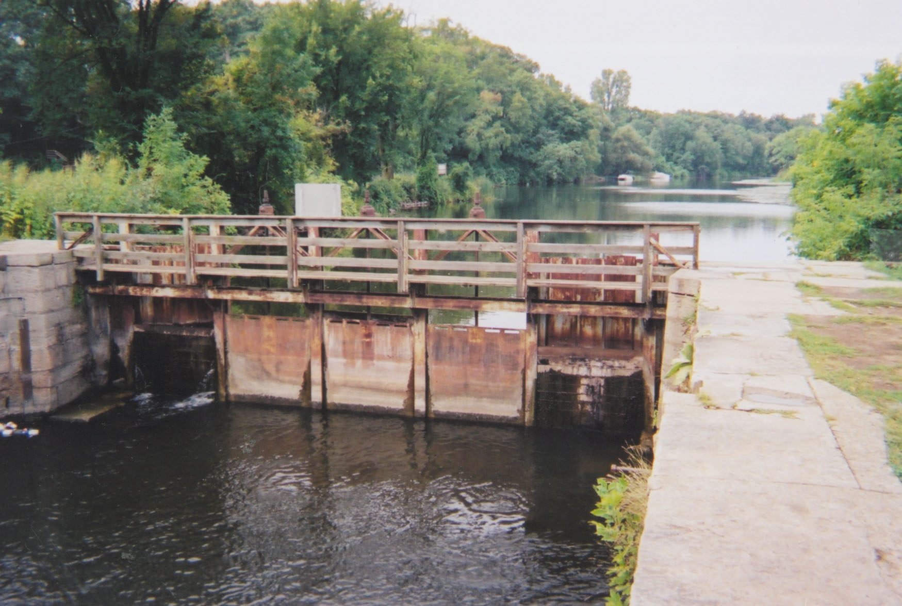
The two dams in the City of Montello that form Montello and Buffalo Lakes (mentioned above) are classified by the WisDNR as large dams. The dams are actively maintained and are designated “high hazard.” WisDNR had no plans for the dams at the time of writing the Plan. The DNR has, however, conducted periodic drawdowns that have been successful in improving water quality and helping to address sediment loading and siltation. Drawdown is considered one of the most economically feasible ways to deal with water quality issues, though it may be only a temporary fix to long-term problems that should be addressed on a broader watershed scale.
    - Floodplains
In Wisconsin, seasonal floods are one of the most common types of natural disasters. The Federal Emergency Management Agency (FEMA) designates floodplain areas. These are areas predicted to be inundated with floodwaters in the 100-year storm event (e.g., a storm that has a 1% chance of happening in any given year). The predictions are based on computer models. The State requires City regulation of development in floodplains. Map 2 shows the general boundaries of mapped floodplains; however, on the map some of these are obscured by wetlands and surface water to show the classification with the highest level of restriction. The National Flood Insurance Program maps produced by the FEMA should be referenced for official delineation and elevations of floodplains. Development is strongly discouraged in floodplains to avoid both on-site and up- and downstream property damage.
    - Wetlands
The City of Montello has large wetland areas. In general, these are located below the Buffalo Lake dam in the eastern portion of the City. The wetlands are part of a more expansive marsh that parallels the Fox River. Wetlands are important for aquifer recharge, groundwater and surface water quality improvement, wildlife habitat, recreation, and aesthetics. Historically, the greatest threats to wetlands have been agricultural drainage and non-farm development.
All known wetland areas over 2 acres have been identified and mapped by WisDNR through its Wisconsin Wetlands Inventory, which was used to create the wetland layer on Map 2. Generally, zoning restricts development in wetland areas.
    - Groundwater
The quality of the City’s groundwater is relatively good. The City’s public drinking water supply is pumped from two deep wells located on the north side. More information on the public water treatment facility is provided in Chapter Five: Utilities and Community Facilities.
The WisDNR has identified areas susceptible to groundwater contamination. According to a State of the Region Report conducted by the East Central Wisconsin Regional Planning Commission, most of the City has low susceptibility to groundwater contamination. There are some areas on the periphery that are subject to a higher potential for contamination. Such areas are generally characterized by relatively thin or sandy soils and fractured bedrock.
    - General Soils Information
Soil suitability is a key factor in determining the best and most cost-effective locations for new development. The soil in the City of Montello is of the Ostemo-Gotham Association (as defined by the U.S. Department of Agriculture). This soil type contains deep, well-drained, and moderately to rapidly permeable sandy loams. These soils are generally suitable for development, except for wetlands.
    - Rare Species Occurrences
WisDNR’s Natural Heritage Inventory program maintains data on the general location and status of rare, threatened, or endangered plant and animal species and natural communities in the State. Although this data is not available specific to the City level, data for the Town of Montello surrounding the City is reported. As of March 2016, there were eleven documented occurrences of rare or threatened species or communities in areas surrounding the City. These included two bird, one bird migratory concentration site, one lizard, one turtle, one butterfly, one fish, one plant, and three natural community types. More specific information on location and type of specie is available from the WisDNR’s Bureau of Endangered Resources. Effective protection of a natural community will maintain populations of many native plants and animals, their interactions, and the ecological processes upon which they are dependent.
    - Public Open Space
There are approximately 65 acres of public open space in the City, comprised of both City and County owned facilities. The City maintains about half of this open space (4 parks) and three boat landings. These facilities are discussed in detail in Chapter Five: Utilities and Community Facilities.

Natural Resource Goal, Objectives and Policies

Goal: Protect outstanding natural features in the City’s planning area.

Objectives:
- Preserve the City’s exceptional lakes, rivers, streams, wetlands, and groundwater.
- Protect and improve surface water and shoreline quality on Montello, Buffalo, and Kilby Lakes, and along the Montello and Fox Rivers.
- Cooperate with the Town of Montello, the County, lake organizations, and the WisDNR to protect and enhance water quality in the City’s lakes and rivers.
- Direct development away from environmentally sensitive areas.
- Pursue opportunities that both support natural resource protection and the health of the local economy.

Policies:
- Protect “environmental corridors” (shown on Map 4) as a composite of the City’s most sensitive natural areas, including wetlands, floodplains, and steep slopes.
- Protect and improve surface water quality by supporting stream bank management, natural shoreline restoration, erosion control, proper agricultural practices, stormwater management and use of vegetated buffer areas.
- Work with the Town of Montello, lake organizations, and the WisDNR to improve the water quality, public access, and shoreline condition of Lake Montello and Buffalo Lake.
- Protect groundwater quality through encouraging the cleanup of environmentally contaminated sites, monitoring and carefully revising uses that may result in contamination in the future, identifying and protecting wellhead protection areas for municipal wells, and supporting sewer connections to existing uses with older septic systems.
- Consider the preservation of natural features of a site, and natural resources in the area, when development proposals are offered.
- Work to protect rare species and wildlife habitat areas, such as through submittal of a “Wisconsin Natural Heritage Inventory Request Form” to WisDNR whenever a new subdivision or major development proposal is offered within a section of land where a rare species has been identified.
- Build on the City’s natural resources, particularly water bodies, to promote tourism and local economic development.
- Support updated mapping of floodplain areas in the future to attempt to remove as much developed land in the downtown area as is consistent with sound science and the law and work with local banks to minimize insurance costs associated with living and operating businesses in mapped floodplain areas.
- Monitor dam maintenance, repair, removal and impoundment drawdown proposals in and near the City.
- Carefully review proposals for metallic and non-metallic mineral extraction operations, requiring the submittal and careful review of site plans, operation plans, and reclamation plans and the protection of adjacent property owners, natural resources, and municipal roads.
- Cooperate with other units of government and non-profit land conservation agencies on preservation of natural resources that are under shared authority or cross government boundaries.
- Encourage programs that help to educate citizens on the tools, programs, and incentives that protect the natural environment.

Natural Resource Recommendations
Expanding on the policies listed above, this section provides specific recommendations for conserving the City’s natural areas.
    - Protect Environmental Corridors
Environmental corridors are a composite of important individual elements of the natural resource base. They have environmental, ecological, passive recreational, stormwater management, groundwater protection and recharge, erosion control, wildlife, timber, and scenic value. Environmental corridors also have severe limitations for development; therefore, minimizing development in these areas also protects private property. Environmental corridors generally occur in a linear (corridor) pattern on the landscape (see Map 4 for Environmental Corridor delineations). Environmental corridors include the following areas:
- Wisconsin DNR-identified wetlands as mapped in the Wisconsin Wetlands Inventory and subject to existing zoning control. This layer may not include all wetlands that are subject to State and/or federal disturbance rules. Protection from development should be provided to these areas (also shown on Map 2) as well as those identified through more detailed field surveys to preserve the significant natural functions that wetlands provide.
- Federal Emergency Management Association (FEMA) designated floodplains subject to existing zoning control. These general floodplain delineations represent the areas potentially subject to the 100-year flood. All areas subject to flooding are not necessarily reflected in mapped floodplains (or within the Environmental Corridor delineation). The City is required to limit development within the 100-year floodplain as shown on Flood Insurance Rate Maps, but encourages the update to those maps if doing so may remove some developed properties in the downtown area from the floodplain.
- Lands with steep slopes of 20 percent or greater. Due to the instability of these soils and erosion concerns, additional development (including buildings and driveways) on these steep slopes is not advisable. There are limited areas of steep slopes in the City, mainly south of Buffalo Lake but also in the water tower/old high school area.
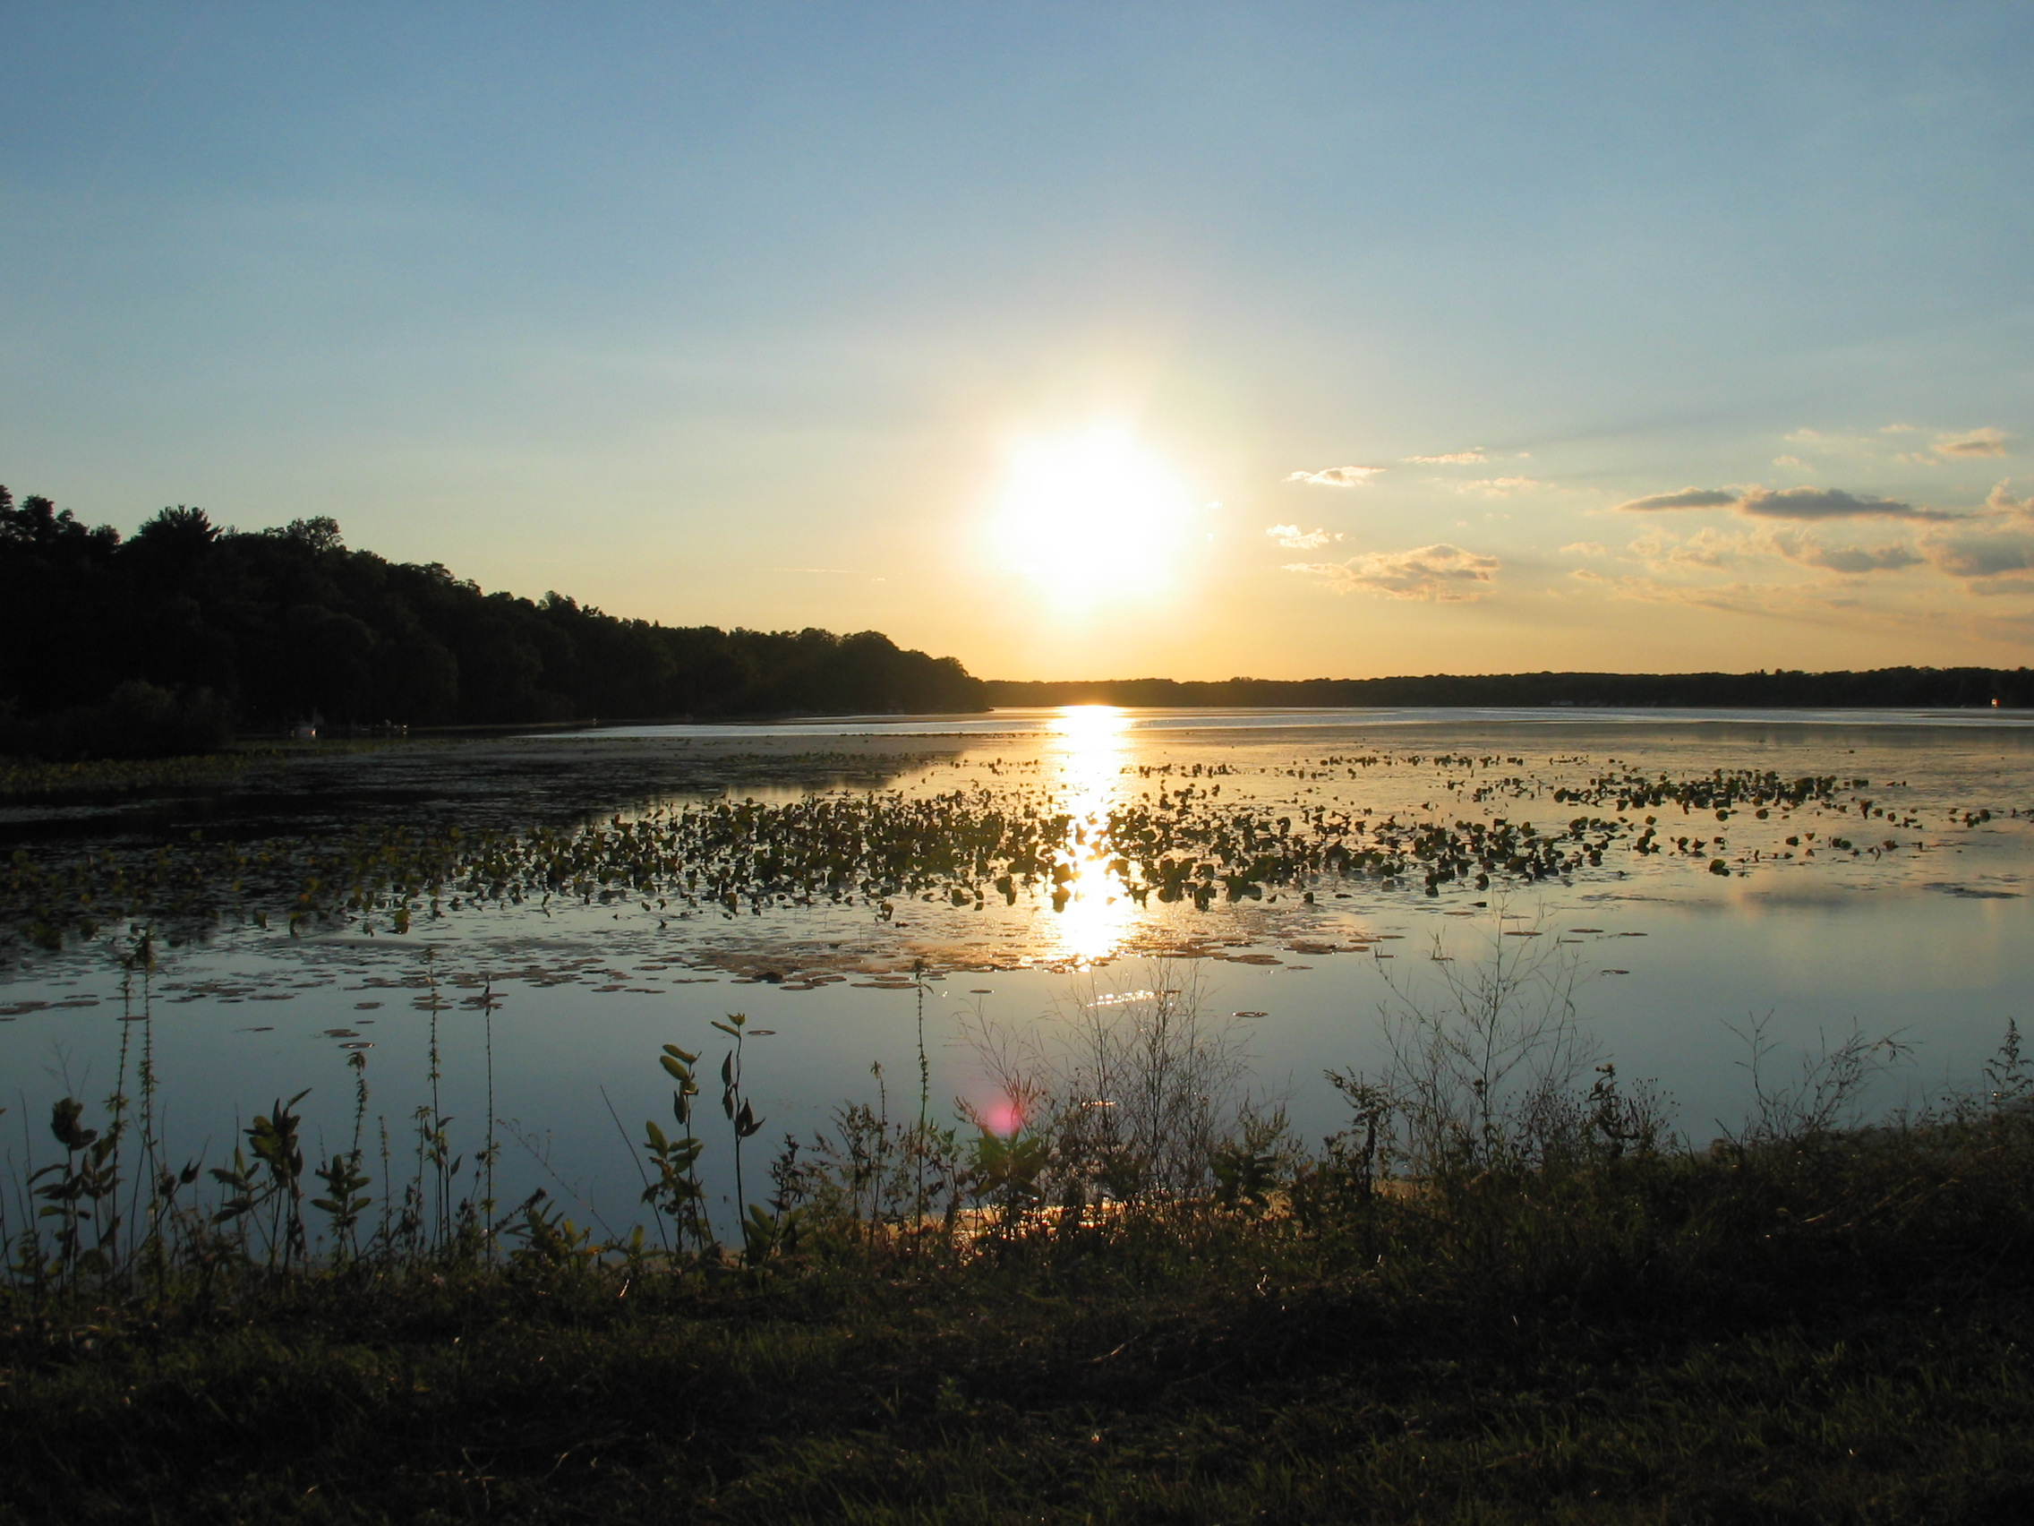
Existing development and farming uses should be allowed to continue within mapped environmental corridors, but some improvements may be limited by underlying floodplain zoning regulations. New buildings that do not replace old buildings and significant expansions to existing building footprints should generally be discouraged, particularly where other, more appropriate building sites are available on the same parcel outside the environmental corridor. Sensitivity to surrounding natural resources should be the guiding principal when reviewing the appropriateness of development in mapped environmental corridors.
The environmental corridors depicted in Map 4 are necessarily general and should be used to identify general areas where new or expanded development may not be appropriate. Unfortunately, much of the downtown area is in the environmental corridor by virtue of its floodplain status. Lands within that designation may be removed under one or more of the following circumstances:
- An updated or more detailed study reveals that the characteristic(s) which originally resulted in its designation as an environmental corridor no longer exists, never existed, or exists in a different location or configuration on the site, or
- Approvals from appropriate agencies are granted to alter a property so that the characteristic which resulted in its classification as an environmental corridor will no longer exist, or
- A mapping error has been identified.
    - Protect Surface Water Quality
Montello and Buffalo Lakes, the Montello River, and the Fox River are central features of the City and some of its key natural resources. General recommendations designed to support the objectives of protecting the quality of water resources are offered below.

Cooperative Lake and Stream Management Programs
The City may wish to participate and cooperate with the lake associations and districts, the Town of Montello, WisDNR, Marquette County, and other neighboring communities, such as the Town of Packwaukee, to develop and implement strategies to protect its “shared resources” – such as Buffalo Lake, Lake Montello, Kilby Lake, the Fox River, and the Montello River. The City and the above organizations and governments may also wish to explore additional recreational and access opportunities.
The City should also stay informed on program and funding opportunities through the WisDNR for river and lake management. Buffalo Lake Association is in the process of pursuing funding through the Lake Protection Grant program, which is available to improve quality of lakes and their ecosystems. Potential protection mechanisms that this grant could fund include purchase of land or easements, wetland restoration, development of local regulations to protect water quality, and other lake improvement activities identified within an adopted lake management plan. Other sources of funding, including Community Conservation Aids, Lake Management Planning Grants, and Aquatic Invasive Species Education, Planning and Prevention and Species Control grants are also available to the City or lake organizations.
In 2015, Marquette County adopted the Healthy Lakes Implementation Plan, enabling County property owners to be eligible for funding assistance for lake shoreland improvements including:
- Fish Sticks in the in-lake shoreland area. Fish sticks are large woody fish habitat structures that utilize whole trees grouped together, at a ratio of greater than one tree per 50 feet of shoreline. Fish sticks structures are anchored to the shore where they are partially or fully submerged.
- Native Plantings in the shore transition area. Large, contiguous areas of native plantings adjacent to the lakeshore.
- Water runoff diversion. Stormwater runoff diversion practices include the use of a berm or shallow trench to intercept and divert water runoff into an infiltration area.
- Rock infiltration practice. Installation of a rock filled trench along structures and other impervious areas to reduce runoff by storing and infiltrating stormwater.
- Rain Gardens. Landscaped shallow depressions that collect and infiltrate stormwater from roofs and driveways.
In 2015, the Healthy Lakes Program had $200,000 in funding available statewide, and provides up to $1,000 in State grant dollars for each "best practice" identified in a proposal for an individual property. Eligible sponsors, such as lake groups, waterfront organizations and municipalities can also apply for funds under this grant program, with a maximum award amount of $25,000 for community projects.

Vegetative Buffers
The City’s zoning ordinance regulates the removal of shoreline vegetation in the area 35 feet inland from the ordinary high water mark. Vegetated buffers provide benefits such as the protection of water quality, flood control, stream bank stabilization, water temperature control, and room for lateral movement of stream channels. Trees and shrubs retained in buffer areas provide the benefit of buffering noise from watercraft, providing privacy to residents, and serving as nesting areas for songbirds. Use of pesticides, fertilizers, and herbicides in these areas should be discouraged. Wider vegetated buffer areas may be appropriate and should be encouraged around high-quality waters, and areas where particular water quality concerns have been identified.

Figure 9: Example of Vegetative Buffer

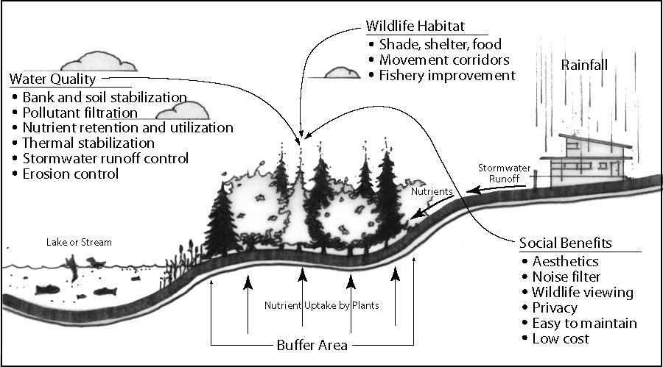
Erosion Control and Stormwater Management Plans
Unmanaged construction sites are one of the greatest contributors to off-site sediment runoff. Under State law, erosion control plans are required for all construction sites over 1 acre in area. The City should help ensure erosion control and stormwater management techniques for protection and continued improvement of its water quality. In particular, stormwater management and erosion control systems should be components of planned new developments, including subdivisions and commercial and industrial projects. Erosion control techniques include silt fencing, minimizing disturbed areas, and quickly reestablishing vegetation. Ongoing stormwater management techniques include natural drainage swales and retention and detention basins. These techniques control the quantity and improve the quality of water run-off during storms and enhance groundwater recharge. This is particularly critical near sensitive waters such and lakes where there are water quality concerns, such as Buffalo and Montello Lakes.
    - Protect Groundwater Quality and Quantity
Groundwater is the source for the City’s drinking water. In addition, groundwater recharges local rivers and streams. This Plan supports several efforts to protect groundwater quality and quantity, including:
- Carefully review new development proposals in wellhead protection areas and in other areas susceptible to groundwater contamination. The northeast portion of the City and lands along the City’s southern border are considered highly susceptible to contamination. These are also some areas that are planned for industrial and commercial uses (see Map 4). The City should carefully review proposals to locate additional commercial and industrial uses within these areas (and within wellhead protection areas), and consider limits on those uses that have higher probabilities of emitting pollutants into the soil or groundwater. These include uses such as additional gas stations or other uses that store fuel or other potential contaminants. Where such new uses are allowed, the City should require that the business prepare and implement a spill prevention and control plan. The City may also wish to work with existing business owners on plans to maximize the potential and severity of spills that may otherwise cause future contamination.
- Carefully consider planning for new development on private wells within about ¼ mile of closed landfills. To protect drinking water quality and public health and safety, the WisDNR requires a separation of 1,200 feet (a little less than ¼ mile) between closed landfills and nearby private water supply wells. This separation is measured from the nearest edge of the former landfill area or, if unknown because it is a filled site, from the site’s property line. There is one closed landfill site in the Montello area that is documented. It is shown on Maps 3 and 4. There are wells in this area that have been approved by the WisDNR based on detailed analysis. Existing residential development shown in the private well setback area may pre-date WisDNR regulations, or may have been granted a variance.
- Partner with property owners in the identification, assessment, remediation, and reuse of “brownfield” sites. These sites have the potential to contaminate groundwater. Significant State and federal dollars are available for brownfield assessment, planning, and cleanup in advance of redevelopment. The City should be active in identifying and helping to clean up and restore to economic use those sites that contain soil contamination. See Chapter Seven: Economic Development, for more specific strategies.
- Connect properties to City’s sewer system where possible. There are a number of homes within the City limits, particularly in the northwest corner, which are not connected to the City’s sanitary sewer system. Some of these homes have older septic systems that are nearing the end of their useful lives. Septic systems that fail may cause surface water and groundwater contamination. The City should work with property owners to provide sanitary sewer service to these properties where practical, and feasible. The City has an ordinance that requires development within the City to connect to the sanitary sewer and water system, where available.
- Remain informed and involved in decisions pertaining to high-capacity wells. Permits for high capacity wells (those withdrawing more than 100,000 gallons per day) must be registered with and permitted by WisDNR. The DNR will not approve wells that impair public water utility supplies. Wells drawing more than 2 million gallons per day are evaluated in terms of whether they impair public water rights or future water use plans, or if they have adverse groundwater effects. The DNR also has authority to deny a request for a high capacity well should it assess the environmental impacts as significant to outweigh the benefit. Should potential new sites be proposed in the Montello area, the City should remain informed and involved in any WisDNR decisions. One way to stay involved in through regular communication and providing public comment during Environmental Impact Statement review periods.
    - Build on Natural and cultural Resources to Promote Tourism
The possibility for expanding Montello’s role in a nature-based tourism economy provides the opportunity for area residents to enjoy financial benefits of increased economic development while simultaneously preserving the area’s environment.
The Montello area’s lakes, rivers, and streams are particularly well suited to attract growth in fishing, paddling, and wildlife watching. Although too shallow in spots, Lake Montello and Buffalo Lake are good locations for boating. These areas are also ideal locations for viewing wildlife and for visitors to experience a quiet and peaceful environment. Birding has become big business and there is a movement to establish The Great Wisconsin Birding Trail, a statewide auto trail that leads people to parks, historic sites, rivers, lakes, and biking trails in Wisconsin. In 2016 there were two sites in Marquette County on the Trail, the Muir State Natural Area and the Observatory Hill Natural Area. Additionally, the Fox River in the City of Montello is part of the Fox-Wisconsin Heritage Parkway. In 2016, preliminary mapping was completed identifying paddler accommodations along the historic waterway.
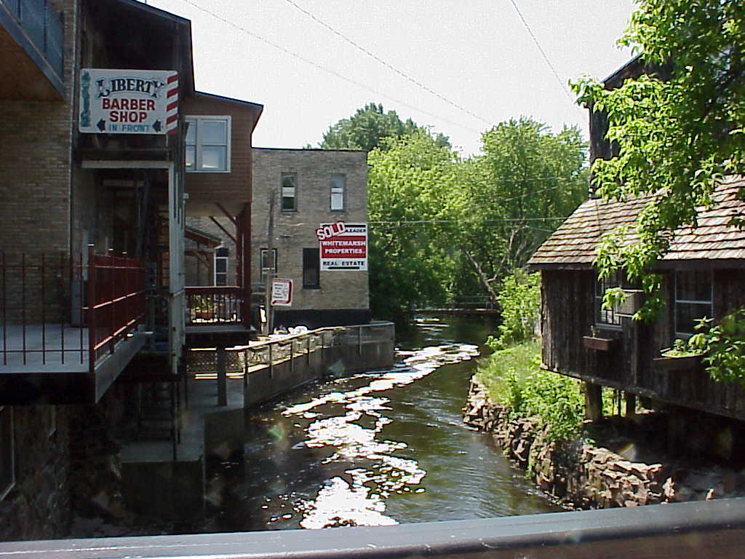
Montello should promote opportunities for tourist and locals alike to explore and enjoy natural resources, and encourage businesses that cater to these types of activities. There are many types of businesses that respond to the market of tourists attracted to the area for its outdoor recreation opportunities, including restaurants, nature stores (e.g. bird and wildlife related items, gift shops, and art galleries), and sporting goods stores. The downtown area may also an appropriate location for lodging facilities such as a bed and breakfast establishment or a small inn. The expansion of waterfront and outdoor dining opportunities would also be an appropriate direction, given the diversity of water resources and views in the downtown area. The City should consider working to develop a plan for a walking path connecting the downtown area to the dam, perhaps using the newly acquired County owned land in the downtown area.
    - Monitor Impoundment Drawdowns and Dam Maintenance and Repair Proposals
This Plan recommends that the City of Montello be involved in any future decisions involving river impoundment drawdowns and dam removals.

Impoundment Drawdowns
Impoundment drawdown may be used for conducting repairs on an unsafe dam, controlling invasive species, or enhancing fish and wildlife habitat. In Lake Montello, a drawdown was conducted in winter 2002-03 to control weed growth. Emergency drawdowns typically occur when a dam is in need of immediate repair for safety reasons. In non-emergency cases, the drawdown should follow a certain process. The drawdown is typically initiated by the dam owner, the WisDNR, or a lake district or association. Where there are formally established water levels, WisDNR is required to conduct an Environmental Assessment prior to the drawdown. The Environmental Assessment includes a consideration of fisheries, wildlife, endangered resources, vegetation, and a broad range of other potential impacts, and management alternatives. Based on the Environmental Assessment and the results of the public meeting, the drawdown activity may be approved or denied. The City has several opportunities to get involved in any future impoundment drawdown process:
- Landowners, lake associations, or lake districts may initiate a drawdown for dam repair, habitat enhancement, or lake management purposes
Dam Repair and Removal Process in Wisconsin
Wisconsin communities have several options for getting involved in a dam repair or removal process, such as.
- Pursuing assistance from the WisDNR to develop a Removal Plan. As part of this plan, the DNR can work with the community to establish a re-vegetation plan and reconstruct channels. Some communities have created extensive park areas with trails, canoe launches, athletic fields, and other public amenities.
- Engaging in community visioning and public involvement to create a forum for discussion of the dam removal and a cooperative, future-oriented approach to planning for the site
- Using dam removal to spur revitalization efforts including river-related development such as wayside parks, a river walkway, and the revitalization of their riverside historic district.
State, and federal resources for dam removal and associated local improvements that communities can pursue include:
- Municipal Dam Grant Program, which funds a maximum of 50% of eligible engineering and construction costs for dam maintenance, repair, modification or abandonment, or removal up to a maximum of $400,000. Funding is only available for municipally owned dams and is prioritized by the size of the dam, downstream hazard rating, downstream zoning, dam repair costs, the financial need of the community, and stream navigability.
- Dam Removal Grant Program, which assists communities, public inland lake protection and rehabilitation districts, and private dam owners to remove small or abandoned dams. The WisDNR will fund 100% of eligible project costs, with a maximum grant award of $50,000. Eligible project costs include labor, materials, and equipment directly related to planning the removal, the dam removal, and restoration of the impoundment.
- State Assistance is available through the Wisconsin Stewardship Program for improvements associated with dam removal.
- Individuals and organizations can review and comment on the WisDNR’s Environmental Assessment. In cases where an Environmental Assessment is not required, comments from local groups, communities, and individuals are encouraged via WisDNR staff
- Attend and provide feedback at the required public meeting and/or hearing

Dam Repair or Removal
Over the planning period, any change in water surface level or water flow due to dam repair or removal can have significant impacts not only the water resource, but also the enjoyment and use of the resource by local residents and visitors. This Plan recommends that the City request notification in order to remain involved in any decisions involving dam maintenance, repair, or removal.
When repair is deemed less desirable from a financial, safety or ecological standpoint, dam removal may be an option. Decisions to remove or repair any dam should be based on a careful analysis of economic, social, and environmental factors. The decision to remove an unsafe or abandoned dam can be made only after an established protocol is followed. This process generally consists of:
- Inspection of dam by a certified engineer
- Contact and notification to dam owner of any problems or hazards that exist
- An official order to repair the dam to meet standards, or dam removal
- Public information session
- Notification and/or opportunity for public hearing prior to WisDNR action
- If dam removal is pursued, an Environmental Assessment or Environmental Impact Statement may be required
The City should work closely with the Town and the WisDNR to consider dam management options, should issues with any of the Montello area dams arise. This is particularly important considering the fact that the two dams located in the City hold back waters where there has been significant waterfront development and are evaluated as high hazard dams. Aging dams or those in need of repair may be community safety hazards and cause environmental degradation. However, the removal of any of the area’s dams, in particular the Fox River dam, could have significant impacts on property use and values along the lakes that should be factored.

Agricultural Resource Inventory
Agricultural land and open space resources help to define the rural character of the countryside surrounding the City. In this area, trends in agricultural land use and conversion have generally followed those of the region and County. According to the U.S. Census of Agriculture the number of farms in Marquette County decreased by 148 between 2007 and 2012, while the average farm size increased slightly from 217 to 251 acres. There are no Class I and II agricultural soils in or near the City. These are the areas best suited to agricultural uses.

Agricultural Resource Goal, Objectives and Polices

Goal: Help protect economically productive farms in the City’s planning area.

Objectives:
- Maintain agriculture as a significant economic activity within Montello’s planning area.
- Recognize the value of farmland for its economic and open space values.
- Protect farm operations from incompatible land uses and activities that may adversely affect the capital investment in agricultural land, improvements, and equipment.
- Work with the Town of Montello to help preserve farming as a viable occupation and way of life.

Policies:
- Carefully consider the location of productive agricultural lands before making decisions on the expansion of City services or growth.
- Consider using extraterritorial land division review in support of this adopted Plan to limit intensive development in productive farming areas.
- Work with the Town and County to encourage a compact, orderly, efficient development pattern that minimizes conflicts between City and rural uses.
- Support County and Town planning efforts that allow only low density non-farm development in Rural Lands areas as shown on the Planned Land Use map.
- Help promote the continuation of the family farm and the growing of specialty-agricultural products by supporting and hosting parades, festivals, fairs, auctions, and other related events within the community; as well as supporting the local use of locally grown products.

Cultural Resource Inventory
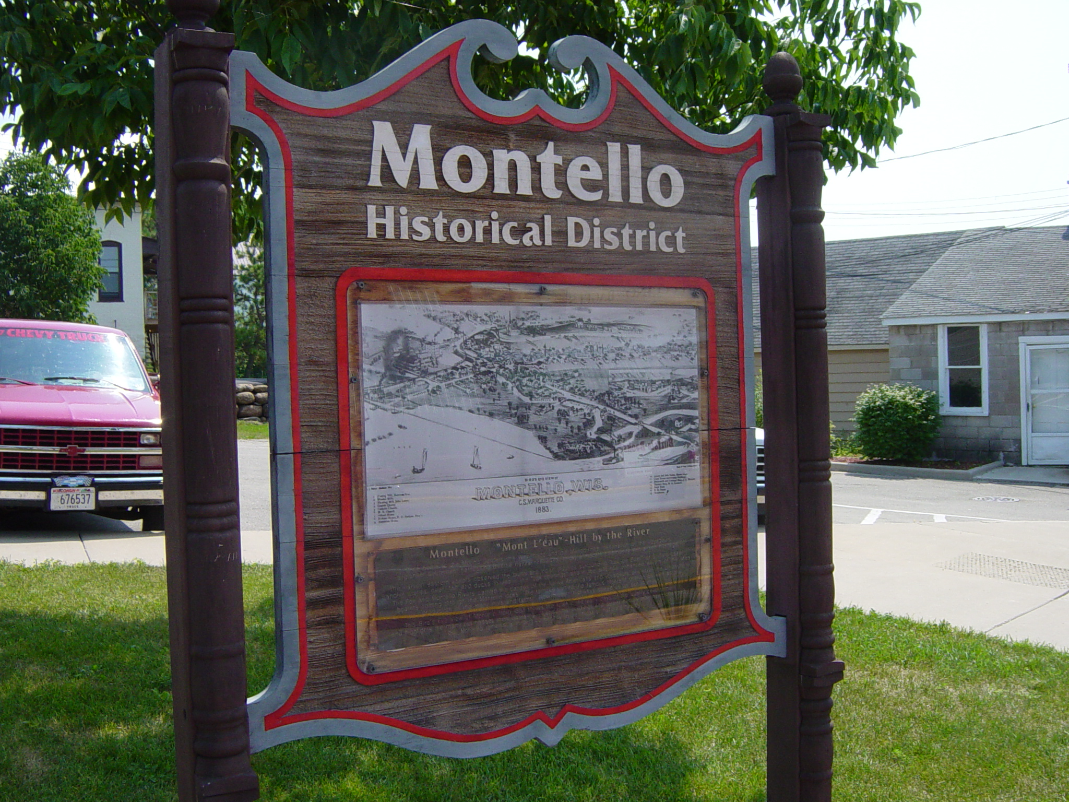
The cultural resources of the City of Montello and Marquette County tell the rich history of the entire region. The area was once home to several tribal Native American groups. The three prominent Native American tribes in the region were the Menominee, Chippewa, and the Ho-Chunk (or Winnebago). In 1673 French Jesuit priest Jacques Marquette and explorer Louis Joliet were the first Europeans to travel the entire length of the Fox River from Green Bay to Portage and onward down the Wisconsin River. From these early beginnings until the 1830s, fur trading was the main activity along the river as numerous types of fur bearing animals were found along waterways and shoreline woodlands. Waves of European immigrants arrived in the region in the mid-1800s, with British and Irish settlers favoring Marquette County. A large influx of German immigrants also settled the County. The American Community Survey 2010-2014 estimates that about 49 percent of the County’s population is of German ancestry, followed by 13 percent of Irish ancestry.
The first land claim in Montello was made in 1849, by Josiah Dartt whose claim included the site of the dam on the Montello River. In 1850 the dam was completed, a sawmill erected, and the first frame building (a store) was built. This same year, a frame hotel and the post office were built. In the following years, the population of Montello and the surrounding area expanded, and businesses and trade flourished.
Each succession of ethnic groups and each generation of residents have added to the cultural, religious, and architectural flavor of the City. Preservation of these historic and cultural resources fosters a sense of pride, improves quality of life, and provides an important feeling of social and cultural continuity between the past, present and future.
    - Historic Resources
The City’s earliest structures include the grist mill (1854), Catholic Church (1856), Protestant Church (1858), and flouring mills. The Montello Granite Company’s quarry opened in 1880 and was operated until the 1960s. The waterfall in Daggett Memorial Park is an attractive reminder of that era. Montello granite is also found in cemeteries, monuments, and buildings nationwide, including Maison Granit, a Georgian Revival style mansion built of Montello granite in 1909.
Montello has four sites or districts listed on the Wisconsin and National Register of Historic Places. These include the Beaux Arts Style Marquette County Courthouse and Marquette County Sheriff’s Office and Jail, the Montello Commercial Historic District, Vaughn’s Hall and Blacksmith Shop at 55 West Montello Street and The Charles Samuel Richter House at 103 & 105 Underwood Avenue. The National Historic Preservation Act of 1966 requires federal agencies to insure that their actions do not adversely affect historic sites on or, eligible for listing on, the National Register.
Some of Montello’s remaining historic resources are among the 188 properties listed as local historic resources in the State Historical Society’s database, the Architecture and History Inventory (AHI). Listed sites include several churches, industrial and commercial structures, and the Montello Theatre. In addition, the AHI documents homes of the Queen Anne, Gabled El, Greek Revival, Colonial Revival and Italianate styles located in the City of Montello.
To preserve and promote these historic resources, the Marquette County Historic Society Museum, located in Westfield, showcases an extensive collection of artifacts, dating from the area's earliest pioneering days through the mid-twentieth century. The Montello Historic Preservation Society is also an active local historic preservation organization.
    - Archeological Resources
There are 42 archeological sites within the City and Town of Montello designated by the Wisconsin State Historical Society. These sites include cemeteries/burial sites, effigy mounds, and campsites/villages. Human burial sites, including cemeteries and Indian mounds, are protected under State law. Sites specific to the City include several burial areas, the Montello Sewer Site, the Montello City Cemetery, Krakow Park, several Native American burial sites along East Water Street, and the Montello Quarry.

Cultural Resource Goal, Objectives and Policies

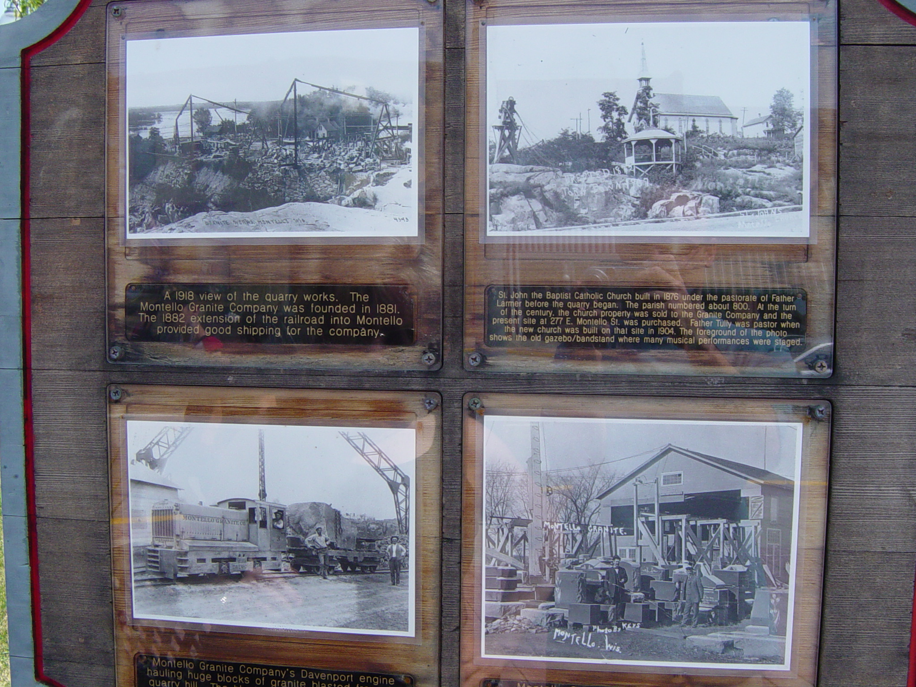
Goal: Preserve the City’s scenic, historic, and quaint character.

Objectives:
- Identify and promote the preservation of the City’s cultural, historic, and archeological resources.
- Cooperate with the Town to promote the historic and cultural character of the combined Montello community.

Policies:
- Encourage private landowners to protect and rehabilitate historic and archeological sites, and incorporate them into the planning of new development areas where appropriate.
- Work with the Town of Montello to promote “heritage tourism” (e.g., local festivals, fairs, farm tours, and markets) that celebrates the heritage and rural setting of the combined “Montello community.”

Cultural Resource Recommendations
This Plan encourages the City of Montello and Montello Historic Preservation Society to preserve and celebrate its treasured cultural resources by pursuing the following strategies:
    - Protect and Rehabilitate Known Historic and Archeological Sites
Using the AHI database as a starting point, the City should explore any opportunities to nominate a single structure, property or groups of properties in Montello on the State or National Register of Historic Places. Once formally listed, there are economic incentives available to private landowners interested in protecting their properties. These incentives help offset additional costs that may be necessary to comply with other, more regulatory aspects of a historic preservation program. The primary economic incentive for historic preservation is in the form of tax credits. The Federal Historic Preservation Tax Incentives program provides tax incentives for buildings that are listed, or eligible for listing, on the State and National Register of Historic Places. Property owners can qualify for a 20% Federal Income Tax Credit (ITC) to rehabilitate their historic commercial, industrial, and rental residential properties. All work must comply with federal guidelines established in the Secretary of Interior’s Standards for Historic Building Rehabilitation. Additional information on the federal program is available at http://www.nps.gov/tps/tax-incentives.htm.
At the State level, the Historic Homes Tax Credit Program provides a 25% Wisconsin ITC for the rehabilitation of owner-occupied structures that either contribute to a National Register-listed historic district or that are individually listed—or eligible for listing—with the National or State Register. To qualify, the State Historical Society must certify that the work is compatible with the historic character of the building and the improvement complies with federal guidelines established in the Secretary of Interior’s Standards for Historic Building Rehabilitation. All applications must be made to the State’s Division of Historic Preservation, where required forms and additional information can be obtained at www.wisconsinhistory.org. Eligible projects can include structural and exterior improvements, heating and ventilation systems, and electrical and plumbing systems (excluding fixtures). The proposed project has to have budget greater than $10,000 and the program has a $10,000 maximum deduction per project, however, a single structure could be eligible for a tax credit for multiple projects.
To avoid disturbing any known archeological site in Montello during development, this Plan advises that the City make a specific request to the Wisconsin Historical Society for more detailed information when a specific development proposal is offered on land in an area where a known historic or archeological site has been mapped, if its location is not readily apparent. Mapped archeological sites are predominantly burial sites. Under Wisconsin law, Native American burial mounds, unmarked burials, and all marked and unmarked cemeteries are protected from intentional disturbance.
    - Promote Heritage Tourism
The City should consider cooperating with others to promote tourism opportunities that celebrate and take economic advantage of the area’s historic, archeological and scenic resources, including the lakes, agricultural and forested land, and the historic downtown. This type of tourism—often called “Heritage Tourism”—will become increasingly popular as the baby boom generation continues to enter retirement. Heritage tourism may focus on museums, vibrant rural communities, historic architecture, historic settlement patterns and the City’s natural amenities and views. Agricultural tourism highlighting both traditional agriculture and organic farms has also been successful in the region, such as seasonal farm events with pumpkin patches, sleigh ridges, corn mazes or tours of organic farms. The City, along with the Town, Marquette County, Montello Historic Preservation Society, and/or the City’s Chamber of Commerce should explore State grant opportunities to study, establish, and fund a heritage tourism program.
    - Park, Open Space, Recreational and Community Design Resources
The planning goals, objectives, policies, maps and programs related to park, open space, and recreational resources in City of Montello are presented in Chapter Five: Utilities and Community Facilities. Goals, objectives, policies, maps, and programs related to community design are presented in Chapter Three: Land Use and Chapter Seven: Economic Development.
Map 2: Natural Areas

Chapter Three: Land Use
This chapter contains a compilation of background information, goals, objectives, policies and recommended programs to guide the future preservation and development of lands in and near the City of Montello. Under Wisconsin law, the City has the ability to include in its plan recommendations for lands outside the current municipal limits. The chapter includes two maps that show existing land uses and recommended future land uses, and provides other related land use data and analysis.
  - Existing Land Use
An accurate depiction of Montello’s existing land use pattern is the first step in planning for a desired future land use pattern.
    - Existing Land Use Map Categories
Map 3 divides existing (2003) land uses in the City of Montello into several categories. These categories include:
Agriculture & Rural Lands: land used primarily for open space, farming, farmsteads, nurseries, and farm-support activities, and limited single-family residential development, generally with densities at or below 1 dwelling unit per 40 acres, and small-scale institutional uses such as cemeteries, churches and town hall buildings. Also includes grasslands, shrub land and sandy or barren land;
Wetlands: Wetlands over two acres identified through the Wisconsin DNR “Wisconsin Wetland Inventory”;
Public Open Space: publicly-owned land designated as State parks and scenic areas; State conservation areas; conservancy land owned by non-profit agencies; County parks and recreation areas; town parks, City parks, or other recreational facilities owned by the public or private utility companies;
Forest: privately-owned forest land, in certain cases including private recreational uses or single-family residential development generally with densities at or below 1 dwelling unit per 40 acres, covered with coniferous, broad-leaved deciduous, and mixed deciduous trees;
Surface Water: lakes, rivers and perennial streams;
Single Family Residential - Rural: groupings of predominantly single family residential development, generally at lower densities (between 1 dwelling unit per acre and 1 dwelling unit per 40 acres), and typically served by on-site waste disposal systems;
Single Family Residential - Sewered: Single-family residential development typically served by a public or group sanitary sewer system at densities up to 6 dwelling units per acre;
Two Family Residential: groupings of two-family and attached single-family residential development;
Mixed Residential: groupings of a variety of residential units (including apartments and mobile home parks);
Commercial Recreation: privately-owned lands designated as recreation areas, such as for-profit campgrounds, private golf courses, fish farms, and waterfront businesses;
General Business: indoor commercial, office, telecommunication facilities, and occasional outdoor display land uses, generally with moderate landscaping and signage;
Downtown: pedestrian-oriented indoor commercial, office, institutional, and residential uses with streetscaping and low-key signage associated with the main historic business district;
Industrial: indoor industrial land uses and occasionally outdoor storage areas, generally with moderate landscaping and signage;
Extraction: sites in active use as a quarry, gravel pit, clay extraction, peat extraction and related land uses;
Institutional: large-scale public buildings, hospitals, airports/landing strips, non-profit campgrounds, and special-care facilities. Small institutional uses may be found in areas designated in other land use categories.
    - Existing Land Use Pattern
Surface water has a significant influence on the configuration of land use in and near the City of Montello. The extensive shoreline has attracted Residential development. The isthmus between Lake Montello and Buffalo Lake contains the downtown and also includes Single Family Residential, General Business, Institutional, and Commercial Recreation uses. There is a concentration of restaurants, bars, antique shops, and other commercial uses. There are several County buildings located on Lake Montello. There are also several parcels of Public Open Space along both lakeshores.
Institutional uses include the high school, two elementary schools, a recycling center, and churches. The eastern part of the City is much more densely developed than the west. With the exception of large Wetland areas lining the Fox River and Public Open Space along both lakes, most of the east part of the City is a mix of sewered Single Family Residential, Institutional, General Business and Industrial development. The east has a grid-like street pattern.
In the west, existing land use is primarily Agricultural & Rural Lands and Forest with rural housing. Here, the street pattern is more spread out and circuitous. The lack of municipal sewer and water services in this area has significantly limited development. Given the large area of undeveloped land within the City limits, it is particularly important to plan appropriate sewer extension areas.
In the southeastern corner of the City is an industrial park consisting of three separate businesses and a vacant structure that previously housed Glen Oak.
Land uses surrounding the City are predominantly agricultural and open lands, forests, and wetlands. There is a large area of rural single-family residential development on the south side of Buffalo Lake. There is another expanse of rural single-family residential development, as well as commercial recreational use outside of the City limits on Lake Montello.
Figure 10 shows the amount, type, and intensity (or percentage) of each existing land use category inside of the City of Montello in 2003.
Figure 10: Existing Land Use Totals – City of Montello
Land Use | Acres | Percent
Agriculture & Rural Lands | 215 | 15.6%
Forest | 212 | 15.4%
Public Open Space | 44 | 3.2%
Wetlands | 101 | 7.3%
Surface Water | 187 | 13.6%
Single Family Residential-Rural | 114 | 8.3%
Single Family Residential-Sewered | 258 | 18.8%
Mixed Residential | 22 | 1.6%
General Business | 58 | 4.2%
Downtown | 10 | 0.7%
Commercial Recreation | 17 | 1.2%
Industrial | 27 | 2.0%
Institutional | 112 | 8.1%
TOTAL | 1,376 | 100%
Source: GIS Inventory, Vandewalle & Associates, 2003
    - Land Development Trends
According to local building permit data, between 2004 and 2015, there were 12 new housing units built in the City of Montello. This means that, on average, the City has added about one new home each year to its housing stock. Of this residential construction, 8 units were single-family housing and 2 were duplexes. Although there was no new commercial development during this time, a church was constructed during this time period.
    - Land Market Trends
The State Department of Revenue (DOR) reported an increase in the total equalized value from 2000 ($58.5 million) to 2014 ($90.5 million) in the City. In 2014, over 76 percent of the City’s Equalized Value was in the residential property class. The average price of residential land has been between $12,000 to $14,000 for unsewered lots near the City. In areas of the City served by public utilities, lots are selling at $17,000 on average. Commercial land sales have been reported to generate roughly $15,000 to $20,000 per acre. As of 2016, there were very limited industrial sites available, making it difficult to determine sales history.
Figure 11: City of Montello Equalized Land Values, 2000 - 2014
 | Residential | Commercial | Manufacturing | Agricultural | Other /  Undeveloped | Forest Land | Total
2000 | $44,254,700 | $11,369,600 | $2,856,100 | $0 | $0 | $0 | $58,480,400
2010 | $68,183,900 | $16,689,000 | $3,208,300 | $6,900 | $15,000 | $0 | $88,103,100
2014 | $69,152,200 | $18,305,300 | $3,079,900 | $7,100 | $0 | $0 | $90,544,500
Source: Wisconsin Department of Revenue, 2015

Figure 12 shows the equalized value of all property in Marquette County for 2000, 2010 and 2014. The highest increases in land value occurred in the residential and swamp and wasteland real estate categories. The increase in swamp and wasteland resulted in a change in real estate classification and a change in market perceptions. By 2000, real estate classified as swamp and wasteland become popular, as more individuals began purchasing this land for hunting and other recreational purposes, and as adjacent land for home sites.
Figure 12: Marquette County Equalized Land Values, 2000 - 2014
 | Residential | Commercial | Manufacturing | Agricultural | Swamp & Waste & Other | Forest Land | Total
2000 | $154,786,562 | $9,073,275 | $549,600 | $30,318,824 | $30,432,440 | $55,785,770 | $280,396,871
2010 | $1,185,390,700 | $72,713,300 | $18,353,800 | $54,287,300 | $137,552,600 | $129,364,500 | $1,597,662,200
2014 | $1,113,594,100 | $77,369,200 | $17,686,000 | $46,039,100 | $148,369,300 | $106,177,600 | $1,509,235,300
Source: East Central Wisconsin Regional Planning Commission, 2003 & Wisconsin Department of Revenue, 2015
    - Existing and Potential Land Use Conflicts
There are few existing conflicts among different land uses in the City. Some stark transitions in land use occur where the gas station adjoins Daggett Memorial Park in the downtown area, and in scattered spots where industrial or heavier commercial uses abut residential areas.
The concentration of the City’s development on the lakes has both benefits and drawbacks. The lakes provide a very attractive backdrop for development and have the potential to spur additional economic development for the City. However, too much development along the lakes may have a negative effect on water quality of the lakes as runoff is increased. In addition, public lake access opportunities can diminish.
There may be future City expansion into certain planned areas in the neighboring Town of Montello over the 20-year planning period. Planning for the City’s expansion should be conducted in a manner that considers the interests of both communities to avoid conflict. In general, this Plan seeks to avoid potential future land use conflicts through thoughtful and comprehensive land use planning at the local level, considering this individual planning effort in the broader intergovernmental context.
Map 3: Existing Land Use
    - Projected Land Use Supply and Demand
This Plan projects land use demand over the 20-year planning period (in five-year increments) for residential, commercial, industrial, and agricultural uses. Projected demand is then compared to the potential supply of land to meet that demand, as presented in Figure 13.
Residential land use projections in the City of Montello are based on population forecasts prepared by the Department of Administration and discussed in Chapter One: Issues and Opportunities and recent housing development trends. Using these forecasts, and assuming that the average future residential home site in Montello will be 1 acre (including roads), Figure 13 shows the amount of residential acreage needed to accommodate future growth in five-year increments.
Figure 13: Projected City Residential Land Use Demand
 | 2015-  2020 | 2020-  2025 | 2025-  2030 | 2030-  2035 | 2035-  2040 | Total  2015-2040
Projected Number of New Residents | 15 | 45 | 10 | -10 | -45 | 15
Projected Number of New Housing Units | 7 | 16 | 5 | 0 | 0 | 8
Projected Residential Land Use Acreage Demand | 7 acres | 22 acres | 5 acres | 0 acres | 0 acres | 8 acres
Source: Wisconsin Department of Administration; Osterberg Planning
Future residential development shown on Map 4 and allowed under the policies of this Plan will provide more than enough capacity to accommodate this expected residential land use demand through the year 2040, even if new home demand is substantially higher than these projections.
To calculate commercial land use projections, the current ratio of commercial land use acreage to population in the City (1 acre for every 16 residents) was assumed to remain constant over the planning period. Based on this methodology, the City would need to accommodate about 1 acre of new commercial land area over the planning period. It is important to note, however, that some future commercial areas may be intended to serve a much larger market area and are not tied solely to City population forecasts.
To calculate industrial land use projections, the current ratio of industrial land use acreage to population in the City (1 acre for every 18 residents) was assumed to remain constant over the planning period. Based on this methodology, the City would need to accommodate about 1 acre of new industrial land area over the planning period. Again, it is important to note that some future industrial areas shown on Map 4 are intended to accommodate regional economic growth, which does not depend solely on local population forecasts.
This Plan projects that agricultural land uses in the City of Montello will decline over the planning period, following current trends of agricultural land conversion. In general, agricultural land within the City is projected to be an interim use pending development of the sites. The amount of land for agricultural uses in the City is expected to decline by roughly the amount of new residential, commercial, and industrial land added in the City limits every five years over the 20-year planning period. The adjacent Town of Montello is planning for a significant portion of its land base to remain in rural and agricultural use over the next 20 years.

Land Use Goal, Objectives and Policies

Goal: Promote a balanced future land use pattern consistent with Montello’s character and its role as the “center” of the County.

Objectives:
- Plan for a sufficient supply of development areas for a variety of land uses, including residential (single and multi-family), commercial, industrial, institutional, and open space uses.
- Ensure a desirable and compatible mix of land uses consistent with the City’s historic character.
- Promote the revitalization of the historic downtown and areas in close proximity.
- Guide development to promote efficient land use patterns without undue limits on economic growth.
- Promote high quality design and building sizes that relate to existing buildings in the area.
- Encourage practices that minimize conflicts between nearby land uses (e.g. residential and industrial).

Policies:
- Follow the land use recommendations mapped and described in this Plan when making detailed land use decisions, such as subdivision requests and future zoning decisions.
- Modify the City’s zoning ordinance where necessary to implement the goals, objectives, and recommendations of this Plan; minimize potential land use conflicts, guide growth and development, ensure high quality site development, adequately protect water quality and is administered and interpreted in an understandable manner.
- Promote compact development that utilizes existing infrastructure and utilities wherever practical.
- Guide new development to areas adjacent to existing development and where logical extensions to streets, sewer lines, and water lines may occur.
- Continue to require all development within the City to connect to sanitary sewer and public water systems, and discourage development in planned sewered development areas outside of the current City limits until sewer and water services are available.
- Make practical park and green space decisions on a neighborhood level, and preserve key corridors for open space connections (e.g. lakes, rivers, and wetlands).
- Assure that incompatible land uses are not located close to one another or require appropriate separation and screening (e.g. fencing or landscaping).
- Emphasize redevelopment of older properties or cleaned-up brownfield sites and near the City’s downtown, and rehabilitation of aging or vacant buildings for productive economic use.
- Promote road and trail connections between the City center, existing and new residential areas, and City amenities, in particular the shorelines and parks along Lake Montello and Buffalo Lake. The City will work with Marquette County to develop a master park plan for the newly acquired land in the downtown area to connect the Andrew Krakow Fishery Area to the Downtown.

Land Use Recommendations
Map 4 presents recommended future land uses over the 20-year planning period for the City of Montello and lands around the City. The original 2005 Planned Land Use Map was prepared in consultation with the Town of Montello and during the 2016 Plan update process the City consulted the Town of Montello Planned Land Use Map. Map 4, along the recommended policies in this chapter, should be used to guide City decision-making on future land use changes. Changes from the existing land use pattern to realize this planned land use pattern may occur if and when private property owners make requests for annexation, rezoning, subdivisions, conditional use permits, or other development approvals.
Map 4 uses numerous planned land use designations to describe the desired type and future location of different land uses in and around the City. These planned land use designations were prepared in a joint effort with other towns, villages, and Marquette County working on the multi-jurisdictional early 2000s planning effort and the 2016 Plan update process.
In order to carry out the recommendations of this Plan, the City should update its existing zoning map to both reflect current land use and desired future land uses. Major amendments to the text of the zoning ordinance may also be required to implement the recommendations of this Comprehensive Plan and to ensure that the zoning ordinance is efficiently administered and easily understood by the City’s property owners. However, strategic changes are suggested in the sections that follow.
The following is a description of each mapped planned land use designation in Montello and recommended programs and policies for each designation shown on Map 4.
    - Single Family Residential – Sewered
Description: The designation is mapped over existing and planned single-family detached residential development, generally on ¾ acre lots or less, and served by Montello’s public sanitary sewer and water systems. Map 4 recommends Single Family Residential – Sewered uses for planned new development areas throughout the City. These planned areas are generally within the existing (2016) City limits, with limited exception of an area south of Fern Road and west of State Highway 22.

Policies and Programs:
- The City will compare Map 4 with the existing zoning map, and update the zoning map as appropriate. Areas shown as Single Family-Residential - Sewered are zoned with one of the City’s compatible districts: R-1 or R-2 Single Family Districts. The R-1 district requires a minimum lot size of 12,000 square feet, and the R-2 requires a minimum lot size of 8,000 square feet. These districts allow a range of land uses that complement residential settings.
- Apply the appropriate residential zoning district as future areas planned for Single Family Residential – Sewered use are platted and zoned for development.
- Minimize potential for incompatible land uses (e.g., high traffic generators, noisy uses, etc.) within or next to Single Family Residential – Sewered areas. Where such uses do occur in close proximity, the City should encourage the creation of landscaped buffers.
- Consider updating the City’s land division ordinance to carry out the objectives and policies set forth in this Plan.
- Consider use of the City’s Planned Unit Development conditional use option for areas that are predominantly desired for residential use, however may also be appropriate for compatible small-scale commercial uses. The Planned Unit Development option could facilitate a gentle transition between existing residential and commercial land uses by providing for an innovative mixture of compatible uses, while encouraging design standards to ensure high-quality development.
- Administer property maintenance codes to maintain neighborhood quality and tax base stability.
- Support efforts to preserve and rehabilitate historically and architecturally significant homes in residential areas.
- Continue to thoughtfully locate community facilities such as roads, paths, parks, sidewalks, schools, churches, and libraries so that they provide convenient access to residential areas.
- Plan for interconnected road networks in new residential areas.
    - Single Family Residential – Rural
Description: This designation includes single-family detached residential development, generally at densities between 1 dwelling unit per ¾ acre and 1 dwelling unit per 10 acres, and served by individual on-site waste disposal (septic) systems. In the City of Montello, this designation is generally found in areas of existing residential development that is served by individual on site septic systems, particularly in the area on the west side of Montello Lake along Carriage Road and Woodland Drive. Upon extension of sanitary sewer service, these areas would revert to the Single-Family Residential – Sewered Planned Land Use designation. Within the Town of Montello, Map 4 shows a Single Family Residential – Rural area in the area south of Buffalo Lake, between CTH F and STH 22 (north of CTH XX), and generally in areas outside of the 2016 City limits. These areas were generally mapped in this designation to correspond with the Town of Montello Comprehensive Plan.
The appropriate zoning district of areas designated as Single Family Residential – Rural is dependent upon whether these areas are in the Town of Montello or are in the City. The County’s Agricultural Residential (AG-3) zoning district is most appropriate in the Town. The City’s Rural Development (R-4) district is most appropriate in the City. Both of these zoning district options require a minimum lot size of 2 acres.
    - Mixed Residential
Description: The Mixed Residential plan designation allows for a variety of residential units, including duplexes, multiple-family housing (3+ unit buildings), senior housing, and manufactured and mobile home parks, served by public sanitary sewer service. This designation was mapped over existing multi-family housing between 3rd and 4th Street west of STH 22, the senior living facility off CTH F, and at the northwest corner of Park Street and Doty Street. Map 4 envisions an expansion of the Mixed Residential area in the southern part of the City, as well as a new area between 2nd and 3rd street, west of Cass Street. Future Mixed Residential areas are mapped on the west side of the City north of STH 23 and north of the school complex. Conversion of the old high school into multi-family housing is also recommended. New areas mapped in this designation were selected because most provide a gentle transition between commercial or industrial uses and proposed single-family residential development. The areas mapped as Mixed Residential are dispersed throughout the City, thereby avoiding the over concentration of multi-family housing in any one part of the City. In addition, these sites are relatively close to services in the City (e.g. shopping, businesses, parks, schools).

Policies and Programs:
- Compare the Planned Land Use Map (Map 4) with the existing zoning map, reviewing all developed parcels to determine if use of the land is appropriately zoned in the compatible zoning district: the R-3 Multi-Family Residential District. The City’s R-3 District has a minimum lot size of 10,000 square feet in area.
- Apply the suitable zoning district as undeveloped areas planned for Mixed Residential use are platted and zoned for development. Consider use of the City’s Planned Unit Development conditional use option for areas that are predominantly desired for residential uses, however may be appropriate for compatible small-scale commercial uses. The Planned Unit Development option could facilitate a gentle transition between existing residential and commercial land uses by providing for an innovative mixture of compatible uses, while encouraging design standards to ensure high-quality development.
- Consider the appropriateness of mobile home parks (as distinct from manufactured homes) in this land use designation and the City’s Multi-family Residential (R-3) zoning district. At a minimum, the City should update its zoning standards applied to mobile home parks to ensure that they do not interfere with neighboring uses or detract from the character of the area in which they are located.
- Consider updating the City’s land division ordinance to carry out the objectives and policies set forth in this Plan.
- Require that all proposed projects submit a detailed site plan, building elevations, landscape plan, lighting plan, grading/stormwater management plan and signage plan prior to development approval. Recommended design standards for Mixed Residential development projects are provided in Chapter Seven: Economic Development of this Plan.
- Multi-family residential projects envisioned in Montello’s Mixed Residential areas should meet minimum design standards as presented in Chapter Six of this Plan. New building sizes should generally be limited to 8-10 units.
    - Downtown
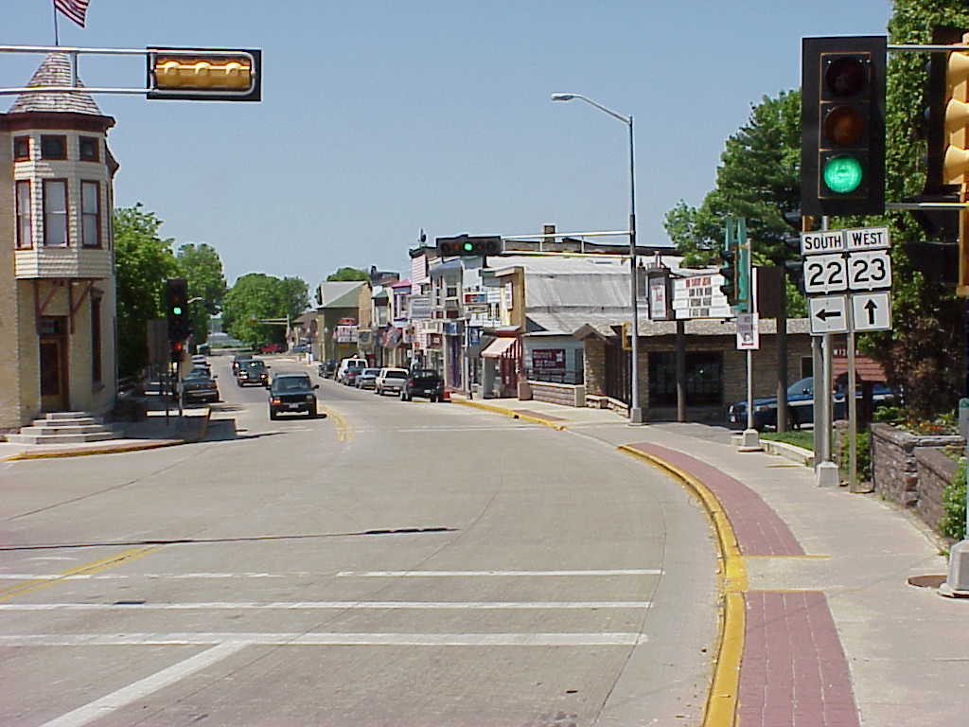
Description: This designation includes pedestrian-oriented commercial, office, institutional, and residential uses in a traditional “downtown” setting with minimal setbacks and on-street parking. In Montello, this designation was mapped over the existing downtown area along Main Street and STH 22/23 in the central part of the City. This is generally the area that is characterized by two-story historic commercial buildings, single-family residences and other structures that are not set back from the street right-of-way.

Policies and Programs:
- The most appropriate zoning districts for this area General Commercial (B-1 and R-3 Multifamily Residential. This district allows for a range of uses that are generally compatible with the downtown.
- Consider development of a new zoning district for the downtown area. The new district should contain development and rehabilitation design standards to preserve the overall flow, character, and feel of the area, promote compatibility with existing buildings in the downtown, and avoid stark land use transitions. Standards may consider issues such as maximum setbacks, building height and mass, materials, architectural elements, and signage. Design standards should at a minimum address the appropriateness of certain remodeling and demolition activities. More design suggestions for Downtown Montello revitalization are provided in Chapter Seven of this Plan.
- Continue downtown beautification efforts (e.g., planters, banners, streetscaping), and consider expansion of these programs to include efforts such as building façade improvement incentives, particularly for historically significant buildings.
- Explore additional opportunities for downtown parking, including opening up parking areas behind buildings on the south side of Main Street and west of the river.
- Work with downtown property owners and others to promote the Montello River, Lake Montello and Buffalo Lake as scenic backdrops to the downtown, expanding waterfront dining opportunities and ensuring that access to the waterways is maintained and improved where possible.
- Promote the downtown as a commercial, civic, and social center. This includes continuing to support parades, special events and celebrations in the downtown to reinforce this important civic area. Specific strategies are discussed in detail in Chapter Seven: Economic Development.
- Use marketing, investment, and incentive strategies to promote and retain specialty retail, financial services, offices, retail, entertainment business and services.
- Work to expand uses that provide goods and services to tourists attracted to the area for its outdoor recreation opportunities or rural charm. Such businesses might include additional restaurants, nature stores (e.g. bird and wildlife related items), gift shops, art galleries, home and garden stores, and sporting goods stores.
- Work with Marquette County to develop a plan for a trail connecting the downtown area, new County Park, and the Krakow Fishery area.
- Market downtown Montello as a place to start up small, aspiring businesses and promote increased utilization of second story space for housing and offices.
    - Neighborhood Business
Description: Planned Neighborhood Business use areas include small-scale, neighborhood supporting retail, service, and office uses that preserve surrounding residential character through building scale and appearance, landscaping, and signs. This designation is mapped over areas with existing small-scale commercial lots and buildings, many of which are converted residences. Several of these areas continue to have intermixed residential uses. These planned areas are mapped along Main Street between the downtown area and the Fox River, on the north side of STH 23 east of downtown, and along CTH B west of the downtown.

Policies and Programs:
- Consider the future rezoning of these planned Neighborhood Business areas to Convenience Commercial (B-2). This zoning district allows for a mixture or residential and small-scale commercial uses.
- Reconsider the minimum front yard setback of 50 feet in the B-2 zoning district to accommodate existing buildings with smaller setbacks.
- Consider new development and rehabilitation design standards for the B-2 zoning district to preserve the overall flow, character, and feel of the area, promote compatibility with existing buildings, and avoid stark land use transitions. Standards may consider issues such preservation of residential character, even as homes are converted to businesses or demolished for new commercial structures.
- Update the City of Montello Zoning Code to require all proposed commercial projects submit a detailed site plan, building elevations, landscape plan, lighting plan, grading/stormwater management plan and signage plan prior to development approval. Recommended design standards for commercial development projects are provided in Chapter Seven: Economic Development.

    - General Business
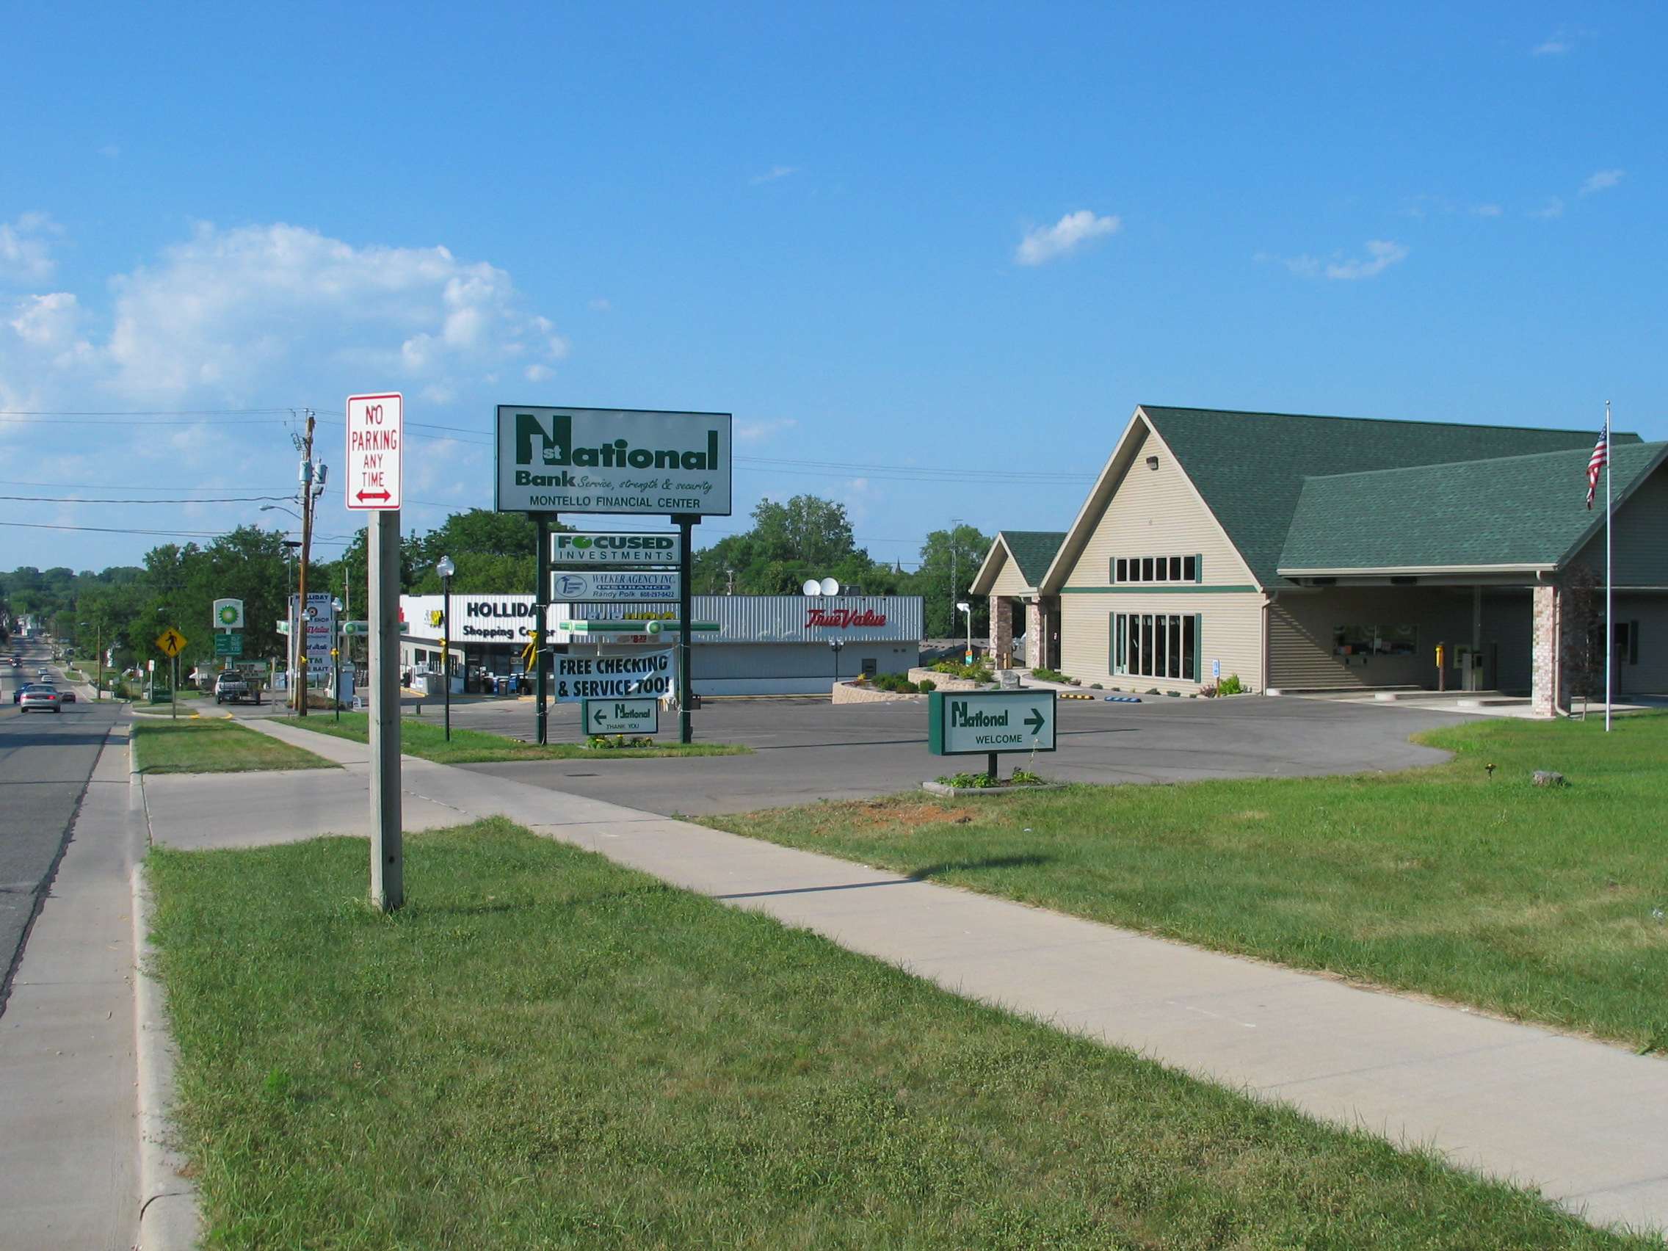
Description: Planned General Business use areas are mapped over existing commercial areas in Montello, as well as future planned areas generally on or near STHs 22 and 23, and two areas in the west central and east central portions of the City. This designation includes indoor commercial, office, institutional, telecommunication facilities, and outdoor display land uses, with new development adhering to high-quality building design, generous landscaping, modest lighting, and limited and attractive signs.

Policies and Programs:
- Compare the Planned Land Use Map (Map 4) with the existing zoning map. The most appropriate zoning district to implement the General Business planned use designation is the Highway Commercial (B-3) district. This district allows a range of highway- and community-serving business uses.
- Work cooperatively with the Town on the future development and jurisdiction of General Business areas outside of the current City limits. City utilities and services in these areas would allow for businesses that are more intensively developed and generally of higher assessed value.
- Update the City’s Zoning Code to require that all proposed commercial projects submit a detailed site plan, building elevations, landscape plan, lighting plan, grading/stormwater management plan and signage plan prior to development approval. Recommended design standards for commercial development projects are provided in Chapter Seven: Economic Development of this Plan.
- Carefully regulate commercial uses that have the potential for groundwater contamination, particularly near the City’s south edge where the susceptibility for groundwater contamination is fairly high.
- Encourage access controls for new development off of County and State trunk highways. Numerous private access points can result in more congestion and more traffic-related conflicts along these highways, as well as create problems for parking and loading. Limiting the number of and ensuring adequate spacing between access points can help to control the type and pace of new development. Shared access drives and interconnected local access roads should be promoted.
- Revise the City’s sign regulations to provide appropriate levels of advertising while avoiding excessive signs that can negatively impact traffic safety and character.
    - Commercial Recreation
Description: This designation includes privately owned lands designated as recreational areas or businesses, such as for-profit campgrounds, private golf courses, fish hatcheries, and waterfront businesses. In the Montello area, existing for-profit campgrounds are shown on Map 4. New Commercial Recreation areas are mapped adjacent to existing Commercial Recreation Development.

Policies and Programs:
- The best existing Zoning District to implement the Commercial Recreation designation is R-4 Rural Development.
- Given the amount of Commercial Recreation development within the City of Montello, consider addition of a new zoning district to better implement the Commercial Recreation designation.
    - General Industrial
Description: This designation includes indoor manufacturing, warehousing, distribution, and office uses, some with outdoor storage areas. New development should adhere to high-quality building design, generous landscaping, modest lighting, screened storage areas, and limited and attractive signage. In Montello, this designation is mapped over the City’s existing industrial/business use areas on the south side of the City and in scattered areas with existing industrial uses elsewhere in the City. Map 4 also suggests a southerly expansion of the City’s main industrial area in the STH 22 corridor near the southern edge of the City.

Policies and Programs:
- Compare the Planned Land Use Map (Map 4) with the existing zoning map. The most appropriate zoning district to implement this planned use designation is the General Industrial (I-1) zoning district.
- Work cooperatively with the Town on the future development and jurisdiction of General Industrial areas outside of the current City limits. City utilities and services in these areas would allow for businesses that are more intensively developed and generally of higher assessed value.
- Require that all proposed industrial projects submit a detailed site plan, building elevations, landscape plan, lighting plan, grading/stormwater management plan and signage plan prior to development approval. Recommended design standards for industrial development projects are provided in Chapter Seven: Economic Development of this Plan.
- Carefully regulate industrial uses that have the potential for groundwater contamination, particularly near the City’s south edge where the susceptibility for groundwater contamination is fairly high.
- Encourage the creation of landscaped (or tree preservation) buffers where existing and planned industrial use areas abut existing or planned residential areas.
    - Institutional
Description: This designation includes generally large-scale public buildings, and cemeteries. Due to the City of Montello’s role as a governmental and educational center, these uses are fairly prominent in the community. Small institutional uses, such as small cemeteries and churches, may be in other planned land use designations.

Policies and Programs:
- Work with the Montello School District to provide adequate community and recreational facilities and viable schools in Montello.
- Cooperate with Marquette County on integrating County facilities into the fabric of the community and on possible future joint City/County projects, including participating in the planning and development process of a 10-acre vacant parcel acquired by the County in 2014. The parcel adjoins the County’s current Highway Department, Human Services and Service Center buildings south of Underwood Avenue.
- In the development of new residential areas, consider how they relate to current and proposed Institutional uses.
- Ensure that all land use decisions related to the Institutional designation are in coordination with the Utility and Community Facility recommendations of this Plan.
    - Rural Lands
Description: This designation includes privately owned undeveloped lots, small woodlots, and open lands in agriculture use mapped in and by the neighboring Town of Montello. Appropriate development in mapped Rural Lands areas includes seasonal and permanent single family residences with a density between 1 new residence per 10 gross acres and 1 new residence per 40 gross acres, and other related rural land uses. The City should not support development in the Rural Lands area if the density is greater than one residence (or other intensive land use) per 10 acres.
    - Public Open Space
Description: This designation includes publicly owned land designated as scenic or conservation areas; parks or recreation lands; or other recreational facilities owned by the public or non-profit agencies. This designation also includes existing and planned forest lands owned by a State, County, town, City, or school district. In Montello, this designation includes parks like the Montello City Park and Daggett Memorial Park, as well as the vacant land along Buffalo Lake recently acquired by Marquette County for recreational purposes.

Policies and Programs:
- Consider updating the City’s land division ordinance to ensure that new residential subdivisions provide appropriate Public Open Spaces to serve neighborhood residents. These areas are not shown on Map 4.
- All existing and planned residential areas should ideally be located within a ten-minute walk (approximately 1/3 mile) of existing or new park facilities.
- All public parks should be designed with multiple access points from surrounding neighborhoods.
- Park facilities should be designed to meet the needs of all residents of the City including special groups such as the elderly, the disabled, and pre-school age children.
- Ensure that all land use decisions related to the Public Open Space designation are in coordination with the Utility and Community Facility recommendations of this Plan.
    - Environmental Corridor
Description: This overlay designation includes generally continuous open space systems based on lands including sensitive natural resources and limitations for development. This designation includes Wisconsin DNR-identified wetlands subject to existing State-mandated zoning, FEMA designated floodplains subject to existing State-mandated zoning, and slopes of 20 percent or greater.

Policies and Programs:
- If new or expanded development is proposed on lots where this designation is mapped, the landowner should identify the exact boundaries of the Environmental Corridor based on the wetland, floodplain, or steep slope feature that defines the Environmental Corridor in that location.
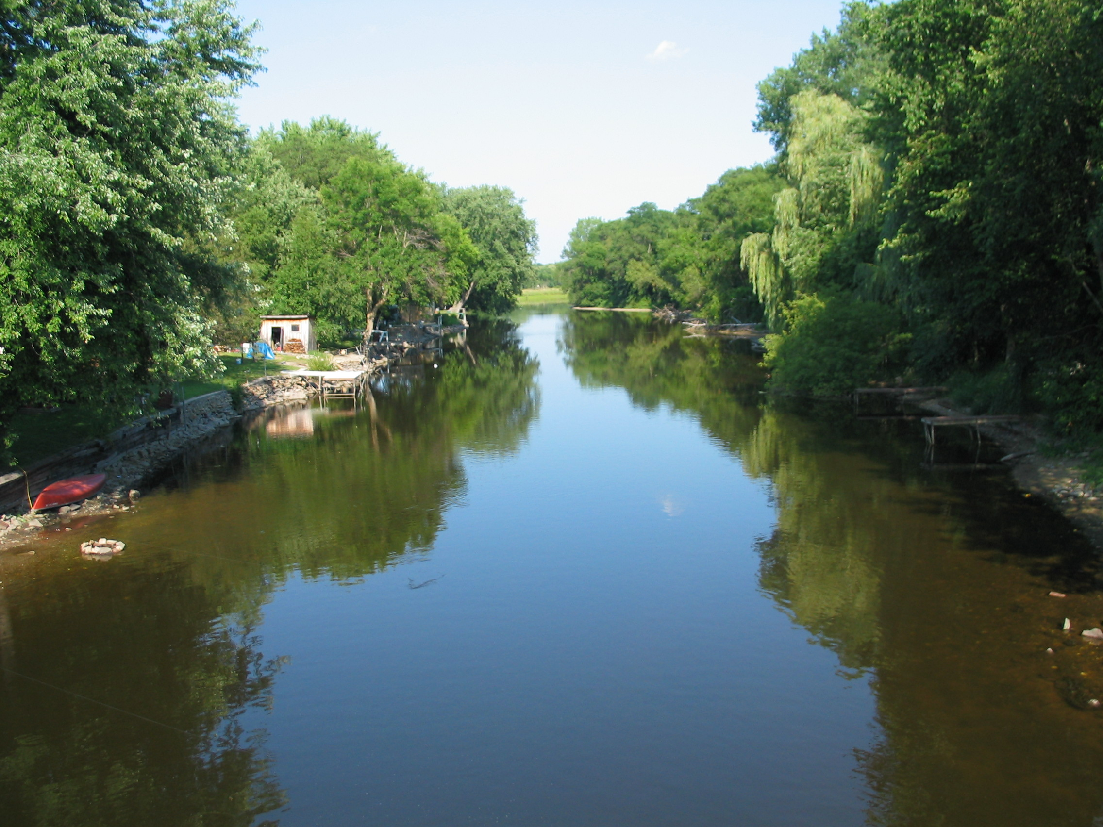
- Allow existing development to continue within the Environmental Corridor, recognizing that some improvements may be limited by underlying floodplain zoning regulations. Support further studies that may reconfigure the floodplain boundaries in the future.
- Discourage new buildings that do not replace old buildings and significant expansions to existing building footprints, particularly where other, more appropriate building sites are available on the same parcel outside the Environmental Corridor.
- Permit existing cropping and grazing in mapped Environmental Corridor areas.
    - Well Setback Area from Landfill (Boundary)
Description: This boundary depicts the 1,200-foot setback area around closed landfills where the installation of a private drinking well is generally prohibited under WisDNR rules, unless a waiver is granted. The City and Town should not plan for any new intensive residential development on private wells within this ¼ mile setback area.
    - Smart Growth” Areas
Wisconsin’s comprehensive planning law requires comprehensive plans to identify “Smart Growth Areas,” defined as “areas that will enable the development and redevelopment of lands with existing infrastructure and municipal, State, and utility services, where practical, or that will encourage efficient development patterns that are both contiguous to existing development and at densities which will have relatively low municipal, State governmental, and utility costs.” This Plan designates the Downtown, Neighborhood Commercial, and nearby residential neighborhoods (including the former high school building) as “Smart Growth Areas.” The designation of these areas as a Smart Growth Areas draws upon the potential for rehabilitation and re-use of vacant and older buildings utilizing existing streets and connections to Montello’s utility system, as identified as a priority from public input through this planning process. The City will support the reuse, revitalization, and further investment in these areas.
    - Opportunities for Redevelopment
This Plan identifies specific areas that present opportunities for redevelopment in the City of Montello. Many of these correspond to the “Smart Growth” areas listed above, as well as, areas designated Downtown and Neighborhood Commercial on the Planned Land Use Map. The former high school building is one example of a structure ripe for redevelopment – for instance into multi-family housing. Vacant or deteriorating buildings in the downtown area could be re-used. In addition, the City encourages conversion of many of the former residential structures along STH 22 on the south side of the City to businesses and service uses that perpetuate the neighborhood feel of the area. Monitoring of the City’s former landfill site will be complete by 2023; at that time the City should revisit the planned land use category over this parcel to help facilitate appropriate redevelopment of the site.
Map 4: Planned Land Use

Chapter Four: Transportation
Access is a key determinant of growth because it facilitates the flow of goods and people. This chapter includes background information, goal, objectives, policies and recommended programs to guide various modes of transportation in the City of Montello. The chapter compares the City’s transportation policies and programs to County, State and regional transportation plans.
  - Existing Transportation Network
    - Roadways
Roadway Function
Classification System
Throughout Wisconsin, all local, county, state and federal transportation routes are classified in categories under the “Roadway Functional Classification” system.
As identified by WisDOT, the functional classification system groups roads and highways according to the character of service they offer, ranging from rapid through access to local land access. The purpose of functional classification is to enhance overall travel efficiency and accommodate traffic patterns and land uses by designing streets to the standards suggested by their functional class. The three main functional classes include:
- Arterials that provide primary access to and through an area
- Collectors that disperse traffic within an area, and
- Local streets that provide access to individual properties.
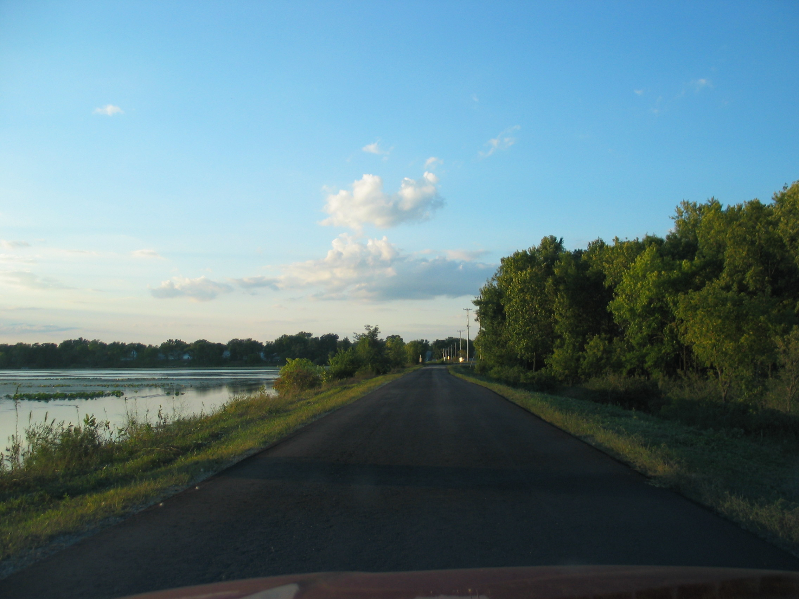
Several State and County highways radiate outward from the City of Montello. The City is served by two main State highways. State Trunk Highway (STH) 23 is an east-west arterial that bisects the City, connecting Montello to the other communities in Marquette County, including the Village of Oxford and Interstate 39 to the west, and the City of Princeton to the east. STH 23 experienced a decrease of 12% in traffic between 2000 and 2008 as measured on the west side of Montello) with average daily traffic (ADT) of 3,700 vehicles in 2008.
STH 22 is the major north-south thoroughfare running through the City, connecting it with Wautoma to the north and Portage to the south. Traffic counts on STH 22 decreased by about 23% over this same period, to an ADT of 1,700 vehicles by 2008.
County Trunk Highways (CTH) B, Y, C, F and K also connect the City with surrounding communities and countryside. CTHs C & B run through the central part of the City on the isthmus between Montello and Buffalo Lakes. CTH F, south of Montello, had an average daily traffic of 1,100 vehicles. CTHs B, C, and K are considered moderate-volume County highways, with ADTs between 450 and 800. CTH Y is a low volume County Highway with an ADT of less than 450 in 2008.
City roads are another important component of the local transportation system. In the eastern portion of the City, roads form a grid pattern. The western part of the City is much less dense and therefore has a more irregular street pattern.
Interstate 39 (USH 51) is located 8 miles west of the City, accessible via STH 23.
The lack of adequate parking is considered a problem in the downtown area.
    - Airports
There are no airports located in Marquette County. The nearest airport is the Portage Municipal Airport in Columbia County, which is classified as a “medium general aviation” airport serving small general aviation single and twin-engine aircrafts. There are also “small general aviation” airports used for recreational flying, training, and crop dusting near Wautoma and Friendship. Larger air carrier and passenger facilities are located to the south in Madison at the Dane County Regional Airport, to the north in Mosinee at the Central Wisconsin Regional Airport and to the east at the Outagamie County airport in Appleton.
    - Rail
There is no rail line running through the City. The Union Pacific Railroad runs through the southern part of Marquette County beginning in the Town of Buffalo and through the Towns of Montello and Oxford. This freight rail line connects the cities of Chicago, Milwaukee and Minneapolis and traverses Wisconsin in a roughly diagonal route.
    - Water and Truck Transportation
There is no waterborne freight movement in the area. Semi-truck shipments are most prevalent along Interstate 39, but also occur along STHs 22 and 23.
    - Bicycle and Pedestrian Routes
Bicycle and pedestrian movement is important for a community like Montello, where many primary destinations (e.g., schools, parks, businesses) are within walking or biking distance of one another. Biking is also important for commuting and recreational use, as well as for tourism development. Planned growth should accommodate, or at least not impede, safe bicycle and pedestrian travel.
Local neighborhood roads, sidewalks and Montello’s compact character provide an appropriate setting for bicycling and walking. Highly scenic rural roads also provide opportunities for bicycling and bike touring in the area. In recognition of this opportunity, a group made up of the Citizens Recreation Committee, County Highway Department, and Marquette County Board cooperatively identified and mapped several on-road bike route tours in the County in 1999 (see Map 5).
There are ten County bike routes consisting of about 140 miles. Two are routed through Montello. The Buffalo Lake Route begins in downtown Montello and loops 16 miles around the eastern portion of Buffalo Lake. The 19-mile Germania Jaunt starts at the Montello City Park, running north to the Germania Marsh Wildlife Area in the nearby Towns of Crystal Lake and Shields. No off-road recreational trails for bicyclists and hikers are available in the City or County at the present time.
The fact that much of the City’s housing is in close proximity to the schools may enhance opportunities for students to walk to school and could help to alleviate over-full parking lots, although residents report that many students still drive to school. The downtown area also has parking deficiencies, which may make biking or walking more attractive modes of transportation in these areas.
    - ATV Routes
Between 2011 and 2014, Marquette County, local municipalities, and the Marquette County ATV Club identified, designated and appropriately signed over 300 miles of County and municipal roads as an on-road ATV Route. The ATV routes connect area population centers to commercial businesses and serves as an important transportation and recreational amenity for Marquette County residents and visitors. There are several ATV routes in the City, connecting neighborhoods and adjoining towns with commercial areas in the City of Montello.
    - Ice Age Trail
A portion of the Ice Age Trail is proposed along a route running near Montello. Tracing Wisconsin’s rich glacial history, the route of the Ice Age Trail passes through Marquette County as it loops through the State some 1,000 miles from Door County to Interstate Park on the St. Croix River. Using a combination of public land, easements across public property, and abandoned rail corridors, the completed trail will be an exceptional resource for recreationalists wishing to hike its entire length or merely a small portion of it. A 10-mile segment of the trail has been designated between Portage and John Muir County Park, is considered to be one of the highlights of the trail. The remainder of the trail, which awaits designation, would extend to Montello, Harrisville, Westfield, and north into Waushara County. A chapter of the Ice Age Trail in Marquette County was established to assist in the planning and development of this trail. In the City of Montello, the trail will go from the south side of Buffalo Lake, along CTH K to CTH B.
    - Snowmobile Routes
Designated snowmobile trails are located throughout the countryside surrounding the City. Several Club and State trails radiate out from the City, paralleling the State and County trunk highways to connect Montello to neighboring communities. These are shown on Map 5.
    - Transit and Para-transit
Montello does not have a public transit system. The City has a taxi service that is considered an important and valued part of the City’s transportation system. Para-transit is a specialized transit service to specific segments of the population that require more accessible vehicles and flexible routing. The Marquette County Commission on Aging administers a para-transit program with limited services for local and longer distance trips. The largest proportion of the population served is the frail elderly who are either living in their own homes, in nursing homes or some type of community based residential facility. As of 2015, the Commission has five buses and a van providing transportation for elderly and disabled passengers from 8 a.m. to 4:30 p.m., Monday through Friday.
Three programs administered by Wisconsin Department of Transportation (WisDOT) utilize federal and State funding for transportation assistance. These are:
- Elderly and Disabled Transportation Capital Assistance program. Eligible applicants include private and non-profit organizations, local public bodies that do not have transportation providers available, local public bodies that are the approved provider of transportation services for the elderly and disabled. The program provides grants that cover 80% of the cost of eligible equipment.
- Wisconsin Employment Transportation Assistance Program (WETAP). This program supports transportation services to link low-income workers with jobs, training centers and childcare. Applicants must prepare a Regional Job Access Plan that identifies the needs for assistance. Eligible applicants include local governments, public transit agencies, and non-profit agencies.
    - Review of State and Regional Transportation Plans
The following is a review of State, regional and County transportation plans and studies relevant to the City. There are no known conflicts between the policies and recommendations set forth in this Comprehensive Plan, and those of these State, regional and County plans.
Marquette County Transportation Improvement Plan
The Highway Department maintains a five-year plan for future improvement projects on County Highways. From 2015 to 2020, planned improvements to the County highway system include relatively minor activities such as roadway resurfacing. The County’s 5-Year Transportation Improvement Program (2015 – 2020) includes resurfacing portions of CTHs O, JJ, M, Y, J, E, and T.

2014-2018 Marquette County Human Services Public Transportation Coordinated Plan
In December 2013, Marquette County adopted the 2014-2018 Marquette County Human Services Public Transportation Coordinated Plan. This plan provided an analysis of existing public transportation options, user surveys, and recommendations on how to improve public transportation within Marquette County. The Public Transportation Coordinated Plan recommended increasing the availability of para-transit and providing transportation options to medical facilities outside of the County. These recommendations rely on increased program funding at the federal, State, and County levels.
Wisconsin State Highway Plan 2020
The Wisconsin State Highway Plan focuses on the 11,800 miles of Trunk Highway routes in Wisconsin. The plan does not identify specific projects, but broad strategies and policies to improve the State highway system. That plan includes three main areas of emphasis: pavement and bridge preservation, traffic movement, and safety. The plan identifies Interstate 39 (USH 51) as a major “Corridors 2020 Backbone” to the State highway network. The State’s Corridors 2020 Plan identifies portions of the regional highway system that are expected to be congested if no capacity expansion projects are completed over the following 20 years. These portions include STH 23 near Montello. Where State Highways run through urban areas, congestion typically occurs with more local traffic, on-street parking, more access points, and slower speeds or stop lights. Capacity expansion in these areas is often restricted by limited right-of-way, dense commercial and residential development, and local desires to maintain pedestrian-friendly areas.

Wisconsin State Highway 6-Year Improvement Program
WisDOT prepares 6-Year Highway Improvement Programs for each region in the State. The 2015-2020 Plan for the North Central Region identifies 14 projects in Marquette County, most of which involve pavement reconditioning and resurfacing. The entirety of State Trunk Highway (STH) 22 through Marquette County is planned for resurfacing between 2017 and 2020, with bicycle and pedestrian improvements added through the City of Montello during this timeframe. The State also plans on reconstructing 0.63 miles of STH 23 within the City of Montello.

Wisconsin Connections 2030: Wisconsin’s Long-Range Multimodal Transportation Plan
Adopted in October 2009, Connections 2030 is part of the Wisconsin Department of Transportation’s long-range transportation plan. It identifies 37 priority transportation corridors in the State that are vital to State’s economy. The Wisconsin River corridor runs through Marquette County, extending from the City of Madison to Ironwood, Michigan. Interstate 39 is classified as a “Backbone Route”—a multilane, divided highway interconnecting major population and economic centers of the State and linking them to the national transportation network. The future corridor vision includes continued improvements to I-39 and transit services from Madison, Wisconsin to Minneapolis, Minnesota with stops in Portage, Stevens Point, and Wausau.

Wisconsin Bicycle Transportation Plan 2020
Wisconsin Bicycle Transportation Plan 2020 presents a blueprint for improving conditions for bicycling, clarifies the WisDOT’s role in bicycle transportation, and establishes policies to integrate bicycling into the transportation system. The plan shows State trails and future “priority corridors and key linkages” for bicycling along highways. STH 22 from Montello to Wautoma is listed as a key linkage.

Wisconsin Rail Plan 2030
The Wisconsin Rail Plan 2030, adopted in 2014, provides a vision for freight rail, intercity passenger rail and commuter rail service within the State. The plan also identifies priorities and strategies that assist in determining rail investments for a twenty-year period. No critical rail transportation issues related to Marquette County are identified.
2010 Wisconsin State Airport Systems Plan
The 2010 Wisconsin State Airport Systems Plan includes an inventory of the 98 public use airport facilities in the State and provides a framework for the preservation and enhancement of a system to meet current and future aviation needs of the State. The plan includes recommendations to upgrade existing facilities through runway extensions, replacements and facility improvements, but does not identify new locations for airports to meet future needs. There are no recommendations related to Marquette County within this plan.
Wisconsin Pedestrian Plan 2020
This Plan outlines Statewide and local measures to increase walking and promote pedestrian comfort and safety. The plan also provides a policy framework addressing pedestrian issues and clarifies WisDOT’s role in meeting pedestrian needs. There are no recommendations related to the City.

Transportation Goal, Objectives, Policies, and Programs

Goal: Provide a safe, efficient transportation system that serves multiple users.

Objectives:
- Provide for adequate road capacities and safe conditions in conjunction with the County and State.
- Ensure that transportation improvements are coordinated with existing and future land use.
- Provide for adequate on- and off-street parking facilities, particularly in the downtown area.
- Support safe biking and walking routes, and consider non-motorized transportation in land use decisions.

Policies and Programs:
- Maintain, upgrade, and ensure safety on roadways that serve the City by:
- Addressing problem roadways and intersections. The City should add possible road and intersection improvement projects to a three to five year City Capital Improvement Program. Desired projects to pursue include complete reconstructions of Underwood Avenue, Forest Lane, Douglas Street, Park Street and Montello Street. The City should also program repaving of existing roadways as needs warrant.
- Discouraging the use of local City streets for through and truck traffic by designating weight limits on all secondary streets.
- Working with the State and County to establish reduced speed controls on State and County trunk highways at and near the City’s edges (i.e., further out than they exist today).
- Ensuring maintenance of roads to meet acceptable standards for safe cycling, such as by removing obstacles and providing bike lanes where appropriate.
- Supporting applications to federal and State programs for transportation improvement projects. Additional information on these programs is available in the Marquette County Comprehensive Plan, from the WisDOT North Central Regional Office in Wisconsin Rapids.
- Working with the State, County, and Town to consider and implement strategies to minimize future congestion along major roads, particularly STHs 22 and 23. Potential strategies include improving intersections for smoother traffic flows, including turning or passing lanes. Roads with multiple access driveways tend to be more congested than similar roads without many driveways, so access control is also important. The City may work with the State to identify where adding travel lanes is feasible. Limits associated with bridges, developments, natural areas, and budgets may make adding lanes to large segments of STHs 22 and 23 impractical.
- Pursuing grant funds for City Transportation Improvements. The City of Montello will actively seek federal and State grant funds to help ease the financial burden of providing a safe, efficient transportation network. The following grant programs are available to the City of Montello:
- Connecting Highway Aids (CHA) – Assist communities with the costs associated with increased traffic and maintenance on streets and highways that connect segments of the State highway system.
- General Transportation Aids (GTA) – Provide a partial reimbursement to offset County and municipal road construction, maintenance, traffic, and police costs.
- Local Bridge Improvement Assistance Program – Assist with costs to rehabilitate and replace existing bridges on local roadways with a sufficiency rating of 80 or less.
- Local Roads Improvement Program (LRIP) – Assist with improving seriously deteriorating county highways, town roads, and municipal streets.
- Highway Safety Improvement Program (HSIP) – Funds highway safety projects at sites that have experienced a high crash history.
- Transportation Alternatives Program (TAP-21) – Promote multi-modal activities that complement a project or an area served by a transportation project (e.g., sidewalks along State highways).
- State Infrastructure Bank (SIB) Program – WisDOT applied for federal seed money to create a revolving loan program. Communities can borrow the money to provide needed transportation infrastructure improvements to help preserve, promote and encourage economic development and/or promote transportation efficiency, safety and mobility. The Wisconsin SIB program is a revolving loan program providing capital for transportation projects from loan repayments and interest earned from funds remaining in the bank. SIBs can be used in conjunction with other programs to better facilitate the timing of economic development projects.
- Transportation Economic Assistance (TEA) – Provides funding for transportation projects that help attract employers, or assist in business retention.
- Disaster Damage Aids (DDA) – Assist local governments with improving or repairing roads or roadway structures that have significant damage due to a disaster event, such as fire, flooding, mudslide, tornado or storm Petitions must be submitted to WisDOT within sixty days of the disaster event.
Additional information on these and other special programs (e.g., TIGER, STP-Freight) is available from the WisDOT North Central Region office in Wisconsin Rapids and University of Wisconsin Transportation Information Center.
- Plan for an interconnected local street pattern to serve new development areas. Map 4 shows suggested areas of new residential development. The City should plan for new streets to serve these planned development areas. These include the northwest portion of the City west of Lake Montello, the area north of CTH C west of City boundaries, and the area north of Fern Drive and east of STH 22 in the eastern part of the City. Construction of these roads would coincide with new subdivisions. Sidewalks are encouraged along road extensions shown on Map 4.
New roads should provide multiple routes to destinations. Spreading traffic among several roads minimizes traffic congestion on a few main roads. An interconnected system also helps with bike and pedestrian access, police and fire service, street maintenance, and snow plowing. New subdivisions should be designed with road connections to future planned subdivisions; cul-de-sacs should be avoided unless natural features prevent the extension or looping of through roads.
- Review and, as appropriate, amend the City’s subdivision ordinance to promote the standards advised in this chapter. The subdivision ordinance should include standards to ensure street interconnectivity and proper design and placement of new roads and paths in association with future subdivision plats. Then, before the City approves any certified survey map or plat, it should ensure that the proposed subdivision is consistent with all ordinance standards and this Plan.
- Expand bicycling and walking opportunities. In addition to providing a safe, interconnected street network, these recommendations will improve the environment for cycling and walking:
- Require or provide sidewalks along the City’s main roads and key routes to schools, parks, and other community facilities.
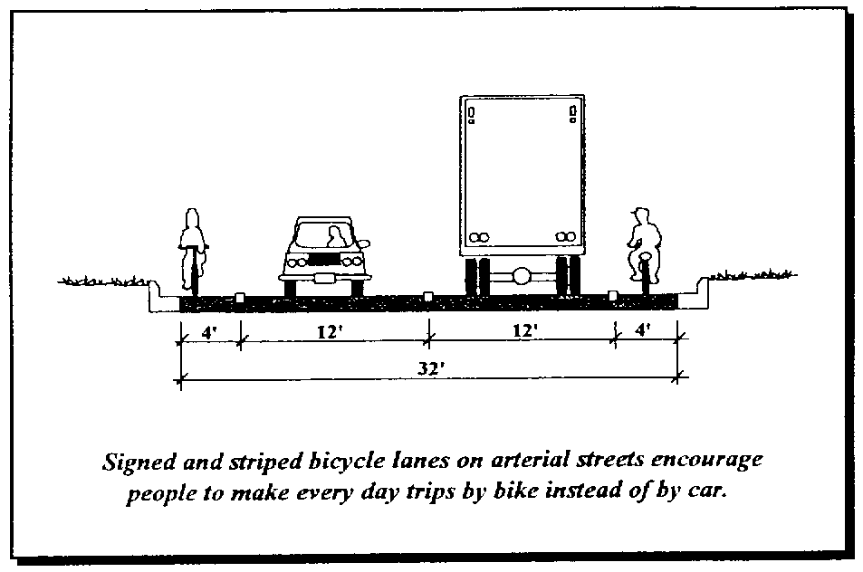
- Better mark the two County bike routes within the City limits.
- Encourage the provision of on-street bicycle lanes along main highways (e.g., 22, 23, C, B).
- Establish a walking path/trail from the Montello River downtown to the Fox River.
- Repave and reestablish a walking trail along Sunset Drive and consider nominating this road to the State’s “Rustic Road” program, which would place it on State maps as a tourist destination.
- Work with Marquette County to designate an-off street pedestrian path from the Andrew Krakow Public Access and Fishery Area to the vacant parcel acquired by Marquette County in 2016 for recreational purposes.
- Ensure adequate downtown parking and off-street parking for new developments to alleviate congestion of public rights-of-way, particularly in the City’s downtown area. The City will continue to explore behind-building and other common parking opportunities downtown.
- Monitor and participate in pending Statewide long-range plans for highways, local roads, air, water, rail, bicycle, pedestrian, and transit systems. Ensure that the City’s preference for State Highway 22 remaining in its current location is incorporated into any long range plans or right of way preservation studies.
- Work with the Montello School District to develop a Safe Routes to School (SRTS) program. The Safe Routes to School program encourages children to walk and bike to school by a combination of infrastructure and social incentives. SRTS programs can promote a healthier lifestyle for school aged children, improve pedestrian and cyclist safety, and reduce auto emissions near schools. Additionally, many school districts see a reduction in busing related costs after implementing a successful SRTS program.
- Coordinate with other units of government on other forms of transportation, such as rail, air, trucks, and water.
- Work with the County, State, and Regional Planning Commission to explore and, where appropriate, implement other transportation options, such as:
- A rubber-tire trolley to circulate residents and tourists around the City during the summer. Access between the downtown and lake areas would promote both as tourist/recreational venues, encourage local economic health, and provide transportation for less-mobile residents.
- Additional para-transit services for the growing elderly and disabled populations and transportation services for lower income workers. This Plan advises continuation and, if needs and funding increases, expansion of para-transit services, particularly to serve the growing elderly population. The City of Montello and Marquette County should explore the following two programs administered by WisDOT that utilize both federal and State funding to provide transportation assistance for the elderly and disabled populations:
    - Rural Transit Assistance Program (RTAP). This program provides education to individuals who provide transit service in rural areas. Scholarships for educational activities are available; however, they must be applied for a minimum of thirty days prior to the training or conference date.
    - Enhanced Mobility of Seniors and Individuals with Disabilities Program. A funding program for the purchase of vehicles and operating assistance for organizations providing transportation to the elderly and disabled. This program provides grants that cover 80% of eligible costs.
- The State also funds the Wisconsin Employment Transportation Assistance Program (WETAP). This program supports the development of transportation services to link low-income workers with jobs, training centers and childcare facilities. Applicants to the program must prepare a Regional Job Access Plan that identifies the needs for assistance. Eligible applicants include local units of government, public transit agencies, tribal organizations, non-profit agencies and metropolitan planning organizations.
- Possible bus service or other regional transportation services to Portage and Madison.
Map 5: Transportation and Community Facilities

Chapter Five: Utilities and Community Facilities
This chapter of the Plan contains background information, goals, objectives, policies and recommended programs to guide future maintenance and development of utilities and community facilities in the City.
  - Existing Utility and Community Facilities
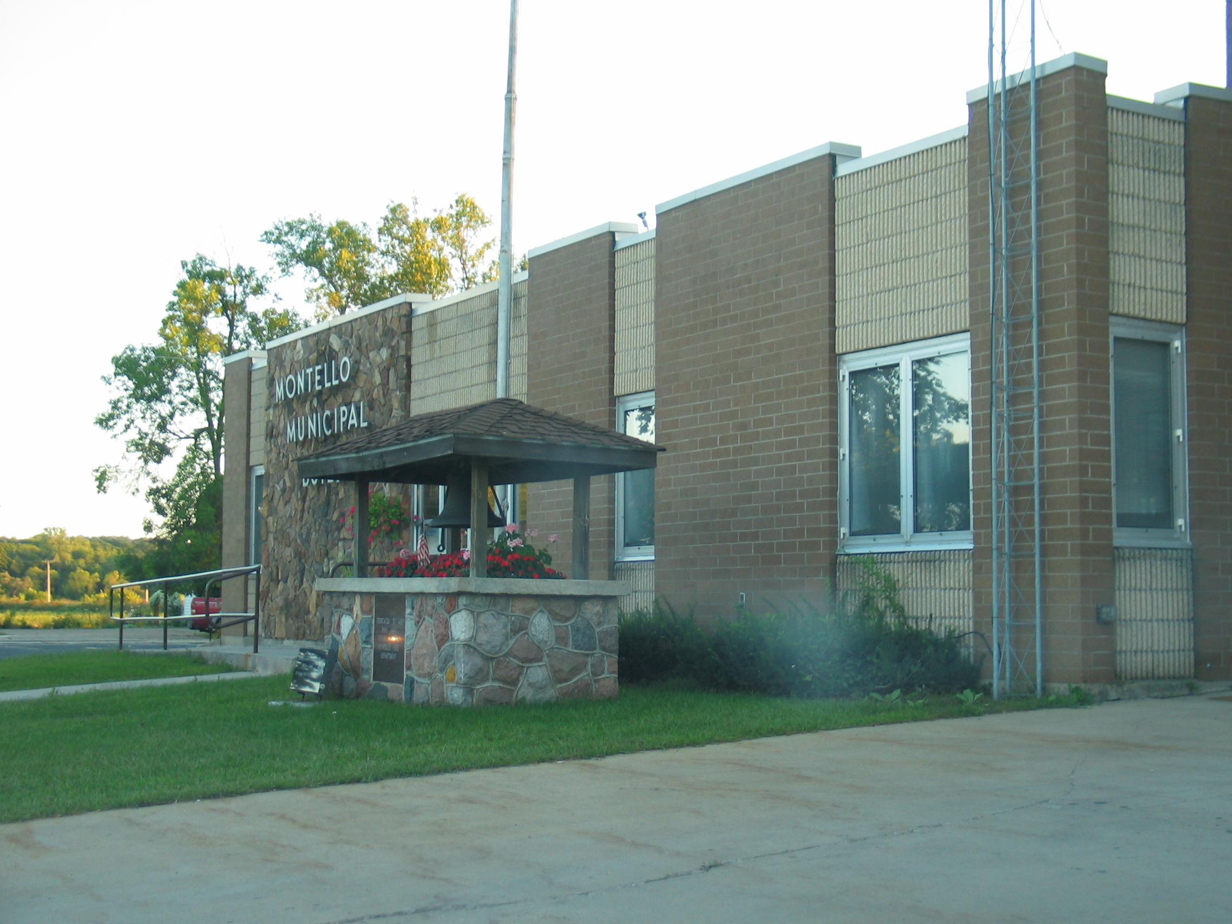
    - City Facilities
As the largest community and county seat of Marquette County, Montello has numerous outstanding facilities that serve City residents, as well as the County and region.
The joint Municipal Building, Fire Department and Police Department building is located on the western edge of downtown. The Senior Center and the Montello Public Library are also in this area. The City’s Farmers’ Market is held in the Municipal Building parking lot on Saturdays June - October.
    - County Facilities
Marquette County’s government offices operate out of several buildings in Montello; most located in the County’s courthouse building on West Park Street. Other County facilities include the Highway Department Facility, Service Center and Human Services Building along Underwood Avenue, in the Montello area.
    - Parks and Recreation Facilities
Montello has approximately 62 acres of parkland available for public use, including:
- Montello City Park, located along the east shore of Lake Montello along Doty Street (CTH Y), is the largest and most used City park. Its 22 acres include lighted softball fields, play equipment, picnic facilities, a public swimming beach, and volleyball courts. The park has two open-air shelters, a bandstand, bathroom facilities, concession area, and parking. The growth of weeds and poor water quality may compromise the swimming experience at the park.
- On the south shore of Lake Montello is Wells Point Park, a 2.4-acre site off Underwood Avenue. Picnics and fishing are common activities in this park. Fourth of July Fireworks are also displayed at this location.
- Daggett Memorial Park is a small area in the heart of downtown, overlooking the former quarry and its waterfalls—Montello’s most recognizable landmark. A green space and parking area are also maintained on the opposite side of the street.
- From the dam creating Buffalo Lake northward toward downtown is the Buffalo Lake Causeway. This park has an improved boat landing and parking area, car-trailer parking, and a road (Sunset Drive) that also serves as a bicycle and pedestrian route. There are additional public boat landings on the west shore of Lake Montello, Kilby Lake, and the Fox River.
- The efforts of the WisDNR, Marquette County, and City made possible the acquisition of the Andrew Krakow Public Access and Fishery Area, which includes 11.6 acres of parkland below the dam on Buffalo Lake and on the hillside south of the river. The Site was refurbished in 2014 and includes a dual boat launch, two ADA accessible fishing piers, fish passageway into Buffalo Lake, a canoe portage, picnic benches and chairs. In 2016, 18-acres adjacent to the Fishery Area came under the management of Marquette County for recreational purposes.
Various improvements have been suggested to existing parks. These include expanding the range of activities available to include winter sports (ice skating, snowshoeing, and cross country skiing), a splash pad, lighted basketball court, and additional youth and adult recreation programs.
Marquette County has 140 miles of designated bike routes, including two routes that begin in the City and traverse the surrounding countryside. In addition, Marquette County maintains about 100 miles of public snowmobile trails, including two routes in the City. Both types of facilities are shown on Map 5.
    - Police, Fire, Emergency, Health Care Services and Child Care Facilities
The City houses and is served by the City of Montello Police Department. The City operates a fire district with the Towns of Montello, Shields, Packwaukee, and Buffalo. Residents consider the Fire Department excellent. The Fire Station that operates out of Montello is somewhat overcrowded and could benefit from expansion. The Fire Department is well equipped – including two pump trucks, two tankers, one rescue truck, one rescue boat, one brush truck, and a 6 X 6 utility vehicle. The City, along with parts of the Towns of Montello, Shields, Mecan, Buffalo, and Packwaukee, are served by the Marquette County Emergency Medical Service. EMS operates out of the County Service Center on STH 23.
There are no major hospitals in the County; the nearest hospital is located in Portage. As of 2016, there were no childcare facilities available in Montello.
Figure 14: Fire and Ambulance District Boundaries (2004)
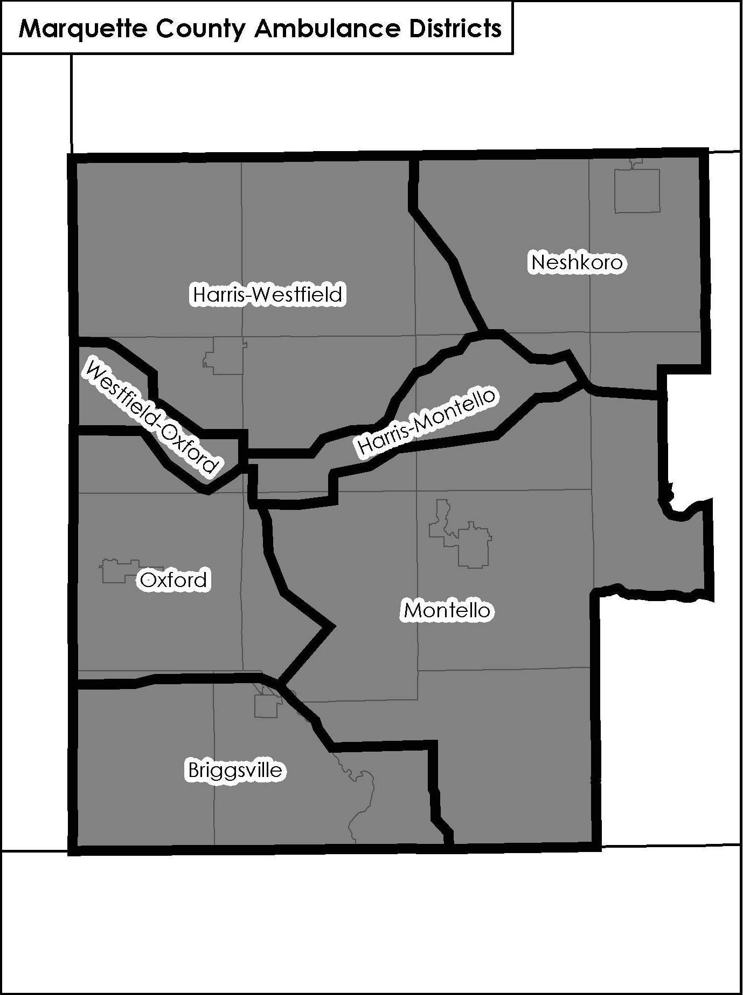
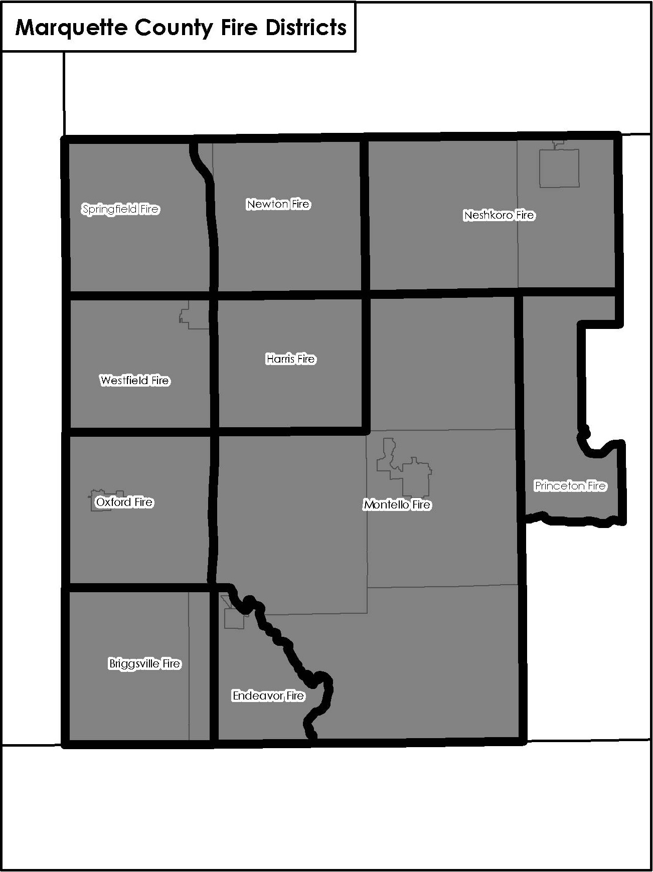
    - Schools
Students in the City are served by the Montello School District. This District serves 2,788 households and had a total K-12 enrollment of 729 students in the 2014/15 school year. Total enrollment has remained steady in the District over the past five years, ranging from 690 to 736 students. The District also serves students from the Towns of Montello, Shields, Packwaukee and Buffalo. The District’s only high school, middle school and elementary school are all located in the City of Montello. The District’s 120-acre school forest and interpretive nature trail, known as Hungary Hills, is located in the Town of Montello. The boundaries of the five school districts serving Marquette County are shown on Map 1. The following figure compares the Montello School District’s enrollment to that of the other major district in the County, the Westfield School District.
Figure 15: School District Enrollment, 2008 - 2015
 | 2008/2009 | 2009/2010 | 2010/2011 | 2011/2012 | 2012/2013 | 2013/2014 | 2014/2015
Montello School District | 736 | 699 | 690 | 700 | 713 | 719 | 729
Westfield School District | 1,208 | 1,223 | 1,142 | 1,122 | 1,105 | 1,067 | 1,079
Source: Wisconsin Department of Public Instruction, 2015
Marquette County is in the Madison Area Vocational Technical district. According to public visioning, residents desire additional local facilities for adult education and work force development.
    - Libraries
Marquette County is part of the Winnefox Regional Library System. Montello has one of six libraries in Marquette County. The others are located in the Villages of Endeavor, Oxford, Neshkoro, and Westfield and the Town of Packwaukee. These libraries have a circulation of 61,058 volumes.
    - Other Community Services and Organizations
There are several active organizations that serve the community through their activities and participation. These include the Lions organization, the Rotary Club, the Senior Citizen’s Center, and the Montello Area Chamber of Commerce. These organizations organize regular events including fundraisers, social events, and outings for all ages. The Chamber of Commerce also organizes the annual Father Marquette Days, a one-day celebration of the area’s heritage and Fish-n-Fun, a three-day spring festival. The Rotary Club is the official sponsor of the City’s Fourth of July celebration. The Montello Senior Center organizes holiday parties, monthly potlucks and other social events.
The above organizations could be utilized to help create generational partnerships within the community, and design programs that link the City’s youth to its senior citizens. In addition, according to visioning efforts new methods of outreach to Montello’s citizens are needed. Potential methods include greater use of the City’s website and community calendar.
    - Water Supply
The City of Montello has the only public water system in the County, serving about 710 addresses. The municipal system includes one water tower and two active wells located on the north side of the City that pump, on average, 162 thousand gallons per day. The water system has remaining capacity; however, there are concerns as to how to cost effectively extend the public water system to certain parts of the City.
The Montello Water Department conducts routine testing for contaminants in the City’s water supply. Microbiological, inorganic, or radioactive contaminants are within acceptable levels.
    - Wastewater Treatment Facilities
Montello’s municipal sewer system serves most of the City, with the exception of the north and west sides, along STH 22 and CTH B. About 30 percent of sanitary sewer main lines were replaced in the early 2000s. Effluent from the wastewater treatment plant, located at the southeast edge of the City, is discharged to the Fox River. Although there are not plans for expansion at this time, there is the potential for extending the sewer lines. There are challenges associated with serving the western part of the City. Extension is constrained by physical limitations such as gravity flow and the distance to existing sewer lines, as well as related financial limitations.
The City of Montello’s waste water treatment system has a designed capacity of 600,000 gallons per day, as of 2016, the City was operating at less than a 1/3 of total capacity, therefore the City has ample existing capacity to serve intensive land uses and an expanded area.
Properties not connected to the Montello municipal sewer system are served by private on-site wastewater (septic) disposal systems, including some lots on East Water and West Water Streets, and west of CTH B. There are concerns that older septic systems in the Montello area may contribute to the deterioration of groundwater and surface water quality over time. These on-site systems, generally discharge the wastewater to underground drainage fields. The County regulates septic systems through authority granted by the State, through the Wisconsin Department of Safety and Professional Services.
    - Telecommunications
Local telephone and Internet service in Montello is provided by Frontier Communications and the Marquette-Adams Telephone Cooperative. There is also a wireless Internet provider. As of July 2016, Charter Spectrum will also provide telephone, Internet, and cable television services. There are multiple cell towers located in Marquette County and the City of Montello. The City Water Tower and County Courthouse have attached cell towers.
    - Electric Generation and Power Distribution Systems
Alliant Energy and the Adams-Columbia Co-op provide the City of Montello’s electric services. There are two hydropower electrical generating facilities in Marquette County; one in the City of Montello and one in the Village of Neshkoro. There are no major transmission lines running through the Montello area.
    - Recycling Facilities
The County adopted its Recycling Plan in 1991 to establish a framework for the development of an effective recycling program to serve the entire County. There is a collection facility at the north edge of the City off Fern Avenue, formerly a landfill. Trash and recyclables are collected weekly in the City.
    - Cemeteries
There are four cemeteries located in the Montello area; one of these is located within the City limits.

Utilities and Community Facilities Goals, Objectives, Policies & Programs

Goal: Preserve the City’s sense of community and quality of life through maintaining and enhancing access to public services and facilities.

Goal: Coordinate utility and community facility systems planning with land use, transportation, natural resource, and recreation planning.

Objectives:
- Ensure that basic public services such as adequate police and fire protection, streets, sanitary sewer and water services, and education are made available to all residents.
- Provide quality, accessible park, recreation, library, and open space facilities and services to meet the needs of all age groups in Montello.
- Encourage logical, cost-efficient expansions and upgrades to public sanitary sewer and water systems to serve compact future development patterns.
- Maximize the use of existing utilities and facilities within the City, and plan for an orderly extension of municipal utilities and facilities in the planned growth areas (shown on Map 4).
- Work with community groups and other governments to provide shared and private services.

Policies and Programs:
- Prepare and annually update a 3 to 5-year capital improvement program to set priorities for competing public facility needs. This type of mid-range facility planning effort can help avoid large fluctuations in budgets on a year-to-year basis.
- Expand the City’s municipal water system and rehabilitate and expand the City’s wastewater treatment systems facility to accommodate needs within the City as a first priority. Carefully plan expansions of these systems to planned growth areas in and around the City.
- Thoughtfully plan for extensions of the sanitary sewer and water system to serve new development areas and areas of existing development that may require such services. The Montello area will continue to experiences conversions of seasonal to year-round homes, increasing housing density, and failure of septic systems. Extension of the sanitary sewer system to existing rural development areas on Buffalo, Montello, and White Lakes may be warranted in the future. It is the City of Montello’s policy to only serve areas within the City’s municipal boundary.
- Work with the Town to coordinate future land development with planned improvements to the public sanitary sewer and water system, guiding urban development into areas with public sanitary sewer and public water close to the City. This includes residential, commercial and industrial uses planned for the south, west and east sides of the City. This approach will maximize the considerable investment that has already been made into public utilities and result in more compact, higher value commercial and industrial uses. The Town and City could address the future development of the planned residential, commercial and industrial area near the City’s boundaries, and associated utility extension and municipal boundary issues, through an intergovernmental agreement. An intergovernmental agreement is addressed more comprehensively in the Intergovernmental Cooperation Chapter. At a minimum, the City is required to share a portion of the property tax revenues generated from any areas annexed from the Town for a period of five years, unless other previously agreed upon arrangements apply.
- Explore avenues to assure a high-quality and abundant supply of groundwater, such as:
- Working to cleanup and promote the cleanup of contaminated sites (brownfields) in the City.
- Developing contamination contingency plans for accidental spills. Wisconsin statutes require that spills of hazardous materials be immediately reported and cleaned up to protect the State’s citizens and resources. WisDNR Regional Spill coordinators work with local emergency planning agencies and fire departments on spill response issues. This issue is particularly relevant to the City given the presence of two State highways.
- Minimizing unnecessary impervious surfaces and promote water infiltration (e.g., stormwater basins, drainage swales).
- Locating and managing snow and salt storage areas to avoid groundwater and stream pollution.
- Expand and rehabilitate the City’s storm sewer system to better address area wide and localized flooding issues and promote water quality improvements in the area’s lakes and rivers. Areas of concern are primarily associated with Wisconsin State Highways, where storm sewer infrastructure is generally improved as part of a greater highway reconstruction project.
- Investigate potential grant opportunities to assist with the costs associated with providing community facilities in the City of Montello, such as the Wisconsin DNR Clean Water Fund which provides cost share assistance to communities seeking to improve their wastewater treatment or stormwater systems.
- Encourage erosion control practices during private development site construction and ongoing stormwater management after construction for subdivisions and other larger projects to protect water quality and prevent flooding. Progressive stormwater management practices, such as infiltration and retention ponds, should be incorporated into development proposals to address the water quantity impacts to area waterways and “downstream” property owners. Post-development stormwater run-off should not exceed pre-development conditions.
- Work with the County and neighboring communities on new or extended joint service agreements to consolidate and coordinate services, achieve better services, and/or achieve cost savings. These types of agreements are particularly important in the current era of diminishing government financial resources. Current agreements related to fire and EMS services will need to periodically reviewed and renewed. In addition, the City should work with the other communities in the Montello Fire District on long-range space options for the Fire Department.
Importance of Local Schools
The Montello School District, similar to many other rural Wisconsin districts, is facing budgetary difficulty. Retaining local schools is important on a multitude of levels, not just in providing a quality education for area children but also in the long term viability of the City itself. Potential impacts of closing and/or consolidating schools include:
- Increased transportation costs associated with a greater number of students using busing services and traveling longer distances.
- Decrease in the ability of students to participate in extra-curricular activities due to distance from school and additional time spent in transit.
- Potential decrease in housing values. Bogart and Cromwell in the March 2000 Journal of Urban Economics, found that in the decade following a school closure in Shaker Heights, Ohio residential property values decreased by 9.9%.
- Property owner preference for nearby schools. A 2008 study by the National Realtor’s Association found that 21% of homebuyers listed proximity to local schools as a motivating factor when purchasing their home.

- Enhance and improve the City’s park and recreation system by:
- Planning for new neighborhood parks in conjunction with new subdivision developments. In general, park siting should provide for a combination of active and passive features in the same park. Where possible, neighborhood parks should locate adjacent to environmental corridors (which ultimately may include trails). All residents should generally be within a 10-minute walk (at most ½ mile) from a neighborhood park.
- Requiring parkland dedication with new subdivisions.
- Enhancing public boat landings to ensure adequate public access to the Lake Montello and Buffalo Lake for recreational activities.
- Creating a trail connecting the Montello River to the Fox River, running through the downtown area. Apply for State or federal grants for this project.
- Continue to participate in Marquette County’s Outdoor Recreation Planning Process, which will enable the City to obtain State and federal recreation grants for park improvements and land acquisition projects. The County’s Outdoor Recreation Plan is updated every five years, with the next update scheduled for 2021.
- Possibly through the County’s Outdoor Recreation Plan update, plan for more “lifetime” recreational activities and winter recreational programs and facilities to serve the recreational needs and desires of all Montello residents. Particular focus should be on facilities and programs for youths and seniors.
- Exploring, ideally through the Outdoor Recreation Plan process, additional recreational facilities for which interests were expressed through the planning process, including a lighted basketball court, a municipal swimming pool, and additional lake access.
- Retain and Improve Montello Schools. The Montello School District has confronted declining funding over the past decade or two. This should be a major concern for the City of Montello, as a vicious cycle may result. It is increasingly difficult to retain and attract young families, businesses and other desirable economic development without healthy local schools. In addition, local schools are important to community identity. Schools serve to define a community’s character and result in a sense of pride and optimism. Integrating social and community activities into schools serves a variety of groups in a community. While municipal government is not directly involved in public education, maintaining primary and secondary education is critical to the City’s future. Therefore, the City encourages appropriate investment in the Montello School District, and primary and secondary education.
- Incorporate standards for telecommunications facility siting (e.g., cell towers) in a zoning ordinance update to supports co-location of multiple antennas on a single tower and the use of alternative support structures in locations that are favorable to preserving the City’s character. Support equipment and the base of the tower should be fully screened from adjacent properties and public roads, with fencing or evergreen vegetation.
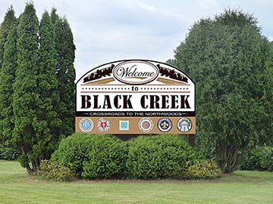
- Expand the City’s digital presence, including further development of the City’s website, and use of social media (such as Facebook and Twitter). Expanded use of digital media will facilitate communication with City visitors, businesses and residents.
- Work on efforts to brand the City of Montello. The City will consider development of a City logo to be used on the City’s website and other official communication. The City will also consider construction of signs at the main entrances to the City to identify municipal boundaries and foster a sense of community. The City of Montello will contemplate using the widely recognized granite falls at Daggett Park as a visual foundation for these branding and marketing efforts.
Community signs, such as the one depicted above, can help foster a sense of community identity and identify municipal boundaries to visitors
- Continue to cooperate with and rely on the broader region to ensure that City residents have all the necessary services, including health and child care, police, fire and rescue, libraries, cemeteries, and other government facilities.
- Stay informed on any plans by the American Transmission Company (ATC) related to the placement of power lines and substations in the City. Because new transmission lines are costly to build and difficult to site, energy providers are increasingly looking to increase capacity along existing routes. This Plan promotes “corridor sharing” or the use of a transmission lines existing right-of-way for other facilities. Corridor sharing reduces the impact by locating linear land uses together, and minimizes the amount of land affected by new easements. It also reduces the proliferation of corridors and easements such as roads, pipelines, power lines, and other linear features.
- Generally follow the timetable shown in Figure 16 to create, expand or rehabilitate community facilities and utilities.
- Consider a cooperative effort with the Town on the collection of refuse/waste and recyclables.
Figure 16: Timetable to Improve or Enhance Utilities and Facilities
Utility or Facility | Comments | Timeframe for Improvements
Capital Improvement Program | Prepare and update 3-5 year Capital Improvements program annually. | Beginning as part of the 2017 budget process
Water Supply | Expand and rehabilitate the City’s municipal water system in coordination with the Capital Improvement Program | Ongoing
 | Coordinate with the Town on expansions to the municipal water system as need dictates. | Ongoing
Sanitary Sewer | Upgrade and expand sewer lines and treatment plant as need dictates, in coordination with a 5-year Capital Improvement Program and Capacity Management Operations Maintenance (CMOM) Plan. | Ongoing
 | Study and explore funding sources for sanitary sewer extension within the City. | Ongoing
 | Study extension of sewer service to the White Lake area. | Ongoing
 | Explore, in cooperation with the Town, other sewer line extensions to rural development in and near the City, such as along Buffalo Lake or Lake Montello, or to the area northwest of the City. | As needed
Solid Waste Disposal and Recycling | Continue current system for solid waste disposal and recycling. Consider cooperative/joint service agreement with the town. | 2016-2036
Stormwater Management | Study and explore funding possibilities for storm sewer improvements within the City. | As needed
 | Ensure that subdivision and zoning ordinances contain adequate erosion control and stormwater management standards for new subdivisions. | 2017-2018
 | Expand and rehabilitate stormwater management facilities as programmed Capital Improvements. | Ongoing
Police Protection | Services and facilities are adequate to serve City in the planning period. | N/A
Fire Protection and EMS Services | Explore with other communities in the Montello Fire District the potential need for additional space for the Department; occasional equipment upgrades will also be needed. | Ongoing
 | Work with Marquette County to evaluate the current provision of EMS service within the County. | 2016-2017
Schools | Keep informed on school district decision making and maintain lines of communication with the school district. | 2016-2036
Park & Recreation  Facilities | Continue to participate in Marquette County’s Outdoor Recreation Planning Processes. | 2021-2036
 | Work with Marquette County and the WisDNR to develop and implement a Plan for the newly acquired County recreation property in the City. | 2017-2018
Telecommunication  Facilities | Include updated telecommunications facilities siting standards in City zoning ordinance. | 2017-2018
 | Expand the City’s social media presence and increase use of the City’s website to communicate with visitors as well as existing and potential residents. | Ongoing
 | Enhance the City’s identity by developing a City logo and identification signage. | 2018-2020
Cemeteries | No present need to identify future sites or expansions. | N/A

Chapter Six: Housing & Neighborhood Development
This chapter contains a compilation of background information, goal, objectives, policies and recommended programs aimed at providing an adequate housing supply that meets existing and forecasted housing demand in the City of Montello. It also provides recommendations for future neighborhood development.
  - Existing Housing Framework
    - Housing Age and Structural Characteristics
There were 788 housing units in the City of Montello, according to the 2010-2014 U.S. Census American Community Survey. As shown in Figure 17, the City’s housing stock is predominately single-family homes (71 percent). This proportion of single-family homes is less than the County (83 percent) as a whole and higher than that of the State (67 percent). The City has a higher rate of single-family homes than the Village of Westfield (65 percent), but lower than that of Endeavor (84 percent).
According to the 1990, 2000, and 2010 Censuses, the number of housing units actually decreased during this period, although participants in the planning process have observed differently. A slight increase in the number of single and multi family homes was offset by a decrease in the number of mobile homes and trailers. This decrease may be attributed to differences in the way mobile homes and trailers were counted. In addition, local acceptance of older, more traditional mobile homes has diminished over this period. Another trend is the conversion of housing structures to businesses.
According to State Department of Administration estimates, Marquette County added about 120 new units per year in the early 2000s. The economic recession of the late 2000s to early 2010s significantly slowed housing growth. Between the 2010 Census and 2013, the Department of Administration estimates that the County added an average of less than 20 new housing units per year. Much of this growth has been occurring in towns.
Figure 17: Housing Types: 2000- 2014
Units per Structure | 2000 Units | 2000% | 2014 Units | 2014%
Single Family | 652 | 73% | 559 | 71%
Two Family (Duplex) | 17 | 2% | 18 | 2%
Multi-Family | 183 | 21% | 159 | 20%
Mobile Home | 41 | 5% | 52 | 7%
Total | 893 | 100% | 788 | 100%
Source: U.S. Census of Population and Housing, 2000, 2010-2014 5-Year American Community Survey
Figure 18 compares other 2014 housing stock characteristics for the City of Montello with the surrounding Town, Marquette County and the State. The median value of owner-occupied housing in the City has increased substantially over the last decade from $78,900 in 2000 to $111,200 in 2014.

Figure 18: Comparison of Housing Stock Characteristics - 2014
 | City of  Montello | Town of Montello | Marquette County | Wisconsin
Total Housing Units | 788 | 806 | 9,887 | 2,635,602
Occupancy Rate | 81% | 61% | 64% | 87%
% Owner Occupied | 63% | 86% | 81% | 68%
Median Gross Rent (monthly) | $531 | $767 | $728 | $772
Median Housing Value/Owner Occ. | $111,200 | $161,000 | $139,500 | $165,900
Source: U.S. Census Bureau, 2010-2014 5-Year American Community Survey
    - Housing Age and Structural Characteristics
The overall condition of housing can be generally assessed through census data, including structural age, presence of complete plumbing facilities, and overcrowding. Figure 19 illustrates the age of Montello’s housing stock based on 2010-2014 American Community Survey data. Over one-third of the City’s homes were constructed before 1939. Homes built before 1959 (well over 50 percent of the City’s housing units) are probably in the greatest need of upgrading of major mechanicals, appliances, and components like re-roofing. This could increase the interest in housing rehabilitation resources. Residents do note that there is a need for housing repair, renovation and general cleanup of housing stock. The City has a number of granite houses that add architectural interest and reflect the history of granite excavation in the area.
Figure 19: Age of City of Montello Housing
As a Percent of the Total 2014 Housing Stock

    - Special Needs Housing
Special needs or subsidized housing is for individuals requiring housing assistance or housing designed to accommodate financial difficulties, disabilities, age, domestic violence situations, or drug abuse problems. Several governmental, private and nonprofit agencies provide some form of housing assistance to meet these types of situations. According to the Wisconsin Housing and Economic Development Authority (WHEDA), there were four federally assisted facilities in the City in 2016. These four facilities include Granite Hills Manor, Montello Senior Village, Montello Senior Village-Fox River and Granite City Heights, which cumulatively provide 36 housing units for low income and/or elderly residents. In addition, the Lake County Senior Village was annexed to the City in the early 2000s. Residents consider the City’s stock of new and affordable senior housing to be a benefit to the community.
    - Housing Needs Analysis
The relationship between housing costs and household incomes is an indicator of housing affordability, gauged by the proportion of household income spent for rent or home ownership costs. The national standard for determining whether rent or home ownership costs comprise a disproportionate share of income is set at 30 percent of gross household income. Households spending more than 30 percent of their income for housing may be at risk of losing their housing should they be confronted with unemployment, unexpected bills, or other unexpected events. Data from the U.S. Census Bureau 2010-2014 American Community Survey indicates that 28% of City homeowners pay greater than 30% of their income towards housing costs and 38% of renters in the City of Montello pay greater than 30% of their income towards housing costs
There are certain areas in the City where residents have identified a priority for new housing development. These include the area between CTH B and STH 23, B and 11th Road, as well as the old high school, and other vacant or underutilized parcels.
    - Housing Programs
The following housing programs are available to homeowners and renters in the City of Montello:
- WHEDA Programs. WHEDA administers a variety of programs designed to assist moderate and low-income homeowners and renters. WHEDA programs also encourage the development of affordable and low-income multiple-family housing by providing private investors with income tax credits when they invest in these types of housing developments. Tax credits are allocated to housing projects on a competitive basis. Local government support is an important factor in the award of tax credits. WHEDA also administers a property tax deferral program, which provides loans to low- and moderate-income elderly homeowners to help pay local property taxes, so that the elderly can afford to stay in their homes. The WHEDA web site contains the most up-to-date information on available programs.
- CAP Services Programs. CAP Services is a regional provider of business, housing and social services and administers a financial assistance program for first-time homebuyers. It provides matching funds to low-and moderate-income first-time homebuyers for down payment and closing costs. CAP Services also provides housing rehabilitation and weatherization for owner-occupied and rental housing.
- Housing Cost Reduction Initiative (HCRI). This State administered program provides funding to local public and non-profit agencies throughout Wisconsin to reduce housing costs for low- and moderate-income households. Funds are administered through a competitive application process. Eligible activities include down payment assistance, foreclosure prevention measures (mortgage and property tax payments), emergency rental aid, and related housing initiatives. Applications are typically due in February. CAP Services administers this program for Marquette County.
- Community Development Block Grant (CDBG) Program. The CDBG program provides grants for housing rehabilitation programs that primarily benefit low- and moderate-income households. Using CDBG funds, communities and counties may establish rehabilitation loans or grants to assist owner occupants with repairs. In Wisconsin, the Department of Administration’s Bureau of Housing administers the CDBG program. Any Wisconsin rural county, city, village or town with a population less than 50,000 residents is eligible to apply for grant funding. Wisconsin is divided into seven regions to ensure grant dollars are allocated equally throughout the State. Marquette County is situated in the Central Housing Region, headquartered in Mauston, WI. In 2014, the Central Housing Region received a $2,103,000 Community Development Block Grant to rehabilitate and improve housing in the region. Interest free deferred loans are available to income eligible homeowners in Marquette County to improve their homes. County landlords, providing housing to individuals meeting the grant program income requirements, are also eligible for low interest rate loans to repair and improve rental units. The 2015 maximum household income eligible was $47,100 for a family of four.
- HOME Homebuyer and Rehabilitation Program (HHR): The HHR program is intended to expand the supply of affordable housing, to very low and low income families. In Wisconsin, the Department of Administration’s Bureau of Housing administers the HOME program. Grant awards typically fund down payment and closing cost assistance for homebuyers, weatherization related repairs, and accessibility improvements. The application deadline is typically in May.
- HOME Rental Housing Development (RHD). The RHD program is a State administered program that distributes federal funds throughout the State. The RHD program targets activities to expand the rental housing market available to low and moderate-income individuals. Grants are available for acquisition rehabilitation and new construction of rental housing units. The program has first come; first serve, set aside for rural housing projects. Applications are generally due in early June.
- Downpayment Plus: This program is administered by the Wisconsin Partnership for Housing Development, Inc., and provides down payment and closing cost assistance to homebuyers who meet income guidelines and other qualifying criteria. Loans are forgivable following a five-year period of owner occupancy.
- Section 8 Program: This federal program provides rent assistance to eligible low-income families based on family size, income, and fair market rents. Typically, the tenant’s share of the rent payment does not exceed 30% of annual income.
- Wisconsin Home Energy Assistance Program (WHEAP). This State program provides payments to utility companies or individuals to help pay for home heating costs. The program is funded by both the State and federal governments, and is only available to individuals at or below 60% of the State median income. Funds are distributed through an application process, administered by Energy Services, Inc. in Montello.
- Wisconsin’s Weatherization Assistance Program. This program provides funding for energy saving improvements to homes primarily occupied by the elderly, handicapped and children under age 6. Energy audits are completed to determine what weatherization services are needed and the identified improvements are then made by agency crews and subcontractors. The Wisconsin’s Weatherization Assistance Program is also administered by Energy Services, Inc. in Montello.
- USDA Rural Development Agency Programs. This federal agency provides housing assistance in the form of low-interest loans to low-income homebuyers; and to very low-income owner occupants, to improve or repair homes, to remove health and safety hazards, or to make homes accessible to disabled household members.
- Habitat for Humanity. Habitat for Humanity offers homeownership opportunities to people of moderate or low incomes in Marquette County. Habitat asks able-bodied purchasers to help build their new home and in return participants receive low interest loans.
- Movin’ Out. Movin’ Out is a regional Community Housing Development Organization dedicated to assisting lower income individuals with disabilities find safe, affordable housing.
- U.S. Veterans Administration Programs. The VA provides low-cost loans and other housing assistance to veterans.

Housing & Neighborhood Development Goal, Objectives and Policies

Goal: Plan for neighborhoods that contain a range of housing types, densities, and costs, but which also maintain the City’s mostly single-family character.

Objectives:
- Support housing to meet the needs of persons of all income levels, age groups, and special needs.
- Encourage high quality new housing construction and maintenance of the existing housing stock.
- Make lands available for new low-income and moderate-income housing.
- Encourage neighborhood designs and locations that protect residential areas from incompatible land uses; promote connected street, path, and environmental systems; and preserve the City’s historic development character.
- Phase new residential development in a manner consistent with public facility and service capacity.

Policies and Programs:
- Plan for a sufficient supply of developable land for a range of different housing types, in areas consistent with City land use goals, and of densities and types consistent with community service and utility availability. The recommended “Planned Land Use Map” for the City of Montello (Map 4) will accommodate expected housing demand over the 20 year planning period and beyond, within a variety of residential designations. Redevelopment opportunities for housing may also be available, particularly in and near the downtown.
- Guide new housing to areas of the City with convenient access to public sanitary sewer service, municipal water, schools, parks and recreational facilities, roads, shopping, jobs, and other services.
- Promote quality neighborhood design and layout in new residential areas, updating the City’s subdivision ordinance as necessary. Within the planned residential areas shown on Map 4, the City should promote the following concepts of neighborhood design:
- Provision of sanitary sewer and water services.
- Mix of housing types, lot sizes and densities.
- Development of neighborhood focal points, such as parks.
- An interconnected network of streets sized to correspond to traffic volumes.
- Orientation to the pedestrian through sidewalks or paths.
- Using clustered development layouts where projects are adjacent to natural areas.
- Modest front yard setbacks and avoidance of “garage-scape” street appearance.
- Use of natural stormwater management to control water quality and quantity.
- Restoration of degraded environmental features, such as wetlands and stream banks.

- Encourage efforts to maintain existing housing and residential areas by:
  - Encouraging owners of historic homes or buildings to pursue State and federal programs to assist in rehabilitation efforts. See Chapter Three for more detailed recommendations related to protecting and rehabilitating historic properties.
  - Enforcing the City property maintenance code to address issues of basic house and lot maintenance, and updating it as necessary.
  - Working with the County or others to identify sources of funding to rehabilitate housing that has deteriorated.
  - Developing a program to educate City property owners and homebuilders on State and federal housing grant programs. This may include working with the Central Housing Region to disperse grant information, adding information to the City’s website, including available grant information in the building permit packet, and hosting educational events.
- Support the private market in developing rental housing, affordable housing (low and moderate income) and housing for the elderly and those with special needs. Several State and federal programs and funding sources are available to assist private developers, local governments, and residents meet housing objectives. Examples of these are described earlier in this chapter.
- Promote infill housing development and redevelopment of existing structures for housing (e.g., old school, second story space downtown). The City encourages development on vacant or under-used lots and buildings within the built-up area of Montello as a means to promote affordable housing. This Plan identifies some of these vacant or underutilized parcels inside the City limits as “Smart Growth” areas. See Chapter Four for more discussion on Smart Growth areas in Montello.
- Increase attractive housing opportunities for families by working with the private sector, Marquette County and the Central Region Housing Authority to ensure an attractive, diverse and adequate supply of housing. There is a reasonable supply of already-built single-family homes in the City of Montello. However, the older age and associated size limitations, maintenance responsibilities, and rehabilitation needs limit their appeal to families. Ideas for possible implementation include:
  - Assuring that attractive areas of the community are available for new subdivision development, and are not jeopardized through the approval of incompatible industrial and other uses nearby. There are presently limited existing lots on which to build new homes in the City.
  - Revisiting minimum lot size and subdivision design standards in zoning and subdivision ordinances to make sure they are not an impediment to new subdivisions and housing. Within publicly sewered areas, new lot sizes as small as 6,000 square feet and modest public improvement standards (e.g., drainage swales instead of curb and gutter) should be considered.
  - Exploring the various State and federal programs to assist low- and moderate-income homebuyers to build and buy new single family homes, or to assist builders to construct them. While tax incremental financing generally cannot be used to incentivize single family residences, “mixed use” and other tax incremental district options under Wisconsin law provide possibilities.
  - Considering incentives for families to build and buy new homes in the City of Montello. The City of Waterloo, Wisconsin provides $4,000 in local merchandise credits for people building new homes ($2,000 for buyers of existing homes). The City's printed “money” can be used at participating businesses to buy groceries, veterinary care, bicycles, and other goods and services.
  - Sharing information and brainstorming with regional real estate agents and builders on these and other ideas.
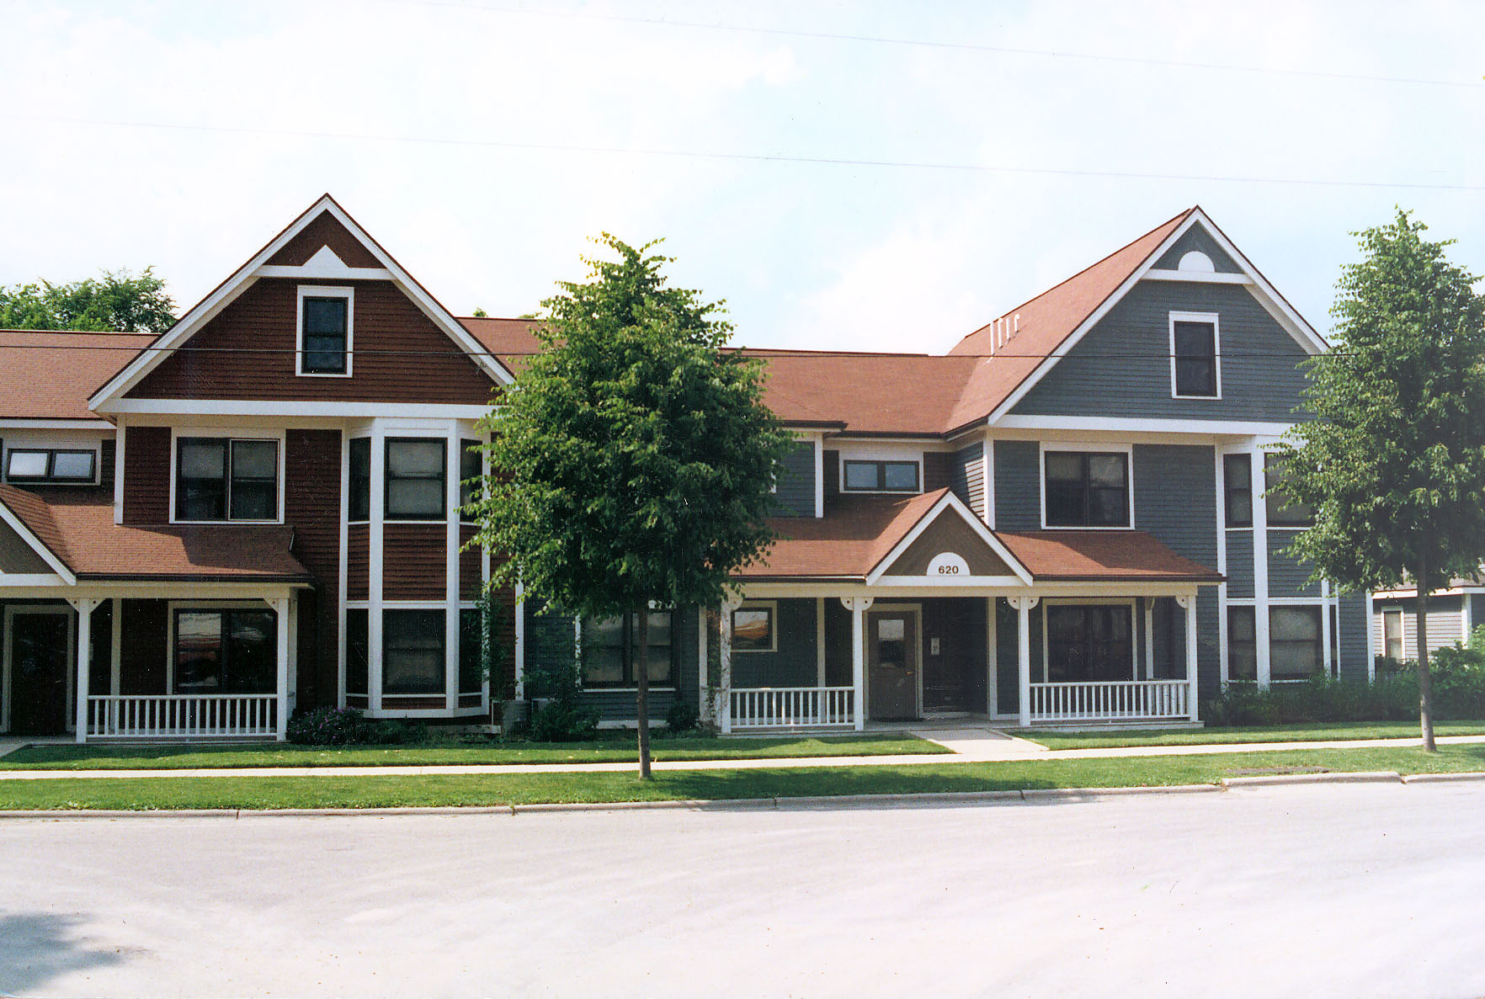
- Promote high-quality designs for multiple family developments. Multiple family housing – both affordable apartment development and higher end condominium type development - is an important component of the community to provide options for the elderly, younger residents, and employees for Montello area businesses, as well as individuals and families seeking alternatives to traditional detached single-family homes. New areas where multi-family residential development would be appropriate for the City are shown on Map 4. The design and scale of these types of residential projects should fit within the historic fabric of the community. This Plan advises that the City review proposals for multi-family residential developments against the guidelines listed below, and make sure that a new City zoning ordinance requires at least Mayor’s Planning and Advisory Committee review of such projects before they get built.
  - Incorporate architectural design that fits the context of the surrounding neighborhood, and Montello’s overall character. Encourage layouts where buildings appear as a grouping of smaller residences. Within and near the downtown, promote building materials, designs, scale, and setbacks that are compatible with the surrounding historic character.
  - Avoid monotonous facades and box-like buildings. Incorporate balconies, porches, garden walls, varied building and facade setbacks, varied roof designs, and bay windows.
  - Orient buildings to the street with modest front yard setbacks, bringing street-oriented entries close to streets to increase pedestrian activity. Include private sidewalk connections.
  - Locate parking, dumpsters, and other unattractive uses behind buildings.
  - For parking lots and garages, (a) locate garage doors and parking lots so they are not the dominant visual element; (b) screen parking areas from public view; (c) break up large parking lots with landscaped islands and similar features; (d) large parking garages are undesirable, but where necessary, break up facades with landscaping, varied facade setbacks, and recessed garage doors.
  - Provide generous landscaping of sufficient size at time of planting. Emphasize landscaping (a) along all public and private street frontages; (b) along the perimeter of all paved areas and in islands in larger parking lots; (c) along all building foundations; (d) along yards separating land uses which differ in intensity, density or character; (e) around all outdoor storage areas such as trash receptacles and recycling bins (also include screening walls in these areas).
  - Provide on-site recreational and open space areas to serve resident needs. Whenever possible, develop contiguous rear yards as a unit to encourage use by residents and guests.

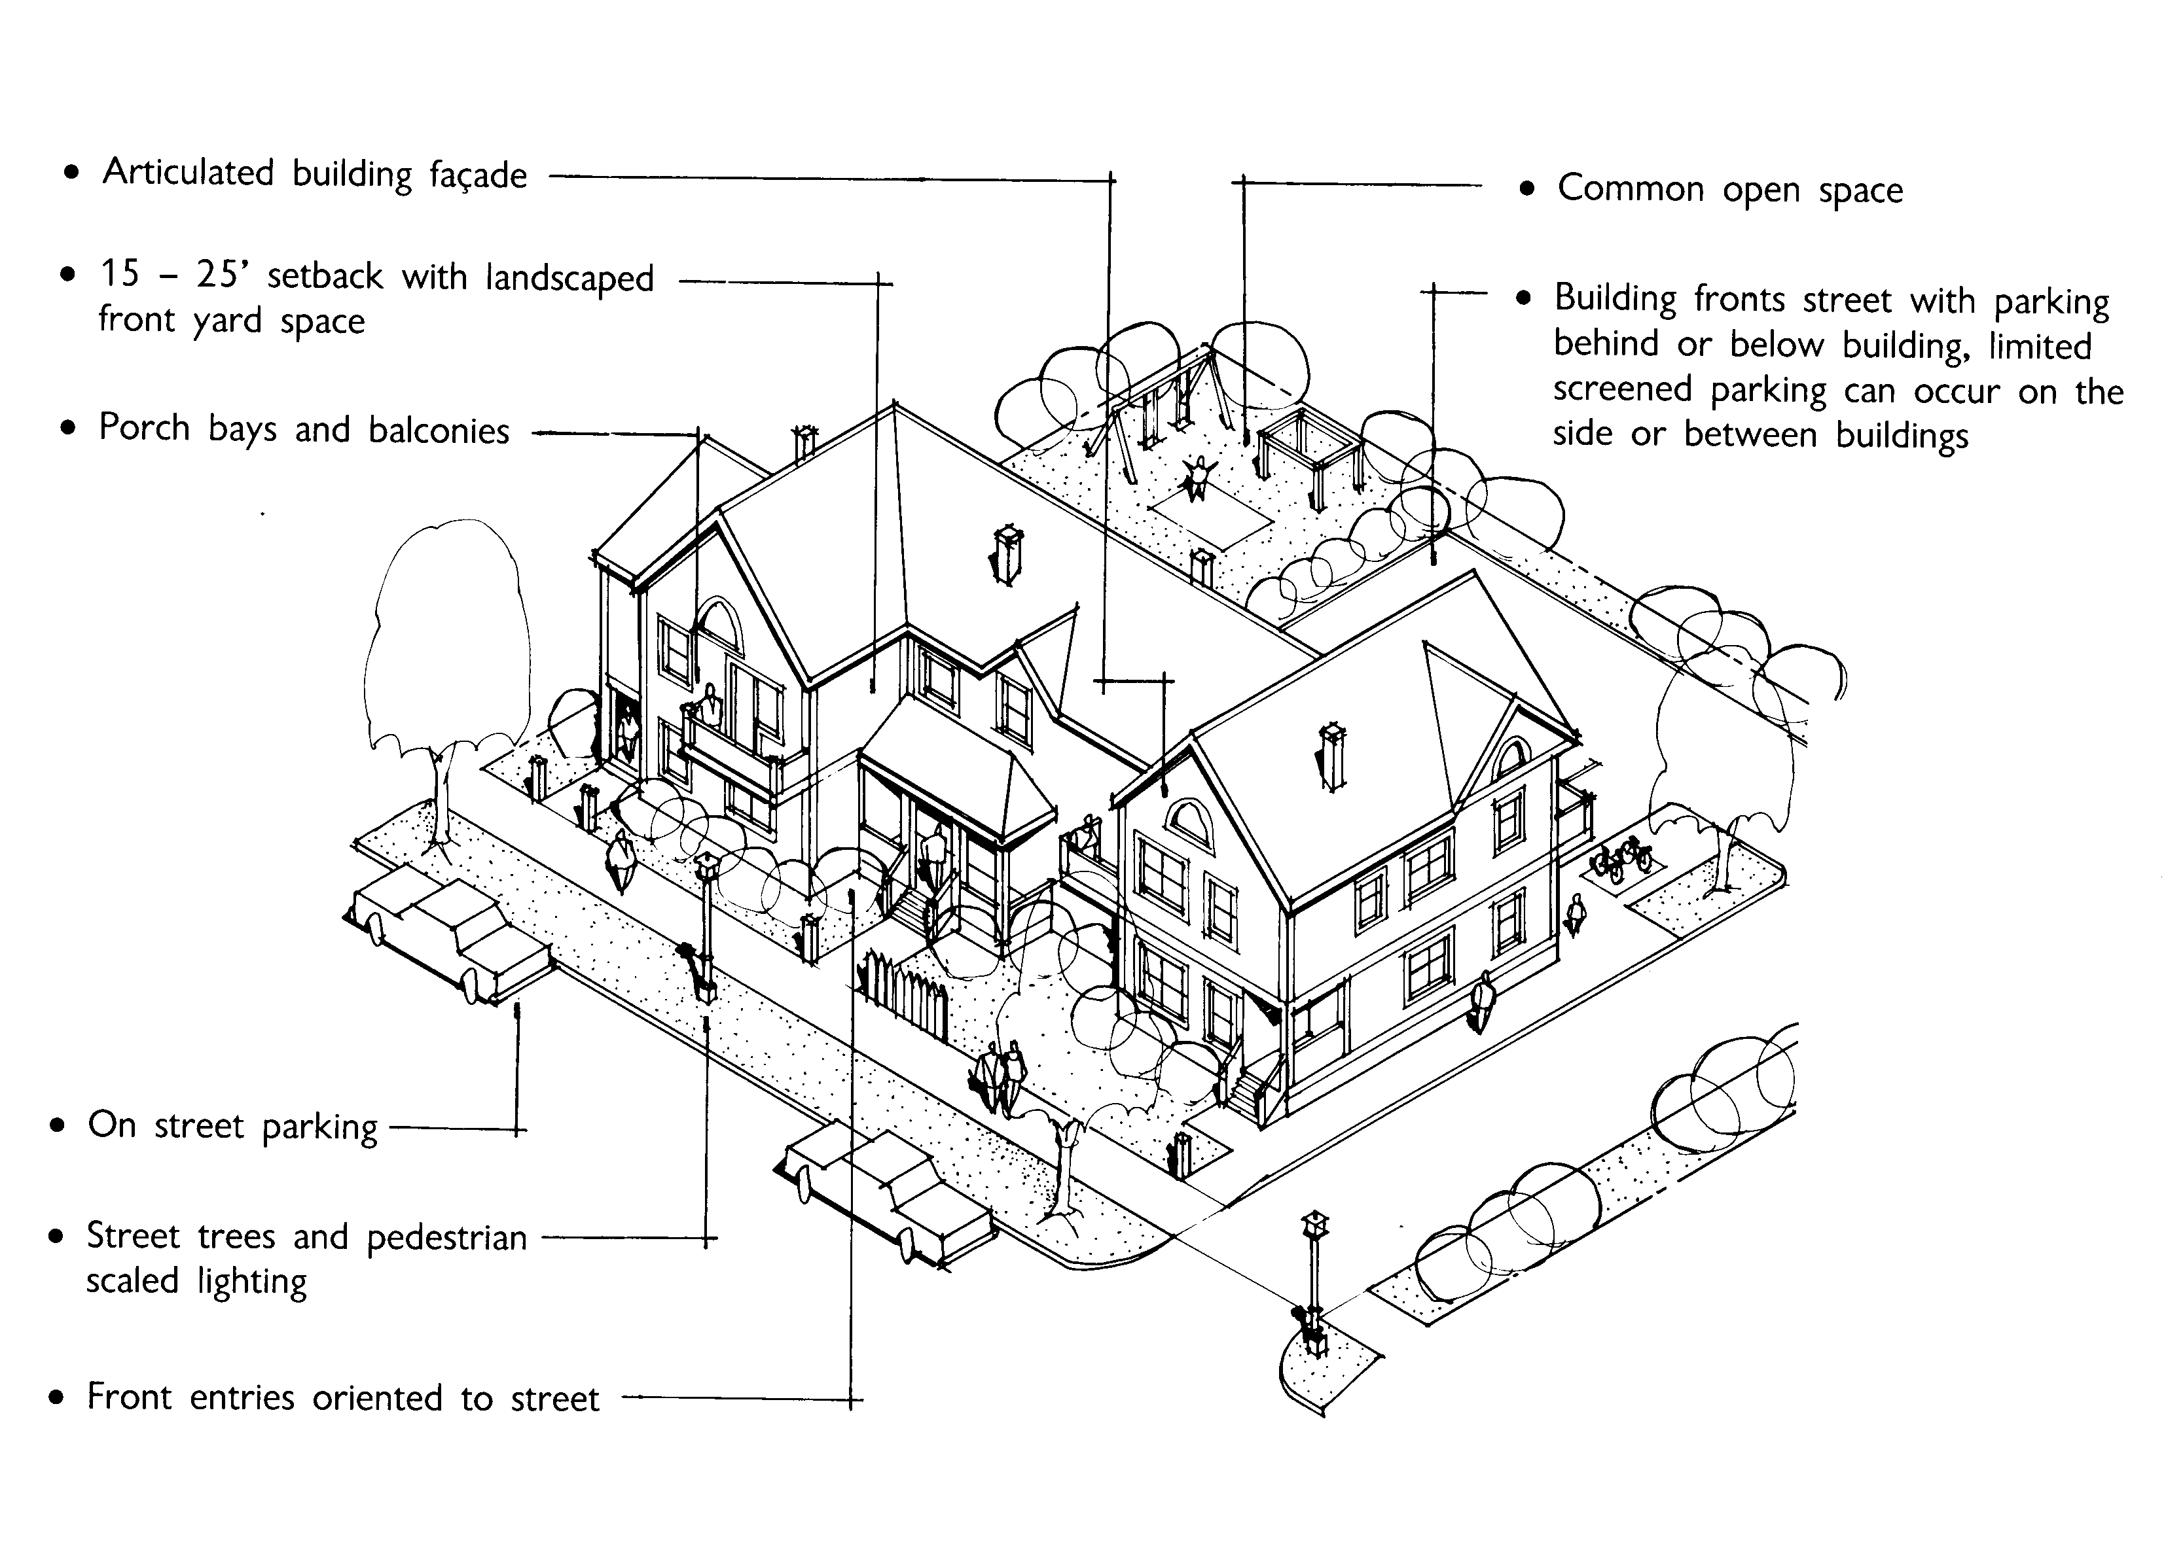

Chapter Seven: Economic Development
This chapter contains a compilation of background information, goals, objectives, policies and recommended programs to promote a strong economy in the City of Montello. This chapter includes an assessment of new businesses and industries that are desired in the City, an assessment of the City’s strengths and weaknesses, and an inventory of contaminated sites for possible redevelopment.
  - Existing Economic Development Framework
    - Labor Force Trends
A community’s labor force is the portion of the population age 16 and older that is employed or available for work. The labor force includes people who are in the armed forces, employed, unemployed, or actively seeking employment.

In 2014, the U.S. Census Bureau estimated that the City of Montello’s labor force consisted of about 730 individuals. This is a 14 percent increase in labor force numbers since 2000. Of the City’s 2014 labor force, 676 persons were employed and 54 were unemployed; resulting in an unemployment rate of approximately 4.2 percent. This is slightly less than the County (5.0 percent) and State (4.9 percent) unemployment rate.
    - Local Jobs
The major employers within Montello are Marquette County government, the Montello School District, Arimon Technology (50-99 employees), and Montello Care Center (50-99 employees).
At the County level, the number of jobs decreased 4% between 2001 to 2013. Job growth in Marquette County has been centered in the manufacturing industries. According to the State’s Department of Workforce Development (WisDWD), manufacturing employment has not been hit as hard in the early 2000s as other parts of the country because most of its products are non-durable goods (e.g., foods and kindred products) which are less prone to fluctuation in typically businesses cycles.
    - Income Data
According to 2010-2014 U.S. Census Bureau American Community Survey, the median household income in the City of Montello was $40,156. This is lower than that of the County, which was $46,875. The County ranks 46th of 72 counties in median household income and is lower than the State median household income (the State average was $52,738). Within the County, median household incomes in the 14 towns ranged from $37,500 in the Town of Shields to 57,222 in the Town of Westfield, and in the City and four villages from $33,125 in Neshkoro to $56,250 in Endeavor.
Adjusted average gross income per return as reported by the Wisconsin Department of Revenue for 2014 was $36,230 within the City of Montello.
    - Commuting Patterns
Approximately 35 percent of the City of Montello’s workforce is employed outside the County, according to the U.S. Census Bureau 2010-2014 American Community Survey. Approximately 41 percent, or 269 City of Montello residents, were also employed within the City. The mean travel time to work for the City of Montello workforce was 22.5 minutes, with over a third of City residents having a greater than 30 minute drive to work.
    - Location of Economic Development Activity
Map 3 shows the location of existing economic development activity, and Map 4 shows the location of planned economic development activity for the planning period. The economic development focus for the City is in the downtown area, the Neighborhood and General Business areas, and the planned Industrial expansion area.
    - Re-Use of Environmentally Contaminated Sites
The Wisconsin Department of Natural Resources (WisDNR) maintains the Bureau for Remediation and Redevelopment Tracking System (BRRTS)—a list of contaminated sites, or “brownfields.” The WisDNR defines brownfields as “abandoned or under-utilized commercial or industrial properties where expansion or redevelopment is hindered by real or perceived contamination.” Sites listed on the BRRTS are in “open” or “closed” status, with a closed status indicating that actions have been taken to the extent practicable to restore the environment. Examples might include a large abandoned industrial site or a small corner gas station with a leaking underground storage tank. Properties listed in the WisDNR database are self-reported, and do not necessarily represent a comprehensive listing of possible brownfields.
As of January 2016, there were 52 closed, historic, or no action required sites within the City listed in WisDNR’s system. There are two open Environmental Repair Sites in the City of Montello, one at CTH B and State Highway 23 and one on Main Street. There are three types of sites listed in the database: Spills, Leaking Underground Storage Tanks, and Environmental Repair Sites.
Brownfield redevelopment programs seek to return abandoned or underused industrial and/or commercial sites to active use through cleaning up environmental contamination and encouraging redevelopment of the sites. The Wisconsin Economic Development Corporation (WEDC) and WisDNR administer several grant programs that fund brownfields cleanup. These programs fund environmental studies that determine the nature and extent of contamination as well as remediation of contaminated sites. Additional information on the requirements a community must meet to receive these grants is available through the WEDC and WisDNR.
    - Economic Development Programs
The following economic development programs and agencies benefit, or are available to, the City or its residents:

Tri-County Regional Economic Development Corporation (TREDC)
Recognizing that individual county economic development corporations would have limited staff and financial resources, Marquette, Green Lake, and Waushara counties formed the Tri-County Regional Economic Development Corporation in 2004. Based in the Marquette County Village of Neshkoro, TREDC employs an Executive Director and oversees numerous economic development programs including a revolving loan fund, economic working groups, and business development resources. Regional economic development goals include informing the public of TREDC services, providing assistance to local businesses, developing and utilizing funding sources for economic development projects, and creating businesses and jobs which enhance tax revenues and provide employment opportunities within the Tri-County area.

Marquette County Economic Development Corporation (MCEDC)
The Marquette County Economic Development Corporation was formed in 2003 and is a “501 c3” nonprofit corporation. After creation of the TREDC, the functions and role of the MCEDC have become more limited. The MCEDC meets twice annually.

Marquette County Tourism and Visitors Bureau
The Marquette County Tourism and Visitors Bureau, formerly known as Marquette NOW, actively promotes and markets Marquette County to external visitors. The Bureau is run by a Committee comprised of representatives from UW-Extension, the three Marquette County Chamber of Commerce organizations, area resort owners, and members of local government. In addition to attending regional events to market the County, the Bureau maintains the www.travelmarquettecounty.com website, develops marketing materials, and maintains signage along I-39 promoting the County’s amenities to the traveling public.

East Central Wisconsin Regional Planning Commission (ECWRPC) Economic Development Strategy
The ECWRPC, which includes Marquette County, was designated an Economic Development District in 1984. ECWRPC is responsible for preparing various economic development strategies for the Region. These strategies are described in the 2013 Comprehensive Economic Development Strategy report, which is used to distribute Community Development Block Grants (CDBG) for designated projects in each county within the region. For example, in 1999, a grant of $835,000 was awarded to the Village of Westfield in Marquette County for various capital improvements to its Industrial Park. This project was designed to attract new jobs to the area and increase the County’s manufacturing base.

Community Assets for People (CAP)
CAP Services, Inc. is a federally designated community action agency for Marquette, Portage, Waushara, Waupaca, and Outagamie Counties. It is the only federally designated Community Development Financial Institution operating in Marquette County. CAP Services programs are designed to assist low- and moderate-income residents address the causes of poverty. Examples include below market rate loans for low to moderate income entrepreneurs wishing to start or expand a business, an income qualified first-time homebuyers program and a Head Start program to provide daycare and childcare. CAP Services manages 117,000 square feet of business incubator space in seven buildings spread across three counties. In 2013, CAP Services’ business programs helped start 13 businesses and provided 25 business loans which in turn have created 21 new living-wage jobs. Households below 80% of the County median income ($47,100 for a family of four in 2014) qualify for these programs.

Montello Area Chamber of Commerce
The Montello Area Chamber of Commerce seeks to foster economic and business success and to promote tourism in the greater Montello area. The Montello Area Chamber of Commerce sponsors regular events including the Montello Farmers’ Market, fundraisers, social events, and outings for all ages.

Wisconsin Rural Partners
Wisconsin Rural Partners (WRP) is a nonprofit organization that focuses on rural community and economic development. WRP currently serves as Wisconsin’s State rural development council. They provide a wide range of services that includes economic development workshops and education. WRP also offers follow-up assessments of a community’s progress in achieving its development goals.

United States Department of Agriculture (USDA)
The USDA provides business loans, technical assistance, distance learning, and telemedicine loans and grants to assist in developing technological and/or medical services in rural areas. The USDA also administers several broadband loan and grant programs intended to accelerate the deployment of broadband services in rural America. This includes the Community Connect grants program to fund acquisition or leasing of facilities to serve residences and businesses, as well as community access points. The nearest USDA-Rural Development Office is located in Stevens Point.

Wisconsin Economic Development Corporation (WEDC)
Formed in 2011, the WEDC administers a variety of programs for businesses, local governments, and entrepreneurs. WEDC supports community development efforts and provide financial incentives for shovel-ready projects. Grant recipients must demonstrate significant, measurable benefits in job opportunities, property values, and/or leveraged investment by local and private partners. Programs that may be of particular interest in the City of Montello include:
- Certified Sites Program. Certifying businesses, buildings, and parcels for commercial and industrial activity and eligible for additional marketing activities.
- Community Development Investment Grant. A financing program for shovel ready projects, preferably in a downtown location. There is a maximum grant award of $50,000 for planning projects and $500,000 for implementation efforts.
- Forward Community Investments Loan Program. Providing loans to non-profit organizations to improve facilities, bridge funding gaps, and expand capacity.
- Main Street Program. Wisconsin Main Street communities receive free, intensive technical assistance to develop marketing, business retention, real estate development, market analysis, and public improvement plans while honoring, and often, restoring historic downtown character.

Community Development Block Grant (CDBG) Program
The federal CDBG program provides grant-funding opportunities via the following five initiatives. These initiatives are available via the Wisconsin Department of Administration. For all five of these CDBG initiatives, any Wisconsin rural county, city, village, or town with a population less than 50,000 residents is eligible to apply for grant funding.
- Public Facilities for Economic Development. Underwrites the cost of infrastructure necessary for business development that retains or creates employment. Using these CDBG funds, local governments can make improvements to public facilities such as water systems, sewage systems and roads, which will principally result in business retention or creation. Successful applications will also need to meet a CDBG national objective. Proposals can be submitted throughout the year with funding awarded on an as needed basis.
- Public Facilities. Provides grant funds to help finance infrastructure development, community centers, fire stations, and other facilities that principally serve low and moderate-income persons. Using these CDBG funds, local governments can improve publicly owned utility systems, streets, sidewalks, handicap accessibility facilities, community centers, libraries, fire stations and medical facilities. These facilities often have a secondary economic development benefit.
- Economic Development. Provides financial assistance to local governments for business loans to expand facilities or purchase equipment, awards for specialized employee training, or business infrastructure projects. The goal is to assist local governments in lending funds to private community businesses. The application process is competitive with successful applications meeting a CDBG national objective, having a minimum 50% funding match and, identifying the private company benefiting from the program. Applications are accepted year round, with funding awarded on an as needed basis.
- Emergency Grant. Helps restore or replace critical infrastructure damaged or destroyed as a result of a natural or man-made catastrophe. Using these CDBG funds, local governments can restore or replace publicly owned utility systems, streets, sidewalks, community centers, and other community facilities.
- Planning Grant. Provides monetary assistance to local units of government for the development of community or site specific planning projects that advance decent affordable housing, a suitable living environment, and the expansion of economic opportunities, principally for the benefit of persons of low and moderate income. $25,000 awards are available for community wide initiatives and $15,000 awards are available for site-specific projects. Applications require a 50% match and need to be submitted to the Department of Administration in early June.

Workforce Development Board of South Central Wisconsin
The Workforce Development Board (WDB) of South Central Wisconsin is a 37-member board that is dedicated to developing strong community partnerships to support innovation and excellence in workforce development. The WDB serves six counties: Columbia, Dane, Dodge, Jefferson, Marquette, and Sauk Counties.

U.S. Small Business Administration
The U.S. Small Business Administration’s Certified Development Company (CDC) Loan Program provides growing businesses with long-term, fixed-rate financing for major fixed assets, such as land and buildings. 504 loans can be used to fund land purchases and improvements, grading, street improvements, utilities, parking lots and landscaping, construction of new facilities, or modernizing, renovating or converting existing facilities. There are six CDCs covering specific geographic areas in Wisconsin—the Wisconsin Business Development Finance Corporation’s office in Oshkosh serves Marquette County.

Wisconsin Public Services Commission (PSC) Broadband Expansion Grants
Administered by the PSC to improve broadband communication facilities and targeted to underserved areas.

Focus on Energy Renewable Energy Incentives for Businesses Grant Program
This program provides financial incentives to businesses to take advantage of clean, green, renewable energy, such as wind, solar, biomass, biogas, and bio-digesters. Further, the U.S. Department of Energy periodically issues competitive funding through the Energy Efficiency & Renewable Energy, Industrial Technologies Program, and other offices. The City can monitor whether any programs align with local needs or business opportunities or present partnership opportunities as they arise.
For additional information about any of the above programs, see the Marquette County Comprehensive Plan.
    - Economic Development Opportunities
The Wisconsin comprehensive planning statute requires that the Comprehensive Plan “assess categories or particular types of new businesses and industries that are desired by the local government unit.” According to public participation activities, residents agree that the City faced several economic development challenges and rate current economic opportunities as fairly poor. These included the struggles of the industrial sector, in promoting tourism, in attracting a skilled labor force, in offering competitive wages, and in encouraging young residents to stay or return to the area.
However, a number of opportunities for economic development also exist, including a high quality of life, an attractive surrounding natural environment, linkages to nearby communities and metropolitan areas, and the focus of County and City municipal functions. In addition, strengthening the downtown area through promoting infill development and cleanup of contaminated sites, improvement to the already exceptional park system, and Montello and Buffalo Lakes provide additional opportunities.
Figure 20 shows strengths and weaknesses with respect to attracting and retaining businesses and industries in the City.
Figure 20: City of Montello Strengths and Weaknesses
for Economic Development
Strengths | Weaknesses
Public facilities- school, parks, library, senior center | Lack of developable land in City limits, particularly for residential development (distant from utilities)
Montello and Buffalo Lakes as center for recreation and backdrop for commercial development; two rivers in the City | Lake water quality and cleanliness
Infill and revitalization potential of older sites & buildings | Labor force skills may be lacking for current and potential industry needs
High quality of life attractive to businesses and commuters | Aging Population
Connections to the countryside and natural resources | Not on Interstate
Existing downtown intact & with charm | Cost of development vs. expected return
Rich history | Few local economic development initiatives
Chamber of Commerce
Convergence of Highways
County seat/Center-point

Economic Development Goal, Objectives, Policies, and Programs

Goal: Be the “economic hub of Marquette County,” through job creation, downtown revitalization, and tax base increases.

Objectives:
- Promote a vital and healthy downtown through approaches like encouraging the redevelopment and reuse of vacant and / or contaminated buildings and sites, and discouraging the relocation of government buildings away from the downtown.
- Diversify economic opportunities – including encouraging more tourism, retail, commercial services, office, and industrial development in the Montello area.
- Update zoning regulations to provide appropriate commercial and industrial zoning districts based on the desired type, scale, layout, and character of different planned areas of development.
- Discourage unplanned, continuous strip commercial development, and an overabundance of competing commercial signs and billboards along major roadways.
- Capitalize on the City of Montello’s assets and comprehensive plan implementation activities to retain and attract young entrepreneurial and professional residents, including via providing attractive neighborhood environments and schools.
- Work to accommodate high quality employment opportunities in areas planned for commercial and industrial uses on Map 4.

Policies, Programs and Recommendations:
- Plan for a sufficient supply of developable land for commercial and industrial uses in areas consistent with the planned land uses shown on Map 4. Based on the analysis presented in Chapter Three, the necessary supply of land for these types of uses is sufficient and should be focused in the downtown area, in newer commercial areas near STH 22 and 23, and in an expanded industrial park in the southeast portion of the City. These areas should be planned and developed in coordination with landowners, the Town, and County. New development should be consistent with the character of the City and with service availability.
- Explore strategies to promote the downtown as a commercial, civic, and social center. The City should recognize that the health of downtown Montello impacts workforce recruitment. If the downtown is neglected, the City may miss out on opportunities for economic development.
  - Maintain and further the City’s position as the County’s government and business center. The courthouse, library, municipal building, post office, and other governmental and institutional uses will continue to bring activity to the downtown. The City should use marketing, investment, and incentive strategies to promote and retain specialty retail, financial, offices, retail, entertainment business and services.
  - Ensure adequate parking. City residents have identified a need for increased parking opportunities in the downtown area. Some areas where parking opportunities could be enhanced include the lands south of buildings lining Main Street, and in the area west of the Montello River.
The City should continue to require a site plan for most multi-family, commercial, and industrial development projects that shows the location of parking.
  - Advance downtown revitalization and redevelopment efforts. Opportunities exist to retain existing businesses, expand opportunities for local entrepreneurs, and recruit additional firms to the downtown area and other redevelopment sites, including brownfields. The following programs may be considered to advance redevelopment of the downtown, brownfields, and other underdeveloped areas of the City:
  - Establish Business Improvement District (BID). Typically, business properties included in a BID contribute to programs designed to promote, manage, maintain and develop the district. Special assessments on businesses within the BID raise the funds to implement a variety of programs to improve the district’s business climate.
  - Apply for the Wisconsin Main Street. This Wisconsin Economic Development Corporation administered program provides assistance in the form of technical support and training to help communities reinvigorate their downtown commercial districts as community and business centers. The program has a successful track record in creating new jobs and attracting businesses to downtowns.
  - Support cleanup of brownfield sites. The City should promote and require proper environmental assessment and any required cleanup before offering final approval of a development proposal on any property identified as possibly having environmental contamination. This is a critical first step in ultimately reusing brownfields. Several State and federal grant programs are available to assist with environmental assessments. After the site assessment process, the City and private property owners should prepare a unique redevelopment strategy for the site.
  - Consider a redevelopment Tax Increment Financing (TIF) district. TIF financing may be used to create incentives for downtown and other redevelopment. TIF provides up-front public expenditures for land, infrastructure for development, and other creative uses like building demolition or site cleanup. The resulting new development and investments pay for such initial expenditures over time through dedicated property tax revenue.
  - Work with the WisDNR and County to develop a trail from downtown Montello to the Andrew Krakow Public Access and Fishery Area.
- Work with the County, State, and local organizations to encourage the location of new businesses in vacant facilities, particularly in the industrial park and downtown. The UW Extension’s Center for Community Economic Development (CCED) provides assistance with market analysis, through online resources and through intensive, participatory community assessments. The phased expansion of the City’s industrial park, with consideration of incentives like TIF and close coordination with area property owners, the County EDC, the Tri-County Economic Development Corporation and the Town of Montello is also advised.
- Explore other programs for workforce development and retention, and business recruitment including many of those listed earlier in this chapter. For example, the City may:
  - Work with local businesses, governments, and educational institutions, particularly Madison Area Technical College (MATC), in an effort to retain younger workers in Marquette County. These institutions should ideally have a greater presence in the County and direct their programs to actual training needs of local workers and businesses. The types of customized programs needed in the County include computer skill training, supervisor training, and workplace safety.
  - Create partnerships between area high schools and businesses to advance youth education.
  - Working with Marquette County to develop a program to retain and attract new residents. The Marquette County Comprehensive Plan sets forth the “Marquette Life” program, which includes a multifaceted work program to market Marquette County as a desirable place to live and build connections between youth and the community to help ensure they will want to remain in Marquette County as they become adults.
- Consider strategic amendments to the zoning ordinance, particularly related to existing commercial and industrial zoning districts. The City should ensure that there are commercial and industrial districts that achieve the goals of the land use categories shown on Map 4, in particular the Neighborhood Business and Downtown planned land use categories. The zoning map should also be revised to correspond with the categories designated on Map 4 to carry out the recommendations of this Plan. Other examples of modifications to the zoning ordinance include:
  - Reconsider the minimum front yard setback of 50 feet in the B-2 zoning district to accommodate existing buildings with smaller setbacks.
  - Consider parking standards that ensure adequate parking, while avoiding more parking than needed. A typical standard is 4 or 5 spaces per 1,000 square feet of commercial space, which is well above the City’s current standard of 8 parking spaces per 1,000 square feet.
  - Require parking in the Downtown area (generally the B-1 zoning district) for uses that can provide parking.
  - Update Planned Unit Development (PUD) standards to accommodate a mixture of residential and nonresidential uses. Consider allowing PUDs as conditional uses in all zoning districts, not just residential districts as is the current rule.
  - For all multi-family residential, commercial and industrial development, include provisions in the zoning ordinance to require submittal of a site plan, landscape plan, natural features map, lighting and sign regulations, and other elements detailed in Chapter Nine.
  - Develop standards for allowing home occupations in residential zoning districts. Many businesses first begin as jobs on the side within the businesses owner’s home. Allowing home occupations in residential zoning districts is a logical step in establishing the City of Montello as a desirable place to relocate while also assisting the City’s existing entrepreneurs.
- Allowing conversion of residential structures to businesses, particularly in the area along STH 22 designated as Neighborhood Business on the planned land use map. The City should encourage measures to ensure that the residential character of the area is maintained, for instance converting the use by renovating rather than demolishing existing houses/structures.
- When reviewing applications and site plans for new commercial or industrial development projects, refer to the policies for General Business and Industrial Areas in Chapter Three and the following design standards:
  - High-quality signage treatment that is based on the area of building frontage, road frontage and façade area. The use of monument signs should be encouraged instead of pole signs.
  - Retention of existing vegetation and high quality landscaping treatment of buffer yards, street frontages, paved areas and building foundations.
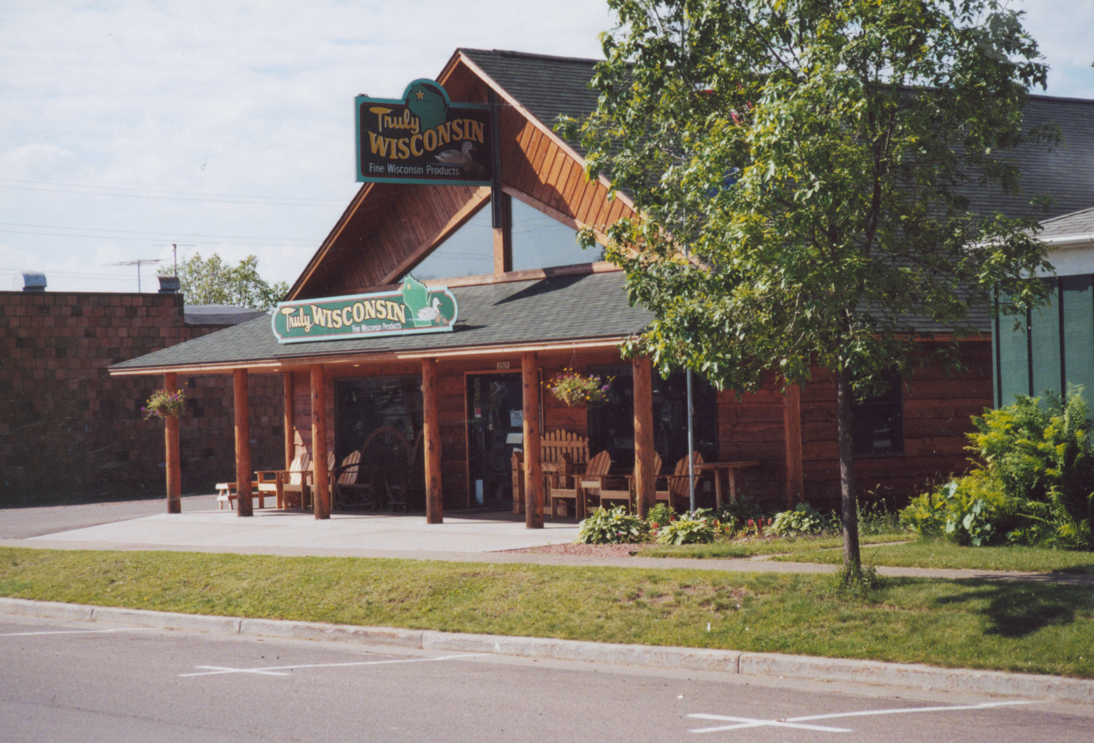
  - Intensive activity areas such as service and loading areas, parking lots, and trash receptacle storage areas oriented to the rear of the building and away from less intensive land uses.
  - Parking lots landscaped with perimeter landscaping and/or landscaped islands, along with screening (hedges, berms, trees, and decorative walls) to limit views from streets and adjacent residential uses.
  - Parking to the sides and rear of buildings wherever possible, rather than having all parking in the front.
  - Interconnected parking lots and driveways to facilitate on-site movement.
  - Location of loading docks, dumpsters, mechanical equipment, and outdoor storage areas behind buildings and complete screening through use of landscaping, walls, and architectural features.
  - Screening where industrial uses abut non-industrial uses, in the form of hedges, evergreen trees, berms, decorative fences or a combination.
  - Limited use of chain-link and other non-decorative fencing.
  - Illumination from lighting kept on site through use of cut-off and downward facing fixtures.
  - High-quality building materials and architectural details, such as canopies, awnings, trellises, bays, windows, and variations in building height and rooflines.
- Work with the Town to promote and diversify economic opportunities for the greater Montello area, including directing large-scale commercial and industrial uses into the City of Montello, where public sewer and water services are available, and police, fire, and other services are closer. The City and Town might consider several tools to work cooperatively on accommodating such development, including boundary agreements and possibly revenue sharing. These are discussed in more detail in Chapter Eight, Intergovernmental Cooperation, and Chapter Nine, Implementation.
- Cooperate in a Countywide effort to create a balanced rural economy. The City and surrounding area’s natural resources provide opportunities for production, tourism, and other nature-based economic development activities. The City should work with the County’s EDC and the neighboring Town of Montello to seek economic development strategies that capitalize on the area’s natural resource base, such as:
  - Encouraging businesses that cater to natural resource recreation or outdoors enthusiasts in the downtown area. These would include outfitters, nature-based shops, and restaurants, cafes, accommodations and other businesses catering to tourism.
  - Promoting industrial development and downtown revitalization.
  - Considering ways to promote and market farm products and agriculture-related activities, such as seminars, markets, farm days, and festivals.

Chapter Eight: Intergovernmental Cooperation
This chapter contains a compilation of background information, goals, objectives, policies and recommended programs for joint planning and decision making with other jurisdictions.
  - Existing Regional Framework
The following is a brief description of the governmental framework for the City of Montello and its relationship to neighboring local units of government, Marquette County, and other regional and State jurisdictions operating within or adjacent to the City. Map 1 shows the boundaries of the various jurisdictions in the region.
    - City of Montello
The City of Montello is the county seat of Marquette County. Montello grew about 7 percent between 2000 and 2010 and its estimated 2015 population was 1,475. The City updated this Plan in 2016, to include updated demographic and grant information. The initial City of Montello Comprehensive Plan was prepared in the early 2000s in coordination with Marquette County and local communities under the Smart Growth Planning Grant program. The City has zoning and subdivision ordinances to regulate land use. At the time this Plan was written, the City was not party to any plans or agreement under §66.0307 or §66.0309, Wisconsin Statutes. The City is party to general cooperative agreements for fire, rescue, and other services with neighboring Towns, or the County under §66.0301.
    - Town of Montello
The City of Montello and Town of Montello have a very close historical arrangement. This has carried forward to the present day with shared services, schools, shopping areas, lakes, and other community features. Clearly, most residents of the Town and City consider themselves to be part of the “Montello Community.”
Intergovernmental cooperation is a keystone element of the City of Montello’s planning process. Montello and Marquette County’s other towns and villages not only share common boundaries, but also school attendance areas, watersheds, bike routes, fire protection services, emergency medical services, roads, lakes, rivers, recycling programs, and rural-based economies. Recognizing the wisdom and benefit in joint planning, in the early 2000s, the City of Montello, Marquette County and 16 of its other local governments agreed to work together to develop comprehensive plans.
The Town of Montello is one of 14 civil towns in Marquette County. The County’s general, shoreland, wetland, and floodplain zoning ordinances are in effect in the Town of Montello. The Town concurrently underwent the early 2000s comprehensive planning process with the City, ensuring a high level of coordination. In addition, the Town of Montello received draft and final versions of this update to the City’s Comprehensive Plan.
There are no apparent or existing conflicts between the long-range plans of the City and Town. The 2015 Town of Montello Planned Land Use Map and the 2016 City of Montello Planned Land Use Map show the same pattern for future development in the area of the Town surrounding the City. Future intergovernmental discussion will be necessary to determine whether these new development areas are better served by the City or are to remain in the Town.
    - Nearby Villages
The Village of Westfield located in west central Marquette County along Interstate 39, and serves as trade center for surrounding towns and interstate travelers. The Village has experienced moderate population growth over the past three decades to reach its current 2015 estimated population of 1,263 residents.
The Village of Neshkoro is located in the northeastern portion of Marquette County. In 2015, Neshkoro was estimated to have 429 residents. Neshkoro is the smallest village in the County
The Village of Endeavor is situated in the southwestern portion of the County, with an estimated 462 residents in 2015.
The Village of Oxford is located in the west-central portion of Marquette County, with a 2015 population of 599.
These four other incorporated municipalities in the County began participated in the County’s early 2000s multi-jurisdictional planning process. The Village of Westfield updated their Comprehensive Plan, in conjunction with Marquette County’s Comprehensive Plan update in 2015.
The City of Princeton located in neighboring Green Lake County, to the east of Montello on STH 23. Princeton is an important regional tourism center.
There are no apparent existing or potential conflicts between the long-range plans of any of these Villages and the City’s Plan.
    - Marquette County
Marquette County covers 455 square miles and is located in the south central part of Wisconsin. The County is situated about 50 miles north of Madison, 110 miles northwest of Milwaukee, and 200 miles northwest of Chicago. The County’s estimated 2015 population is 15,431 residents. The County is made up of 19 local units of government: 14 towns, 4 villages, and 1 city. All of these local jurisdictions are populated with less than 2,000 people, with only a few exceeding 1,000 people.
The County has a farmland preservation plan, outdoor recreation plan, land and water resources management plan, erosion control plan, zoning ordinance, land division ordinance, exclusive agricultural zoning district, and highway access control plan. The County prepared its first-ever comprehensive plan, in coordination and cooperation with other local units of government in 2005. Marquette County updated its Comprehensive Plan and Farmland Preservation Plan in 2015. The Land Use chapter of the County’s plan is a compilation of the various local jurisdiction plans. There are no apparent existing or potential conflicts between this City Plan and the County plan.
    - Regional Planning Jurisdiction
Marquette County is in the East Central Wisconsin Regional Planning Commission’s (ECWRPC) planning jurisdiction, although the County is not an official member. The ECWRPC is the comprehensive planning agency for the counties of Calumet, Fond du Lac, Green Lake, Marquette, Menominee, Outagamie, Shawano, Waupaca, Waushara and Winnebago. Planning services provided by the Commission include comprehensive and land use planning; transportation improvement and corridor planning; open space, recreational and environmental planning; economic development; demographic information and projections; technical assistance to local governments; Geographic Information Services and aerial photography distribution. Over the years, the ECWRPC has prepared several studies for Marquette County and its local governments, including the City of Montello.
The ECWRPC adopted a Year 2030 Comprehensive Plan in 2008 for the ten counties serving the region. This plan crafted thematic vision statements pertaining to each of the nine required elements of the State comprehensive planning law. Recurring themes were identified across all areas of the Year 2030 Comprehensive Plan, these include: provision of education and public awareness; importance of intergovernmental and public/private sector cooperation; recognition of local responsibility; efficient and cost effective service provision; alternative and creative funding options; integrated, proactive, and sustainable planning that takes account of future generations; and the absolute necessity for implementation and monitoring. The ECWRPC Year 2030 Comprehensive Plan includes a regional future land use map.
    - Important State and Federal Agency Jurisdictions
There were several State agencies that affect planning in the area. The City is located within the Wisconsin Department of Transportation’s (WisDOT) North Central Transportation Region, with its regional office located in Wisconsin Rapids. The City is located in the Wisconsin Department of Natural Resources’ (WisDNR) Northeast Region, with its regional office in Green Bay. The nearest WisDNR Northeast Region service centers are located in Oshkosh and Horicon. The University of Wisconsin Extension office is located in the City of Montello and serves as an educational resource for County residents. The City recognized the importance of working with these regional, State, and federal agencies during the course of this plan preparation process; particularly in data gathering. There are no apparent existing or potential future conflicts between Montello’s Plan and the plans, policies, and programs of State and federal jurisdictions.
    - School Districts
The City of Montello is served by the Montello School District. There are no apparent existing or potential future conflicts between the plans, policies, and programs of the School District and Montello’s Plan.
The City of Montello and the rest of Marquette County is part of the 6-County South Central Wisconsin Workforce Development Board. This program provides some funds to the County for this program. The City of Montello is within the Madison Area Technical College (MATC) District, which offers education in liberal studies and over 100 other technical fields.

Intergovernmental Cooperation Goal, Objectives, Policies and Programs

Goal: Work with surrounding and overlapping governments to sustain mutually beneficial relationships.

Objectives:
- Cooperate with the Town of Montello, Marquette County, other area local governments, local school districts (shown on Map 1), lake organizations, and State agencies on land use, transportation and community development issues of mutual concern.
- Cooperate with neighboring governments, school districts, Marquette County and State agencies on providing shared services and facilities.
- Participate in County-level transportation, land use and economic development efforts.
- Work with the Town and County to encourage an orderly, efficient land use pattern that preserves rural character and minimizes land use conflicts.
- Explore an intergovernmental boundary and land use agreement between the City and the Town, or at least remain in close consultation on these matters.
- Stay informed on activities of the School District to ensure the City has the opportunity to be involved in decisions that affect City residents, such as building improvements, tax issues, and transportation.

Policies and Programs:
- Provide copies of this Comprehensive Plan and future amendments to all surrounding governments.
- Cooperate with other units of government, including lake organizations, the County, and WisDNR on preservation of natural resources (as discussed in Chapter Two), for instance:
    - Work with the State and lake organizations to obtain support and funding for lake management.
    - Cooperate with WisDNR to ensure protection of groundwater, monitor dam repair and maintenance.
    - Encourage waterfront property owners to participate in the WisDNR’s Healthy Lakes Implementation Plan to fund shoreland stormwater implementation projects.
- Work with the County and WisDOT on maintaining and improving the City’s transportation system (as discussed in detail in Chapter Five), including:
    - Street construction and maintenance, including addressing problem intersections.
    - Establish and implement roadway and signage standards for bicycles.
    - Update design and layout standards for new streets.
    - Minimize traffic congestion.
    - Provide alternatives to serve the transportation needs of the elderly and disabled.
- Participate with other units of government on joint facility and community utility concerns, including:
    - Agreements related to fire and EMS service provision, including participating in Marquette County’s process to develop a long term plan for the future provision of EMS service.
    - Explore with other communities in the Montello Fire District the potential need for additional space for the Fire Department; occasional equipment upgrades will also be needed.
    - Coordination, and agreement, where possible with the Town of Montello regarding the possible provision of sanitary sewer service to residential and non-residential development near the borders of the City and Town.
    - Discussion and coordination with the Town, County, and White Lake Management District about future alternatives for waste collection, treatment and disposal for the White Lake Area, as well as other areas in the Town with concentrated development as needed in the future.
    - Coordination with the School District for siting, building facilities and sharing services.
    - Work with WisDNR to obtain funding for improvements to park and recreational facilities and new trail and/or path connections, including a path from the downtown to the Andrew Krakow Public Access and Fishery Area.
    - Investigate entering into a contract with Marquette County to collaborate on the provision of zoning and planning services.
- Seek County cooperation and State and federal assistance to support adequate housing opportunities for residents, including housing rehabilitation through CDBG and Habitat for Humanity.
- Participate with Marquette County, the Tri-County Regional Economic Development Corporation, and other communities on an economic development initiative to promote a balanced economy and to develop “niche strategies” for the area, including:
  - Promoting natural resource based tourism development.
  - Retaining and promoting downtown businesses.
  - Developing of programs to stimulate industrial development.
  - Developing a program to retain and attract residents.
- Minimize intergovernmental conflict and ensure that the policies and recommendations of this Plan are implemented by the following processes to resolve potential future conflict:
  - Providing input to the Montello School District regarding long term district planning.
  - Meeting regularly with the Town of Montello to discuss future land use decisions. Engage in and consider dialogue with the Town when major changes in land use are proposed near City boundaries.
  - Continue intergovernmental discussions and consider an intergovernmental boundary and land use agreement with the Town of Montello.

Potential Town-City Intergovernmental Agreement
The City and Town of Montello may consider entering into a formal intergovernmental agreement covering community development issues of mutual concern. These issues may include municipal boundaries, extraterritorial rights, economic development, rural development, growth management, sanitary sewer and water service provision, or even shared revenues from new development. An agreement such as this would help the communities minimize competition for development, share both the costs and benefits of economic development, make sure that future development is of high quality, provide all parties with a greater sense of certainty on the future actions of others, and promote municipal efficiency in an era of diminishing government resources.
There are two main formats for intergovernmental agreements under Wisconsin Statutes. The first is available under Section 66.0301, which allows any two or more communities to agree to cooperate for the purpose of furnishing services or the joint exercise of any power or duty authorized under State law. While this is the most commonly used approach, a “66.0301” agreement is limited by the restriction that the municipalities must be able to exercise co-equal powers. Another format for an intergovernmental agreement is a “cooperative plan” under Section 66.0307 of the Wisconsin Statutes. This approach is more labor intensive and ultimately requires State approval of the agreement, but does not have some of the limitations of the “66.0301” agreement format.
The following is a draft outline of issues that an intergovernmental agreement could cover. Often, intergovernmental agreements are executed after a year or more of meetings, research, consideration of options, writing, and legal review.
  - Municipal Boundary Changes: Intergovernmental agreements between cities and towns frequently suggest limits to long-range municipal annexation, generally in exchange for some compromises from the town. Such compromises may include the town’s agreement not to legally contest any annexation petition that is within the agreed annexation area and/or to limit town development in the possible future annexation area.
Within the context of an intergovernmental agreement between the City and Town of Montello, future (e.g., through 2025) annexation area boundaries could follow the edges of planned Single-Family Residential – Sewered, General Business, and General Industrial areas shown on Map 4. Outside of that area, the City could agree not to annex land. Inside that area, the Town could agree not to promote development before annexation or to contest any annexation.
  - Utility Service Area Boundaries: Some intergovernmental agreements include provisions that define where public sewer and/or water services may be extended and where they may not. These areas largely define where fairly intensive urban (publicly sewered) growth may occur or include existing rural development areas that might require sewer. Some agreements include provisions that do not allow further intensive development with on-site waste disposal systems in such designated utility service areas. These areas may extend into areas where future municipal boundary changes are agreed to.
In the case of the City and Town of Montello, the utility service area boundary could correspond to the negotiated municipal boundary change area, plus any mutually agreed additional areas or existing lakefront development areas in the Town.

  - Future Land Use Recommendations: Frequently, intergovernmental agreements address future land uses or development densities considered acceptable or unacceptable in areas that concern both communities. Some agreements also include provisions that the communities will then amend their comprehensive plans to be consistent with the future land use recommendations negotiated in the agreement, or to not amend their comprehensive plans in a manner that would be inconsistent with the agreement.
Within the context of an intergovernmental agreement focused particularly on the Montello area, the negotiations and resulting agreement could focus on provisions to:
- Amend this Comprehensive Plan and the Town of Montello’s Plan as necessary to achieve full compliance with the future agreement. It should be noted that this Comprehensive Plan and the draft plan for the City were in alignment with respect to land use recommendations in areas of mutual concern.
- Make development (e.g., rezoning) decisions that are consistent with the comprehensive plans and the agreement.
- Implement innovative approaches to achieving shared land use objectives. This may include cooperative extraterritorial zoning, whereby the City and Town could jointly make zoning decisions within 1½ miles of the City.
  - Joint Economic Development Efforts: An intergovernmental agreement provides a potential tool to establish joint economic development or marketing efforts to the mutual benefit of each community. More innovative agreements include provisions on sharing property tax revenue from new development or mitigating tax losses resulting from annexation. For example, an agreement may include a provision specifying that participating communities would share property tax revenue from certain types of new developments (e.g., commercial or industrial). This tends to minimize competition for development, increases development quality, and equalizes municipal “winners and losers” resulting from new development. State annexation law now requires a city or village annexing town land to pay the town, for five years, an amount equal to the amount of property taxes the town collected from that area in the year in which the annexation took place. This requirement does not apply to areas where an intergovernmental agreement specifies otherwise.
Within the context of an intergovernmental agreement focused on the Montello area, the negotiations and resulting agreement could focus on provisions to:
- Jointly pursue State, federal, and County economic development grants and incentives to promote business, tourism and light industrial development.
- Cooperatively plan for economic development areas in mutually agreed areas near STH 22 and 23, and CTH F.
- Consider a revenue sharing agreement for new municipal taxes generated from development in some of these areas, beyond the State’s new requirements.
- Shared Programs or Services: The most common types of intergovernmental agreements focus on shared services or programs between communities. The City and Town of Montello already have such an agreement with respect to fire and EMS services. The management of recreational lands and programs is another service that is occasionally shared across municipal boundaries.
Within the context of an intergovernmental agreement between the City and Town, the communities could discuss greater opportunities for cooperation or consolidation of recycling and waste management. Another issue that could be advanced through the intergovernmental agreement is a joint commitment to work with WisDNR and potentially non-profit groups to improve upon local and regional parks and water bodies.
- Agreement Term and Amendments: An intergovernmental agreement should specify the length of time that it is applicable. Twenty years is a typical timeframe (e.g., through 2025), as this corresponds with the Comprehensive Plan’s time horizon. Occasionally, agreements have provisions for automatic extensions if neither party decides to withdraw. Most agreements also include provisions for periodic review and possible amendments if both parties agree. This keeps the agreement fresh in people’s minds and allows adaptability as conditions change.

Chapter Nine: Implementation
This final chapter provides a roadmap for specific actions to fully implement the Plan’s recommendations. This chapter generally does not cover day-to-day decisions. Instead, it identifies programs and specific actions that the City may undertake over the next several years.
  - Plan Adoption
The City of Montello Comprehensive Plan was adopted following procedures specified by Wisconsin’s comprehensive planning legislation. This included extensive public input throughout the process, a recommendation by the Mayor’s Planning and Advisory Committee, distribution of the recommended Plan to affected local, County, and State governments, a formal public hearing, and City Council adoption of the Plan by ordinance.

Implementation Recommendations
Figure 21 provides a detailed list and timeline of the major actions that the City may pursue to implement the Comprehensive Plan. Often, such actions will require substantial cooperation with others, including County government and local property owners.
The table has three different columns of information, described as follows:
- Category: The list of recommended actions is divided into six different categories generally based on different chapters of this Plan.
- Program or Recommended Action: The second column lists the actual actions recommended to implement key aspects of the Comprehensive Plan. The recommendations are for City actions that might be included, for example, in an annual work program or as part of the annual budgeting process.
- Implementation Timeframe: The third column responds to the State comprehensive planning statute, which requires implementation actions to be listed in a “stated sequence.” The suggested timeframe for the completion of each recommendation reflects the priority attached to the recommendation. Suggested implementation timeframes can be changed at the City Council’s discretion, depending on the ability to coordinate projects with other units of government, other City priorities, and available budgetary and personnel resources.
Figure 21: Recommended Implementation Actions
Chapter | Program or Recommended Action | Implementation Timeframe
Chapter 2:  Agricultural, Natural, and Cultural  Resources | Work with Marquette County and neighboring communities to promote nature and heritage based tourism. | 2016 and Ongoing
 | Work cooperatively with neighboring governments, lake organizations, the County, WisDNR and community stakeholders to maintain the quality of the City’s natural resources and wellhead recharge areas. | 2016 and Ongoing
 | Remain involved in WisDNR decisions relating to the management of dams in the Montello area. | 2016 and Ongoing
Chapter 3: Land Use | Amend the City’s Zoning Ordinance, Domestic Animals and Fowl Ordinance (Ordinance #117-14), and maps to better implement the recommendations of this Plan, such as:  - Add references to this Comprehensive Plan in the zoning ordinance to make sure the Plan is considered in zoning decisions, such as using the design standards included in this Plan in the review of site plans for new developments.  - Clarify the development review and approval process to ensure that it is easily understood by the development community and efficiently administered by the City.  - Establish and clarify the role of the Mayor’s Planning and Advisory Committee, Common Council, and the Zoning Board of Appeals in the development review and approval process.  - Review current zoning districts to ensure that they achieve the goals associated with the planned land use categories shown on Map 4, in particular the Neighborhood Business and Downtown land use categories.  - Establish a new zoning district to implement the Commercial Recreation planned land use designation.  - Consider adopting broader use based categories to allow for a wider variety of land uses within each zoning district and to reduce the need for the conditional use and rezone processes.  - Reconsider the minimum front yard setback of 50 feet in the B-2 zoning district to accommodate existing buildings with smaller setbacks.  - Address non-conforming uses, structures and lots in a clear and understandable manner.  - Consider parking standards that ensure adequate parking, while avoiding more parking than needed. A typical standard is 4 or 5 spaces per 1,000 square feet of commercial space, which is well above the City’s current standard of 8 parking spaces per 1,000 square feet.  - Require parking in the Downtown area (generally the C-1 zoning district) for new or expanding uses that can provide parking.  - Update Planned Unit Development (PUD) standards to accommodate a mixture of residential and nonresidential uses. Consider allowing PUDs as conditional uses in all zoning districts.  - Address domestic animals allowed in residential zoning districts  - For new multi-family residential (3+ unit buildings), commercial and industrial developments, consider including provisions in the zoning ordinance to require submittal of:  - A site plan including the all buildings, parking, loading, vehicle and pedestrian circulation, signs, walls, fences, outdoor storage areas, mechanicals and dumpsters;  - A natural features map that shows water bodies, significant trees, or other natural features;  - A landscape plan that shows position, size and species of plants to be added;  - Grading and drainage plans showing surface elevations and stormwater management improvements;  - Utilities plan showing the location and sizes of existing and propose connections to public sanitary sewer, water and storm sewer;  - Building elevations showing the dimensions, colors, and materials used on all sides of the building;  - Sign and lighting plans showing the location height, and type of signs and lighting.  - Consider standards for the design and location of more challenging land uses (those with a greater community impact), including telecommunication towers  - Reconsider the minimum lot sizes of the R-1 and R-2 zones to encourage affordable new home construction  - Develop standards for the siting of new mobile home parks | 2017-2018
 | Revisit the City’s subdivision ordinance to ensure that it carries out the recommendations of this Plan. The City may want to consider instituting a procedure to extend its subdivision review authority into its 1 ½ mile extraterritorial jurisdiction, at least within areas shown for future development near the City. Other issues the City may want to cover in its subdivision ordinance include establishing a minimum standard for dedication of parks and open space with subdivision creation, updates to road design standards, adequate provisions for erosion control during land disturbing activities and ongoing stormwater maintenance. | 2018 - 2019
 | Work with the Town to help monitor potential contamination of groundwater in the areas with high concentrations of septic systems, such as surrounding White, Buffalo, Montello and Kilby Lakes and develop long-term approaches to sanitary waste treatment. | 2016 and Ongoing
Chapter 4:  Transportation | Include all desired City road improvements in the City’s recommended Capital Improvement Program (recommended in Chapter Five, Utilities and Community Facilities). | 2016 and Ongoing
 | Work with the Town, County, and State to address speeding and traffic congestion in the Montello area. | 2016 - 2018
 | Work with the County on transportation options for those without access to vehicles, and to link residents to programs. | Ongoing
Chapter 5:  Utilities and  Community Facilities | Work with the County and neighboring communities to plan for the future of emergency medical service. | 2016 - 2019
 | Prepare and update 3-5 year Capital Improvements Program annually. | 2016 and Ongoing
 | Cooperate with the Town to designate sewer service expansion boundaries. This will determine how future residential, commercial, and industrial development bordering the City is most appropriately served. | 2020 - 2022
 | Continue to work with neighboring towns and Lake Management Districts to study alternative methods of providing sanitary waste disposal and treatment. | Ongoing
 | Continue to participate in the County’s Outdoor Recreation Planning process to include City owned facilities in the County’s Plan | 2021
 | Consider options and explore funding sources for an expansion of the existing Fire District. | 2018 - 2020
 | Work with the State and County on planning development of the new County park in the City. | 2016 - 2017
 | Explore a long-range facilities study to assess need for City facilities – administrative space, library, senior, recreation, youth center and other community gathering centers. | Ongoing
 | Expand use of the City’s website and social media presence. | Ongoing
Chapters 6 & 7:  Housing, Neighborhood, and Economic Development | Work to connect older residents and others in need of housing assistance with available resources to help them update and stay in their homes. | Ongoing
 | In cooperation with the Central Region Housing Authority, develop a program to educate City property owners on available home improvement grant opportunities. | 2016 - 2017
 | Work with Marquette County and other municipalities to implement a program to attract and retain residents. | Ongoing
 | Coordinate with the County, and State on potential funding resources for housing rehabilitation and economic development, such as CDBG. | Ongoing
Chapter 8:  Intergovernmental Cooperation | Provide a copy of this Comprehensive Plan and all subsequent amendments to surrounding local governments. | 2016 and as amended
 | Stay informed on, and participate in County-level transportation, and economic development planning efforts. | 2016 and Ongoing
 | Investigate entering into a contract with Marquette County to provide zoning and planning services. | 2018
 | Consider a potential intergovernmental boundary and land use agreement with the Town of Montello. | Ongoing

Plan Monitoring, Amendments, and Update
The City should regularly evaluate its progress towards achieving the recommendations of the Comprehensive Plan, and amend and update the Plan as appropriate. This section suggests recommended criteria and procedures for using, monitoring, amending, and updating the Plan.
    - Plan Monitoring and Use
The Mayor’s Planning and Advisory Committee should, on an annual basis, review its decisions on private development proposals over the previous year against the recommendations of this Plan. This will help keep the Plan a “living document.”
The City should constantly evaluate its decisions on private development proposals, public investments, regulations, incentives, and other actions against the recommendations of this Comprehensive Plan. Before submitting a formal application to the City for development approval, the City urges petitioners to discuss the request conceptually and informally with the Mayor’s Planning and Advisory Committee. Conceptual review almost always results in an improved development product and can save the petitioner time and money.
    - Plan Amendments
Amendments to this Comprehensive Plan may be appropriate in the years following initial Plan adoption and in instances where the Plan becomes irrelevant or contradictory to emerging policy or trends. “Amendments” are generally defined as minor changes to the Plan maps or text. Frequent amendments to accommodate specific development proposals should be avoided.
The State comprehensive planning law requires that the City use the same basic process to amend, add to, or update the Comprehensive Plan as it used to initially adopt the Plan. This means that the procedures defined under Section 66.1001(4) Wisconsin Statutes need to be followed. Marquette County staff may also be of some assistance.
    - Plan Update
The State comprehensive planning law requires that the Comprehensive Plan be updated at least once every ten years. As opposed to an amendment, an update is often a substantial re-write of the plan document and maps. The City should complete a full update its Comprehensive Plan before the year 2026 (i.e., ten years after 2016) at the latest. The City should continue to monitor any changes to the language or interpretations of the State law over the next several years.

Consistency Among Plan Elements
The State comprehensive planning statute requires that the implementation element “describe how each of the elements of the comprehensive plan shall be integrated and made consistent with the other elements of the comprehensive plan.” Preparing the various elements of the City of Montello Comprehensive Plan simultaneously has ensured that there are no known internal inconsistencies between the different elements of this Plan.

Appendix I: Map 6: Sewer Service Area Map
Appendix II: Comprehensive Plan Implementation and Update Schedule
As part of the 2016 Comprehensive Plan Update, the Mayor’s Planning and Advisory Committee created the following timeline to update and implement the City of Montello Comprehensive Plan. The Committee believed that by providing a more specific timeline and responsible party, the Comprehensive Plan would remain a relevant document, be updated on a regular basis, and provide a consistent work program for the City. This timeline can be updated as necessary to reflect changing priorities as well as available staff and fiscal resources.
 | Task | Timeframe | Responsible Party
Chapter 7: Economic Development | Market available City properties on the State’s Available Sites website | Ongoing | City Clerk’s Office
Chapter 5: Utilities & Community Facilities | Enhance the City’s social media presence | Ongoing | City Clerk’s Office
Chapter 5: Utilities & Community Facilities | Create a Five Year Capital Improvement Program | Ongoing | Public Works  Director
Chapter 6: Housing | Develop Housing Grant Education Program | Fall 2016 –  Winter 2017 | Mayor’s Planning & Advisory Committee
Chapter 3: Land Use & Chapter 7: Economic Development | Update the City of Montello Zoning Code & Subdivision Ordinance | January 2017 –  December 2017 | Mayor’s Planning & Advisory Committee
Chapter 3: Land Use | Revise development applications to reflect new Zoning & Subdivision Ordinances | 2018 | Mayor’s Planning & Advisory Committee
Chapter 3: Land Use | Update Chapter to reflect current land use needs | 2019 & every three  years thereafter | Mayor’s Planning & Advisory Committee
Chapter 4: Transportation & Chapter 5: Utilities and Community Facilities | Update Chapters to reflect current City priorities and projects, incorporate latest information from WisDOT & Marquette County | 2020 | Public Works  Director
Chapter 5: Utilities & Community Facilities | Participate in the County’s Outdoor Recreation Planning process | 2021 | Public Works  Director
Chapter 1: Issues & Opportunities, Chapter 6: Housing & Chapter 7: Economic Development | Update Chapters to reflect latest information from the U.S. Census Bureau & WI Dept. of Administration | 2023 | Mayor’s Planning &  Advisory Committee

