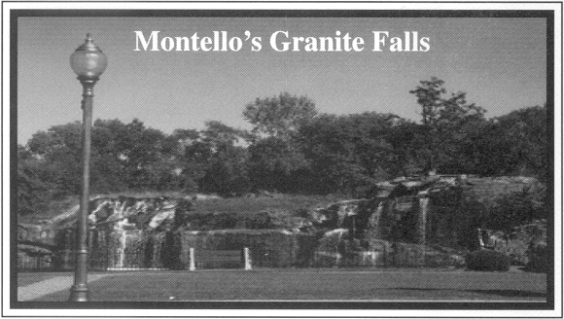
City of Montello

Zoning/Setback/Razing Application

TO THE DIRECTOR OF PUBLIC WORKS / ZONING ADMINSTRATOR: MONTELLO, WI.

The undersigned hereby requests a site plan approval for the following;
(Check all that apply)

- One and two Family residential dwelling: $100.00 _____
- Residential additions and alterations: $75.00 _____
- Residential accessory buildings: $50.00 _____
- Commercial addition/alteration: $150.00 _____
- Commercial accessory building: $75.00 _____
- Signs: $25.00 for 1st 20 sq. ft. and $0.50/sq. ft. thereafter_____
- Other (fence, deck, pool.): $40.00 _____
- Razing: $50.00 for 1st 1000sq.ft. and $25.00 1000 sq.ft thereafter. ________
- Temporary Land use/occupancy permit : $50.00________

Is the building site in the flood plain as designated by the flood plain map on file with the City of Montello?
Yes___
No ___

If so, a Certificate of Elevation is required.

Cost of Project: $__________

Name & Address: ____________________________ Building Address if different:
(Please Print) ____________________________ _____________________
____________________________ _____________________
(Phone #) ____________________________ _____________________

(Email Address) ___________________________________________________

Total Due: $__________

It is understood that all City of Montello zoning/building/setback codes will be read, understood, and followed. It is further understood that all required documentation will accompany application and a permit will not be issued before application and fees are filed with the City Clerk, located at Montello City Hall, 20 Underwood Ave

___________________________Owner
(Signature)

Date of Application_______________, ______
Application Approved_______________, ______by____________________________

